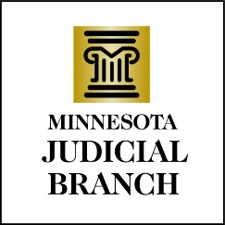

Judicial Council Agenda
February 15, 2024
9:00 a.m.
Room 230, MN Judicial Center and via Zoom

- Decision Item: Approval of Draft January 18, 2024, Meeting Minutes

- Discussion Item: Compensation Council

- Discussion Item: OHI Update

- Discussion Item: Special Topic—Artificial Intelligence Part II

- Decision Item: Generative AI Westlaw

- Discussion Item: Minnesota Court Payment Center Internal Audit

- Discussion Item: Second Quarter Financial Projection

- Discussion Item: Education Opportunities for Judges

- Decision Item: Proposed Revisions to Judicial Council Policy 221, Court Reporter Transcript Rates

- Other Business
a. Performance Measures Review
b. Legislative Update

- Executive Session

- Adjourn

