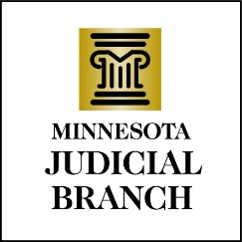

Judicial Council Agenda
January 18, 2024
9:00 a.m.
Room 230, MN Judicial Center and via Zoom

- Decision Item: Approval of Draft December 14, 2023, Meeting Minutes

- Discussion Item: Special Topic – Artificial Intelligence

- Discussion Item: Treatment Court Statewide Performance Measures

- Discussion Item: Revisions to Judicial Council Policy 306, Outside Employment

- Discussion Item: Proposed Revisions to Judicial Council Policy 221, Court Reporter Transcript Rates

- Decision Item: Proposed Revisions to Judicial Council Policy 523, Storage of Captured Records of Court Proceedings and Judicial Council Policy 523.1, Capturing the Record of Court Proceedings-Back Up of Recordings and Redundant Storage

- Other Business
a. Public Access to Judicial Council Materials

- Executive Session

- Adjourn

