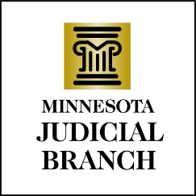

Judicial Council Agenda
March 14, 2024
9:00 a.m.
Room 230, MN Judicial Center and via Zoom

- Decision Item: Approval of Draft February 15, 2024, Meeting Minutes

- Discussion Item: OHI Update

- Discussion Item: District Access and Fairness Survey Results

- Discussion Item: Continuation of Temporary Referees

- Discussion Item: Proposed AI Policy and Governance Framework

- Discussion Item: Psych Services Special Topic Follow Up

- Other Business

- Adjourn

