Invitation and Application

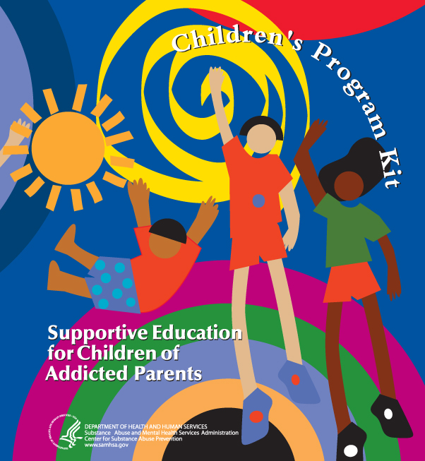

Supportive Education for Children of Addicted Parents

December 10 – 11, 2008
Crown Plaza Minneapolis North
Brooklyn Center, Minnesota

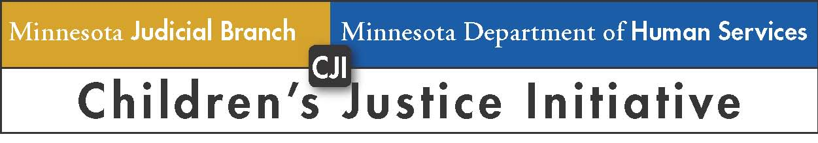

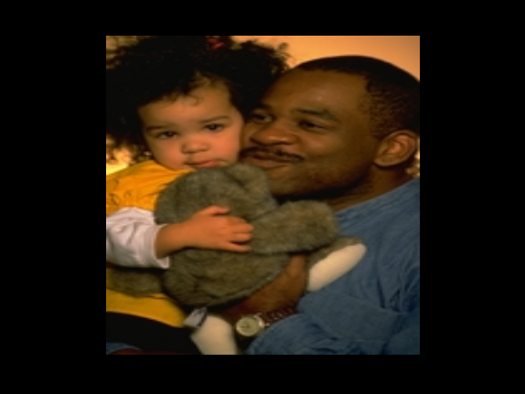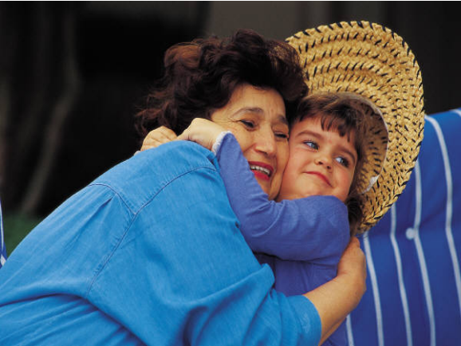

Children’s Program Curriculum and Kit Developed by:
U.S. Dept. of Health and Human Services
Substance Abuse and Mental Health Services Admin. (SAMHSA)

Trainers:
Betty Conger and Kathy Walton
Henry Ford Health System,
Maplegrove Community Education, Michigan

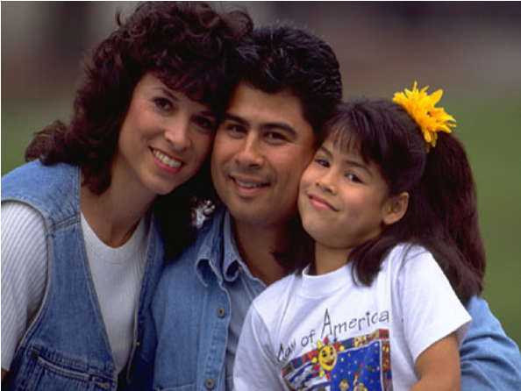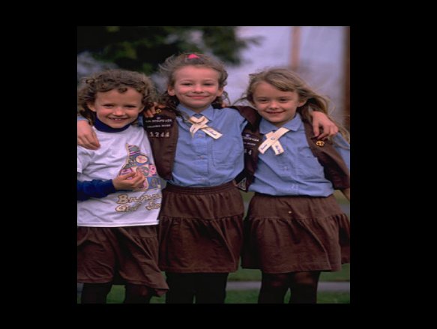

Location
Crown Plaza Minneapolis North
2200 Freeway Blvd.
Brooklyn Center, MN 55430
763-566-8000
Directions: http://www.minneapolisnorthhotel.com/location.php

What is the Children’s Program Kit?
Often, the people hurt most by alcohol and other drug use disorders don’t drink or use drugs – they are the children of alcohol- or other drug-dependent parents. These children are more likely to experience mental and physical problems and are at increased risk of being neglected or abused. They are also at much greater risk to become addicted themselves. The Children’s Program Kit: Supportive Education for Children of Addicted Parents provides educational materials and activities for chemical health treatment providers, therapists, social workers, and other persons who work directly with children and youth to initiate educational support programs for children whose parents have chemical use issues or disorders. The Kit has activities for children of all age levels, as well as information for agencies to distribute to parents to help them understand the needs of their children. See http://ncadi.samhsa.gov/promos/coa/ for Kit details.

Purpose of Children’s Program Kit Training
This training is not a train-the-trainer session. Instead, the Children’s Program Kit training will use interactive methodology to teach the curriculum and learning techniques to attendees. Attendees will then be able to return to their counties or agencies or tribes to teach children and youth the skills necessary to cope with their parent’s alcohol or other drug dependence.

Who Should Attend Training
This two-day training is designed for chemical health treatment providers, therapists, social workers, guardians ad litem, and others at the county and tribal level who work directly with children and youth and who aim to help them make sense of what they have been experiencing as a result of their parent’s addiction, cope with the stresses of their families’ problems, and strengthen their potential for resilience.

Limited Seating Capacity for Training
Due to the interactive nature of this training, the trainers prefer to limit the size of the training class to around 50 – 60 participants. For that reason, acceptance into the training will be based upon a minimal number of application criteria.

Application Criteria
On the attached application, each applicant will be asked to establish that he/she: (1) works directly with children and youth; (2) serves a racially/ethnically diverse child population; (3) has prior experience delivering a curriculum, although such experience is preferred but not required; and (4) has developed a plan for offering at least two series of the Children’s Program to children and/or youth during 2009 (for example, one series may be six 1½-hour sessions for adolescents regarding educational support related to parent addiction issues).

Application Deadline
Applications must be received by 5:00 p.m. on Friday, October 31. All applications will be reviewed for compliance with the application criteria. Applicants will be notified of the acceptance or non-acceptance of their application by Friday, November 7.

Continuing Education Credits
Application has been made for 10 hours of continuing education credits. Information about the number of credits actually approved by the various agencies will be provided at the training.

Fees and Travel Expenses
There is no registration fee to attend the training. In addition, the costs for all training materials, lunch, and morning and afternoon breaks will be paid by the training sponsors through use of federal grant funds. Parking is free. Participants are responsible for all other expenses, including lodging, other meals, and mileage.

Lodging
Participants must pay for all lodging costs ($99 per night plus tax). Details regarding lodging arrangements will be provided to those whose applications are accepted for this training.

Agenda Overview (Tentative, subject to change)

Wednesday, December 10
9:30 Registration, Networking, and Continental Breakfast
10:00 Children’s Program Kit Training
Noon Lunch
1:00 Children’s Program Kit Training (continued)
3:00 Break
5:00 Wrap Up and Adjourn

Thursday, December 11
8:30 Children’s Program Kit Training (continued)
10:00 Break
Noon Adjourn

Questions

Applications, Training Content Logistics, Location, Registration
Jackie Crow Shoe Shannon Campbell, Learning Event Coordinator
Department of Human Services State Court Administrator’s Office
Phone: 651-431-4676 Phone: 651-282-5352
jackie.crowshoe@state.mn.us shannon.campbell@courts.state.mn.us
Children’s Program Kit Training Application – Must be submitted by 5:00 p.m. Friday, October 31 to:
Shannon Campbell, Learning Event Coordinator
Phone: 651-282-5352
FAX: 651-297-1173
EMAIL: shannon.campbell@courts.state.mn.us

Applicant Information (please print):
Name: Title:
Organization Name (agency, tribe, court, etc):
Mailing Address:

Phone: Email:

- I attended the one-hour Children’s Program Kit Overview ITV session on Sept. 25 or Oct. 1 …………….. ◻ YES ◻ NO

- I am (check all that apply) :
A member of a Family Dependency Treatment Court (FDTC) Team ◻ YES ◻ NO
I am a Chemical Health Division (CHD) grantee ◻ YES ◻ NO
I am a Children’s Trust Fund (CTF) grantee ◻ YES ◻ NO
I am a representative of a tribally affiliated agency ◻ YES ◻ NO
A member of a Children’s Justice Initiative (CJI) Team ◻ YES ◻ NO

Application Criteria (please print):
- Describe in detail how you currently work directly with children and youth:
- Describe the racial/ethnic population of the children and youth you currently serve:
- List examples of the prior educational curricula with which you have been involved and describe your specific role in providing or facilitating delivery of the curriculum (prior delivery experience preferred but required):
No. | Curriculum Name or Content Description | Date(s)/Locations Presented | Describe Your Role in Providing the Curriculum (e.g., presenter, facilitator, etc.) | Describe Audience (e.g., adults, children)
1.
2.

- Following is my plan for offering at least two series of the Children’s Program Kit during 2009, including names of therapists or others who will assist with providing the training, how children/youth will be identified and invited to participate, tentative dates and locations for the training
No. | Proposed Series Dates and Locations | Names of Proposed Presenters, Therapist(s), and Facilitators | Proposed Method for Identifying and Inviting Children or Youth | Proposed Curriculum Series (e.g., therapy group, educational support group)

Special Dietary Needs and Other Accommodations (check all that apply):
◻ Please identify any special dietary needs you have (vegetarian options will be offered for lunch, so it is not necessary to identify this as a dietary need):
◻ In compliance with the Americans with Disabilities Act, please identify any special needs you have and any accommodations the training sponsors should provide to assist you:

