Minnesota Judicial Branch Policy/Procedures
Policy Source: State Court Administrator
Policy Number: 506(b)
Category: Court Operations
Title: Copy Fee Policy
Origination Date: July 1, 2008
Effective Date: July 1, 2008, July 20, 2010, March 14, 2011, January 14, 2013
Revision Date: July 16, 2010, February 25, 2011, December 26, 2012
Contact: Director, Court Services Division

Copy Fee Policy

I. POLICY

Pursuant to Judicial Council Policy 506, this policy is implemented to promote consistent fee assessment for services. In furtherance of that policy goal, free copies shall be provided only to those who have statutory authority to receive records without charge, as listed below in Section III (B). Additional fees set pursuant to Minn. Stat. § 357.021, subd. 2(14) are detailed in Section III (C) below.

II. APPLICABILITY

This policy is applicable to all district courts.

III. PROCEDURES

A. Fees provided in Minn. Stat. § 357.021, Court Administrator of District Courts Fees, shall be required as prescribed by law. Such fees include, but are not limited to: various filing fees; issuance of subpoenas; depositing of wills; and registering notaries.

B. Free Copies
1. Criminal justice agencies, including city, county, state and federal.

2. Prosecuting attorneys may require criminal history information related to prior impaired driving convictions and other “enhanceable” offense for the purpose of enhancement or charging subsequent driving conduct as a gross misdemeanor. Documents for enhancement purposes typically include the formal complaint or citation, conviction (sentencing order) and Petition to Enter a Guilty Plea.
AUTHORITY: Minn. Stat. § 169A.43, subd. 4

3. Copies of court documents to public defender.
AUTHORITY: Minn. Stat. § 644.271

4. Copies of the PSI to the attorney representing the defendant on appeal or in post-conviction proceedings.
AUTHORITY: Minn. Stat. § 609.115, subd. 4(b)

5. Identity information requested by the United States Citizenship and Immigration Services (formerly known as INS) of the Department of Homeland Security. Documents required typically include the indictment or complaint. It is suggested that the request should come in writing on agency letterhead.
AUTHORITY: Minn. Stat. § 631.51

6. County is exempt from copy fees for cases initiated by the county. The statute lists the following case types:
a. Child support enforcement or modification, medical assistance enforcement, or establishment of parentage in the district court, or in a proceeding under Minn. Stat. § 484.702;
b. Civil commitment under Minn. Stat. Chapter 253B;
c. The appointment of a public conservator or public guardian or any other action under Minn. Stat. Chapters 252A and 525;
d. Wrongfully obtaining public assistance under Minn. Stat. §§ 256.98 or 256D.07, or recovery of overpayments of public assistance;
e. Court relief under Minn. Stat. Chapter 260;
f. Forfeiture of property under Minn. Stat. §§ 169A.63 and 609.531 to 609.5317;
g. Recovery of amounts issued by political subdivisions or public institutions under Minn. Stat. §§ 246.52, 252.27, 256.045, 256.25, 256.87, 256B.042, 256B.14, 256B.15, 256B.37, 260B.331, and 260C.331, or other sections referring to other forms of public assistance;
h. Restitution under Minn. Stat. § 611A.04; or
i. Actions seeking monetary relief in favor of the state pursuant to Minn. Stat. § 16D.14, subdivision 5.
AUTHORITY: Minn. Stat. § 357.021

7. Parties (including attorneys for the parties, such as Legal Aid) with a current IFP for that case are exempt from copy fees.
AUTHORITY: Minn. Stat. § 563.01

8. Providing copies of harassment restraining orders, domestic violence orders for protection, and domestic child abuse orders for protection to local law enforcement.
AUTHORITY: Minn. Stat. § 518B.01, subd. 13; Minn. Stat. § 609.748, subd. 7; and Minn. Stat. § 260C.148, subd. 8.

8. MNCIS reports that are automatically generated and emailed after a one-time initial set-up. All other emailed reports are subject to the fees provided under III (C) (2).

C. Charging for Other Documents
This list is intended to be used for uniform practice when there is a request for court records to help court staff determine whether a fee should be charged rather than cover all lines of court business.
1. Forms Packets
a. 1-10 pages – no charge;
b. 11 or more pages - $5;
c. Dissolution with Children and Dissolution without Children packets - $10;
d. Harassment Packets – no charge.

2. Copies of Reports Generated from the Case Management System and provided to requester via email or in paper form.
a. 1 – 50 pages - $5 per report;
b. 50 + pages - $25 for every 50 pages, or part thereof, per report.

Note: Per report means each time the report is generated regardless of the amount of information contained in that report or the method in which it is distributed (printed or electronic).

3. Screen Prints Generated from the Case Management System.
a. Certified Copy - $14;
b. Uncertified Copy - $8.

Note: Copies of the Register of Actions must be printed from MPA – Courthouse View.

Note: Certified copies under this provision should use the following certification language:
I certify that this is a true and correct copy of a computerized record of the Minnesota State Court Information System as it appears in the system in my office.
Dated: __________ @ _________ a.m/p.m.
Signature: ________________________
AUTHORITY: Minn. Stat. 357.021, subd. 2(14) and Policy 5.06.

4. Print outs of imaged or electronically filed documents accessible from the
Courthouse view of MNCIS.
a. Certified Copy - $14;
b. Uncertified Copy - $8.

5. Scanning or taking pictures of documents in a court file.
a. If the file remains intact and the person just runs a scanner over or takes a picture of the page(s).
- No Charge
b. If the file has to be dismantled in order to scan or take a picture of the document, court staff shall dismantle the file and make the requested copies.
      - Certified Copy - $14;
      - Uncertified Copy - $8.

IV. RELATED DOCUMENTS

Courts may have members of the public who are unable to pay the fee for Form Packets. They can complete the standard IFP form or use the attached simplified fee waiver form.

V. REVISION HISTORY
February 3, 2009; July 16, 2010; February 25, 2011, December 26, 2012

Approval:

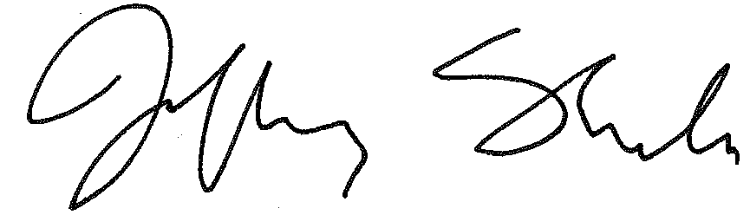
Jeff Shorba, State Court Administrator

December 26, 2012
Date

