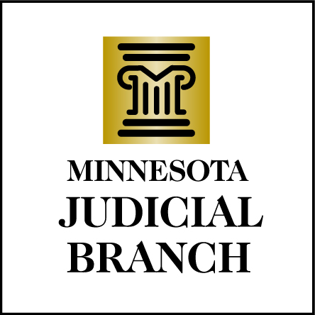

Appearance Request Form
Chief Justice Eric Magnuson

Chief Justice Magnuson receives numerous requests to speak at events. To help us determine which requests can be accommodated, please fill out this brief form.
Email to john.kostouros@courts.state.mn.us; fax to 651-297-5637; or mail to John Kostouros, Court Information Office, Minnesota Judicial Center, 25 Rev. Martin Luther King, Jr. Blvd, St. Paul, MN 55155

EVENT INFORMATION

Event name:

Date: __________________________ Time:

Event Location Address:

Facility Contact Information (name and phone number):

Chief Justice’s Arrival Time: _________________ Departure Time:

Will there be a podium and microphone? _________________________________________

Expected number of people attending:

Are you expecting news media at your event? If yes, which media? Will a press release be sent out?

Suggested topic, speech guidelines or background information on event.
______________________________________________________________________________

______________________________________________________________________________

