

eFile and eServe: New Functionality Quick Reference

Copyright © 2014 by the State of Minnesota, State Court Administrator's Office. All Rights Reserved.

Overview

eFile and eServe (eFS) changes improving usability and business processes will be in effect on Friday, July 25, 2014. The following are the new and enhanced features:

* Envelope Status Updates
* Error Message Enhancements in Service Email Logs
* Fee Multipliers
* Maximum Document and Envelope Size
* Notification of Expired Credit Card
* Service Status Updates
* Addresses and Telephone Numbers in Subsequent Filings
* Reset Password

#### Envelope Status Updates

eFS now provides clearer statuses and tool-tips for filings in the Filings list. The Under Review status has been split into three separate statuses to be more descriptive and logical.

* Under Review – (**Updated**) This status reflects when a court clerk has or is reviewing a filing, but has not taken action of any kind on the filing.
* Processing – (**New**) This status follows Acceptance or Rejection. It indicates that the filing has been reviewed and is now attempting to complete the needed steps (transmission, stamping, email, etc.) before the status will be updated again.
* Court Processing – (**New**) This status indicates that the filing has an error and is in need of additional assistance. This gives court staff an indicator that the filing did not complete processing and should be sought out in the error queue.

All other statuses are unchanged.

#### Error Message Enhancements in Service Email Logs

When a filer is viewing service email logs, error messages are more specific.

#### Fee Multipliers

eFS allows the configuration of fee multipliers to be assigned to specific optional services.

When an optional service is set up at the local level, the filer will be prompted to specify how "many" of the fee (i.e., copy fees) they would like. The number the filer enters is multiplied by the fee amount and one assessment is sent to MNCIS with the total amount. This feature may be best used with various copy and subpoena fees (e.g., plain copy, certified copy, and exemplified copy).

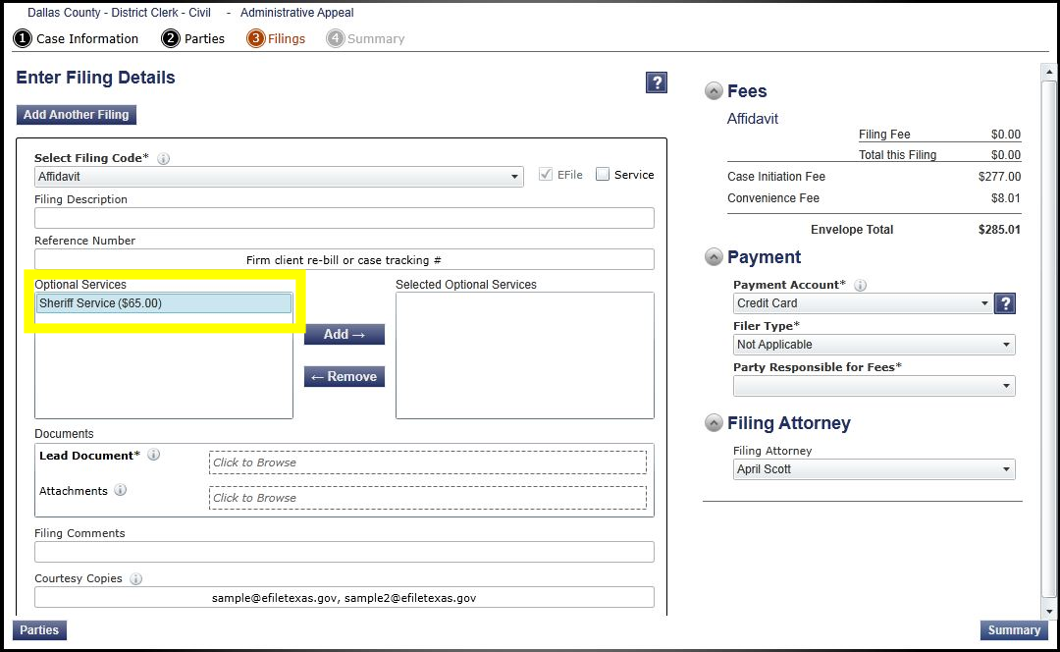

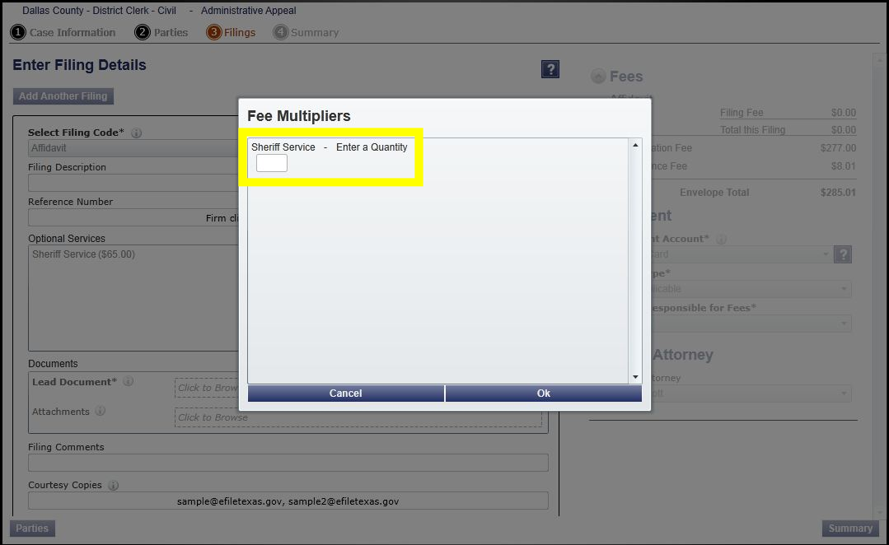

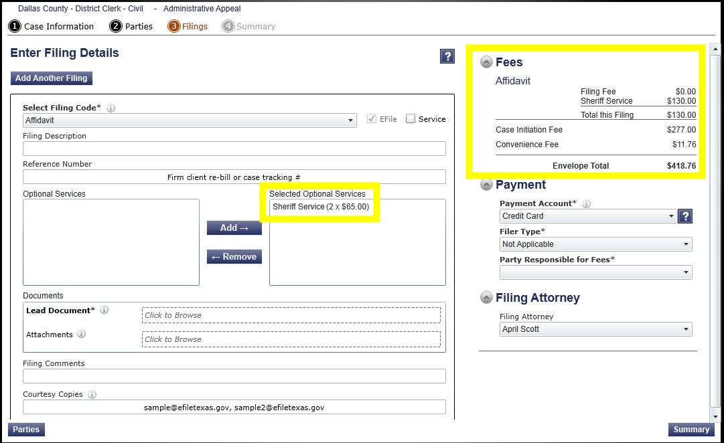

#### Maximum Document and Envelope Size

An error will appear if documents and/or envelopes exceed the maximum limit. [Minnesota General Rules of Practice for District Courts 14.03](http://www.mncourts.gov/Documents/0/Public/Rules/Gen_R_Prac_Tit_I_July_2014.pdf) specifies document and envelope sizes for filing.

#### Notification of Expired Credit Card

eFS now notifies a filer if a credit card is expired and prevents the filer from using an expired card. The filer must access the Payment Account and set up an active credit card in order to submit the filing.

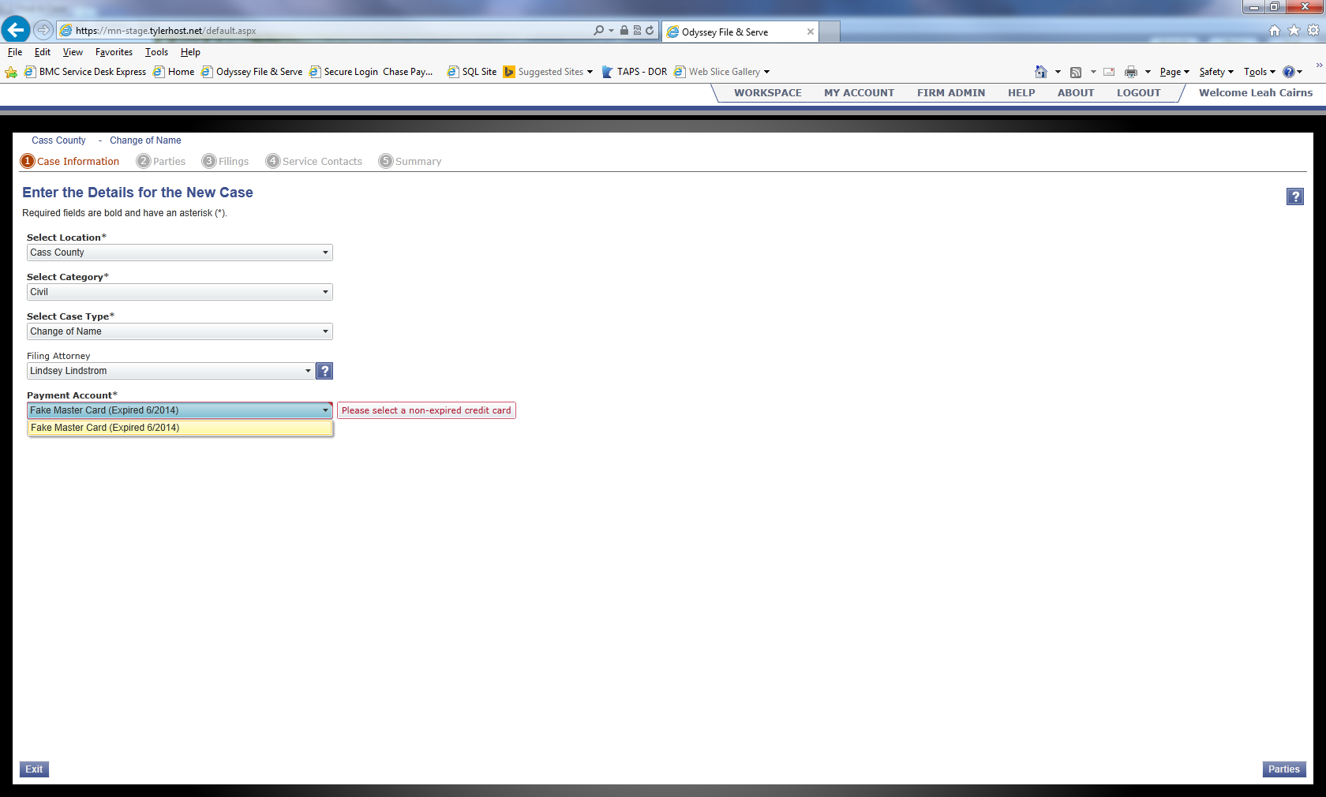

#### Service Status Updates

eFS displays a status of **Served** when all services are completed successfully. If one or more services fail, the status displays as **Service Incomplete**.

* If service is not sent at all, Tyler Technical Support will review and address the issue.
* If an email is sent and errors-out, Tyler Technical Support will not address the issue.
* The original filer may resend the service.

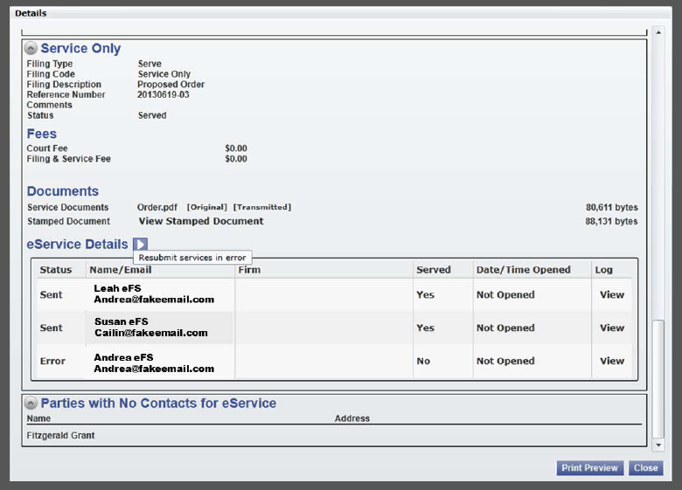

Addresses and Telephone Numbers in Subsequent Filings

Party and participant addresses and telephone numbers will not be visible in eFS during subsequent filings. Parties and attorneys can use pleadings in the case and their own files for this information if needed.

#### Reset Password

eFS provides a more user-friendly method to reset their own password. When logging in to eFS, users may click **Forgot Password** and the system sends a link to reset your password. (Previously the system sent a temporary password.)

