Statewide Standard Citation
Quick Reference Guide Web
Fields with an asterisk (*) indicate new or modified information and are also identified with a red text box alongside the screen print.
Questions? Email us at state.standard.citation@courts.state.mn.us
Field Name/Label on Citation | Field Description | Purpose
Citation Number | Unique number assigned to citation. Number associated with agency issuing ticket.  12 Digits:  2-digit: County #  2-digit: Unique agency #  8-digits: Sequential numbering, agency can include year in sequence | Ease of tracking  for agencies, courts,  and defendant to pay on  web or by phone
Bar Code | Digital representation of citation  number; unique number for  every ticket | Ease of citation processing  No pen strokes within the barcode field
County Name | County where offense occurred | Fine-Split
*Sequential Citations __of___ | Complete if multiple citations issued  (e.g. Page 1 of 2; Page 2 of 2) | Multiple citations, same incident
Identification | DL = Drivers License | Method defendant identified by officer
 | DVS Website
 | Photo ID
 | FP = Finger Print
 | Other
DL Number | Subject’s driver’s license number | DPS Requirement
Name | Full first, middle (not initial), last name. Add suffix: Jr./III | Identification
Address - Street, Apt # | Subject’s residence street address, not mailing address | Identification
City, State, Zip | Subject’s City, State and Zip code of residence | Identification
CDL Checkbox | Commercial Driver’s License | Special handling of offenses per Code of Federal Regulations
State Checkbox | Issuing State of identification | Identification
DOB (mm/dd/yyyy) | Subject's date of birth from DL, ID Card, otherwise verbal | Identification
Height | Height: Feet & inches e.g. 6’4” | Identification
Weight | Weight of citee | Identification
Eyes | Eye color of citee | Identification
Gender | Subject’s gender | DPS Requirement
Juvenile Court Offense Type | JTR = Juvenile Traffic Offense  JPO = Juvenile Petty Offense  DEL = Delinquency | Court processing
*Juvenile’s Parent or Guardian  Name and Address | Name & address of parent or guardian if offender a juvenile | Used to notify juvenile parent/guardian of offense
Same address as Juvenile Checkbox | Indicates that Parent or Guardian’s address is same as the juvenile | Used to notify juvenile parent/guardian of offense

Field Name/Label on Citation | Field Description |  | Purpose
Child’s Race | Race of Juvenile |  | Juvenile Court Rules requirement
Vehicle Lic. No. | License plate number |  | DPS Requirement
Plate Year | Year of Tab on plate
State | State that issued plate |  | DPS Requirement
Make | Manufacturer of Vehicle |  | DPS Requirement
Style | Type of Vehicle |  | DPS Requirement
16+ Passenger  Bicycle  Bus  Construction  Equipment  Electric Bike  Emergency | Farm  Motorboat  Motorcycle  Motorized Bike  Off-road Motorcycle  Off-road recreational  Other |  | Passenger  Road Tractor  School Bus  Semi-truck  Snowmobile  Tow Truck
16+Pass | Commercial transport 16+ passengers |  | DPS Requirement
Color of Vehicle | Color of vehicle
Date of Offense | Date of violation |  | DPS Requirement
Time of Offense | Time of violation |  | Additional incident information
Accident/Crash | Check all that apply: |  | Provides additional detail if incident involved a crash
 | Injury  Fatal | Pedestrian  Property Damage
Unsafe Conditions  Weather | Clear  Cloudy  Fog  Freezing rain  Heavy rain  Ice | Light rain  Snow  Sundown  Sunny  Sunrise | Further defines incident
*Endangering Life or Property checkbox | Indicates if life or property endangered. If checked, then mandatory court appearance required by subject. |  | Further defines violation
Commercial Vehicle DOT # | The USDOT# is put in the field. This is a number that identifies the carrier |  | Further defines violation
# Pounds Overweight | Number of pounds vehicle is overweight |  | Further defines violation
Hazardous Materials | Vehicle is transporting hazardous material |  | Further defines violation
Driver | Citee is the driver |  | Identification
Owner | Citee is the owner |  | Identification
Passenger | Citee is a passenger |  | Identification
Operate | Citee operating equipment |  | Identification
Parked | Vehicle is parked |  | Identification
Booked | Offender was booked |  | Offender was booked
Offense Location | Address of offense |  | Fine split
*City/County/Township/Other | Officer must identify for proper fine distribution; specify subdivision of government, for example:  City  Township  District (e.g. Sanitary district, 3 Rivers Park District, etc.)  If none apply, note county name. |  | Fine split

Field Name/Label on Citation | Field Description | Purpose
Offense
Charge Description | Word description of violation. List only one count per line. | Describes the violation
Statute/Ordinance | Number description of violation | Identifies the violation
*3rd Violation | Indicates a 3rd offense for subject, but the case would still be payable. | Checkbox for ease of citation writing for officer
PM, M, GM | Petty Misdemeanor | Identifies degree of the offense
 | Misdemeanor
 | Gross Misdemeanor
*Speed MS169.14  (subd_____) | Officer must indicate specific subdivision violated for speeding violation. | Checkbox for ease of citation writing for agency, officer must note subdivision.
3rd in 12 months | Check if 3rd offense in 12 months
*MPH | If speeding offense, indicate the miles per hour the subject was driving. | Further defines violation
*Zone | Speed zone/Speed Limit | Further defines violation
*No Proof of Insurance 169.791 | Driver did not provide proof vehicle was insured. Officer must indicate specific subdivision violated for No Proof of Insurance violation. | Checkbox for ease of citation writing for officer
*No Seat Belt Use 169.686.1(a) | Seat belt not used by occupants of vehicle | Checkbox for ease of citation writing for officer
*AC Taken | Alcohol Concentration  (Do not enter PBT) | Defines concentration
*AC | Results of the alcohol concentration test | Further defines the charge
*Test type | Check applicable test | Defines type of test or refused
Officer’s name(s) | Issuing Officer’s name(s) | Identifies who issued the citation
Officer No(s) | Issuing Officer’s badge No(s) | Identifies who issued the citation
Prosecutor | Office that provides prosecution (e.g. St Paul City Attorney). Tied to the community of offense. | Fine Split
Controlling Agency (CAG) | Number of agency issuing the citation | Fine Split and Criminal History
How Issued | In Person = Handed to Citee | Further defines the method of delivery.
 | Mailed = Mailed to Citee
 | Left at Scene
Date of Citation | Date the citation was issued to citee
*Agency Name | Name of agency issuing the citation | Fine Split and Criminal History
*CN/ICR | Case # or report # at issuing agency’s discretion (Not State patrol event #) | Agency case number
Copy Distribution | Original = Court’s copy  Yellow = Prosecutor copy  Pink = Law enforcement copy  Off-white-tag = Defendant/citee copy

Citation Number
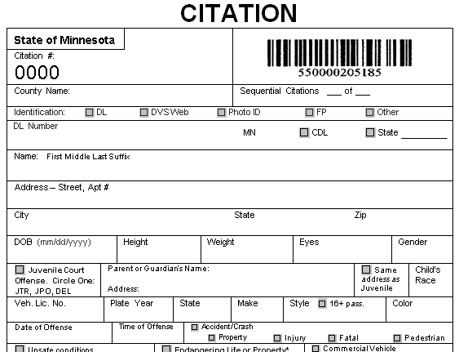
Unique number assigned to citation. Number associated with agency issuing ticket.
12 Digits:
2-digit: County #
2-digit: Unique agency #
8-digits: Sequential numbering, agency can include year in sequence
To top of document

Bar Code
Digital Citation #:
No pen strokes permitted in barcode field

To top of document

County Name
County where offense occurred

Sequential Citations __of__
Complete if multiple citations issued (e.g., Page 1 of 2; Page 2 of 2)
To top of document

Identification
FP = Finger Print
Other Method Defendant Identified by Officer
Photo ID
DVS Website
DL = Driver’s License #
To top of document
DL Number
Citee’s driver’s license number
Name
Full first, middle (not initial), last name. Add suffix: Jr./III

Address – Street, Apt#
City, State, Zip

City, Sate, Zip Code
Subject’s residence street address; NOT mailing address

To top of document

DOB (mm/dd/yyyy)
Subject's date of birth from DL, ID Card, otherwise verbal

Height/Weight
Eyes

Gender

Weight of citee
Height: Feet & inches e.g. 6’4”
Subject’s gender
Eye color of citee

To top of document

Juvenile Court Offense
JTR = Juvenile Traffic Offense
JPO = Juvenile Petty Offense
DEL = Delinquency
To top of document

Juvenile’s Guardian Address
Name & address of parent or guardian if offender is a juvenile
If same address as juvenile check here

Child’s Race
Race of juvenile
Juvenile Court Rules requirement
To top of document

Vehicle Lic. No.
Plate

Year of Tab on plate
License plate number

To top of document

Vehicle Information
State that issued plate
Manufacturer of Vehicle

Style
Type of Vehicle
16+ Passenger Bicycle Bus
Construction Equipment Electric Bicycle
Emergency Farm Motorboat
Motorcycle Motorized Bike Off-road Motorcycle
Off-road recreational Passenger Road Tractor
School Bus Semi-truck Snowmobile
Tow Truck Other
To top of document

16+Pass
Commercial transport 16+ passengers
To top of document

Color of Vehicle
Color of Vehicle Driven by Citee

Date of Offense

Time of Offense
Time of violation
Date of violation
To top of document

Accident/Crash
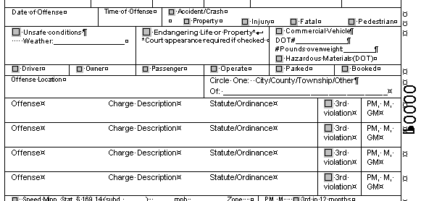
Provides additional detail if incident involved a crash. Check all that apply
To top of document

Unsafe Conditions

Weather

Identify unsafe conditions:
Clear Cloudy
Fog Freezing rain
Heavy rain Ice
Light rain Snow
Sundown Sunny
Sunrise

To top of document

Endangering Life & Property
Indicates if life or property is endangered. If checked, then mandatory court appearance is required by subject.
To top of document

Commercial Vehicle
Indicates if the vehicle involved is a commercial vehicle
DOT#
#Pounds Overweight
The USDOT# is put in the field. This is a number that identifies the carrier
Hazardous Material (DOT)
Indicates if vehicle transporting hazardous material

Number of pounds vehicle is overweight

To top of document

Citee Information
Citee operating equipment
Citee Driving Vehicle
Citee is a Passenger
Citee is the Owner
To top of document

Parked
Vehicle is parked

Booked
Offender was Booked
To top of document

Offense Location
Address of Offense
To top of document

City/Community/Township
Must be identified by officer for proper fine distribution; specify subdivision of government, for example:
City
Township
District (e.g. Sanitary district, 3 Rivers Park District, etc.)
If none apply, note county name

To top of document

Offense

Charge Description

Statute/Ordinance

Word description of violation. List only one count per line.
Number description of violation

3rd Violation

PM, M, GM

Indicates a 3rd offense for subject, but the case would still be payable.

Petty Misdemeanor
Misdemeanor
Gross Misdemeanor

To top of document

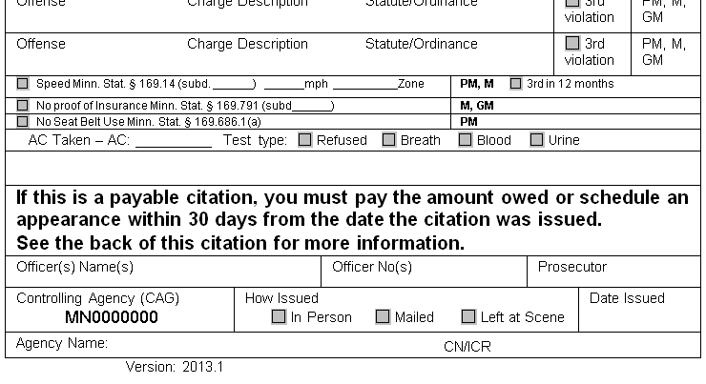
Speed MS169.14 (subd______)
MPH
Speed zone/Speed Limit
Officer must indicate specific subdivision violated for speeding violation.
Zone

If speeding offense, indicate the miles per hour the subject was driving.

To top of document
3rd Violation in 12 Months

If a 3rd offense in 12 months, check the checkbox and indicate the degree

To top of document

No Proof of Insurance 169.791
No Seat Belt Use 169.686.1(a)
Seat belt not used by occupants of vehicle

Driver did not provide proof vehicle was insured. Officer must indicate specific subdivision violated for No Proof of Insurance violation.

To top of document

AC Taken
Results of the alcohol concentration test

AC

Test Type

Check applicable test
Alcohol Concentration
(Do not enter PBT)

To top of document

Officer Information

To be filled out to inform offender of Officer’s Name
To be filled out to inform offender of Officer Badge number

To top of document

Prosecutor

Office that provides prosecution (e.g. St Paul City Attorney)
Tied to the community of offense.

To top of document

Controlling Agency (CAG)
Number of agency issuing the citation
To top of document

How Issued
Defines the method of delivery:
In Person – Handed to Citee
Mailed – Mailed to Citee
Left at Scene

To top of document

Date of Citation
Date the citation was issued to citee
To top of document

Agency Name
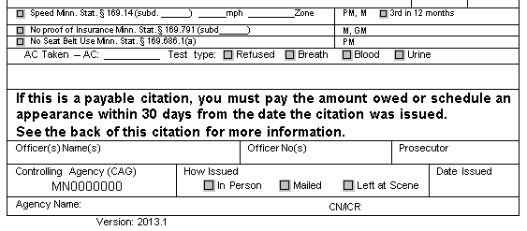
Name of agency issuing the citation
To top of document

CN/ICR
Case # or report # at issuing agency’s discretion (Not State patrol event #)

To top of document

