SUE K. DOSAL
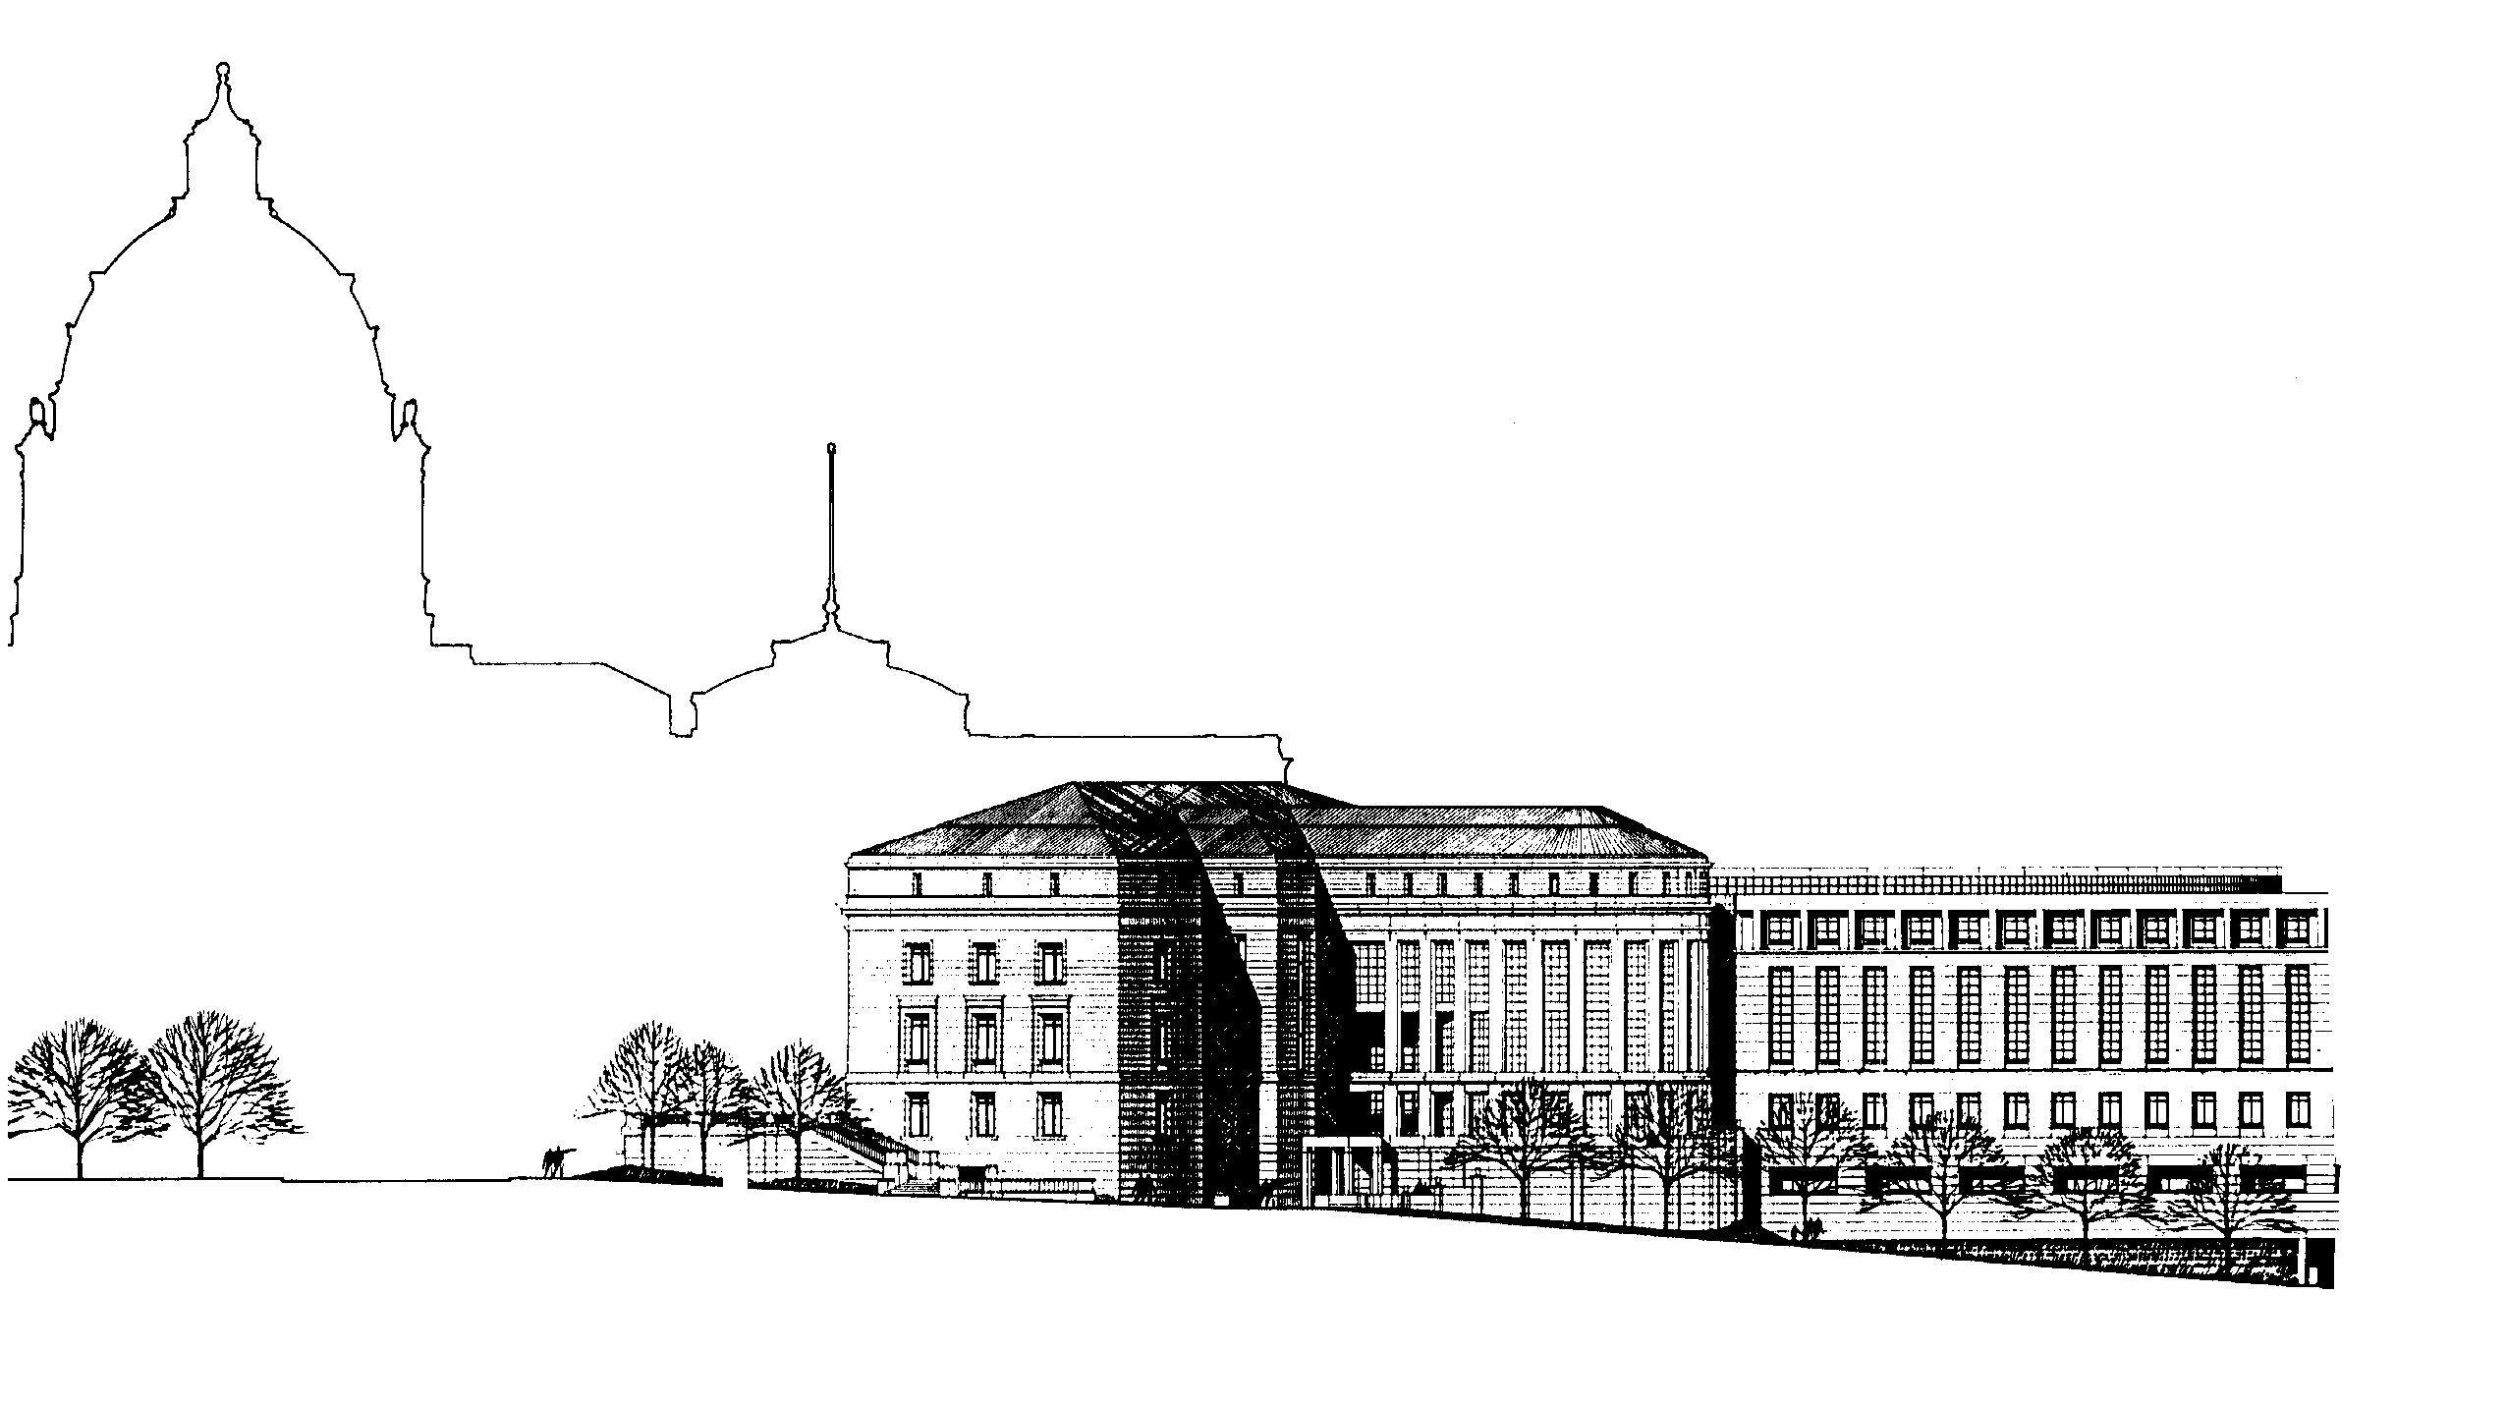

STATE COURT ADMINISTRATOR
25 Rev. Dr. Martin Luther King, Jr. Blvd.
Saint Paul, Minnesota 55155

Data Elements for Adult Citations
December 2011

The State of Minnesota has approved and announced a statewide standard citation to be used by all law enforcement agencies statewide effective January 1, 2012.

Rule 6.01 of the Minnesota Rules of Criminal Procedure, effective January 1, 2012, establishes the required contents of a citation. Rule 6.01 sets forth the required legal content and minimal administrative content of the citation, and directs the State Court Administrator and Commissioner of Public Safety to prescribe and approve a citation form.

It is important to recognize the distinction between paper citations and eCitations as it relates to the new standard. While the new rule applies to paper and electronic citations, its application will differ due to the material differences between how paper and electronic citations are produced, filed and processed.

Minn. R. Crim. P. 6.01, subd. 4 indicates that “any citation, including electronic citations, filed or efiled with the courts must be in a form prescribed by this rule and approved by the State Court Administrator and the Commissioner of Public Safety . . . .” As authorized by Rule 6.01, below is the prescribed and approved citation form for paper and electronically submitted adult citations.

Form of Paper Citation:
The State Court Administrator and Commissioner of Public Safety are mandating the use of one of the following two forms for paper citations:
Example of State Standard Citation - Court Date Option (PDF)
Example of State Standard Citation - Respond by Option (PDF)
That paper citation must include the information required by Minn. R. Crim. P. 6.01, subd. 4.

Form of Electronic Citation:
The State Court Administrator and Commissioner of Public Safety are mandating the following with respect to electronic citations:

Electronic Citations Submitted to MNCIS must take the form prescribed by the court’s schema for adult citations.
Minimum Notice Requirements: While all of the language that appears on the back of the Paper Citation Form is NOT required for electronic citations; all of the following information must be included on the citation issued to the defendant:

Minimum Minnesota Court Payment Center contact information:

For questions or to make payment by credit card using phone or web:
Visit: www. mncourts.gov/fines.
- Call: 1-800-657-3611 (Disponible por teléfono en Español)
651-281-3219 (metro)
Send check or money order to:
Minnesota Court Payment Center
PO Box 898
Willmar, MN 56201.
320-231-6507 (Fax)
If your citation is payable, you have the right to appear in court. If a court date is noted, you must either pay your fine by this date or appear in court on the date, time, and at the location indicated. If no court date is noted, you must pay the amount owed or schedule an appearance within 30 days from the date this citation was issued.

Minimum Legal Notifications:
BY PAYING THIS FINE(S), YOU ARE ENTERING A PLEA OF GUILTY to this offense(s) and voluntarily waive your rights: (Minn. R. Crim. P.23.03)
1. To a court trial, if the offense is a petty misdemeanor, or a court or jury trial for all other offenses;
2. To be represented by counsel;
3. To be presumed innocent until proven guilty beyond a reasonable doubt;
4. To confront and cross examine all witnesses; and
5. To either remain silent or to testify on your own behalf.
If the offense is a petty misdemeanor, failure to pay the fine, appear in court, or contact the Court Payment Center will be considered a plea of guilty and waiver of the right to trial, unless failure to appear is due to circumstances beyond the person’s control. (M.S. 169.91; 609.491.) For all other offenses, failure to pay the fine, appear in court, or contact the Court Payment Center may result in the issuance of a warrant for arrest.
Under Minn. Stat. § 480.15, subd. 10c, unpaid fines may be referred for collections. You have the right to contest the referral.
Additional notices regarding your legal rights can be found on the Judicial Branch website at: www.mncourts.gov/fines.

Note: Citations Created on Mobile Devices (e.g., laptop or handheld) that are not electronically submitted to MNCIS and are filed in paper form must conform to the Paper Citation form (see above).

For citations that were intended to be submitted electronically to MNCIS, but were unsuccessful or rejected and must be filed in paper form, the submitter may file, and the court shall accept, the printed version of the electronic citation even if it is not in compliance with the Paper Citation form.

Frequently Asked Questions (FAQs) related to the statewide standard citation can be found on the Judicial Branch website at: Statewide Standard Citation FAQS.

Additional questions can be directed to: state.standard.citation@courts.state.mn.us.

