An Informal Evening with the Minnesota Supreme Court
Tuesday, October 9, 2012, 6:00 p.m.
Willmar Conference Center, Willmar, MN

Many thanks to our event partner, the Willmar Lakes Area Chamber of Commerce.

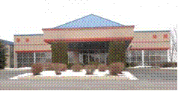
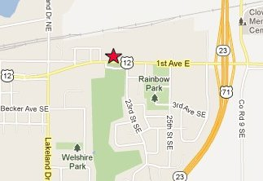

Registration
An Informal Evening with the Minnesota Supreme Court
Tuesday, October 9, 2012 – 6:00 p.m.
Willmar Conference Center, Willmar, MN

Name: ____________________________________________________________________________
Address: ____________________________________________________________________________
City: _____________________________________ Zip: ___________________________________
Occupation/Organization: ____________________________________________________________
Other Attendees: ___________________________________________________________________
___________________________________________________________________
___________________________________________________________________

Number of reservations: _______ x $15.00
Amount Enclosed: _______

Please return R.S.V.P. by September 27, 2012 to:
Willmar Lakes Area Chamber of Commerce, 2104 Highway 12 East, Willmar, MN 56201.
Make checks payable to “Willmar Lakes Area Chamber of Commerce.” For assistance please call
(320) 235-0300. Tickets are non-refundable and will not be available at the door.

