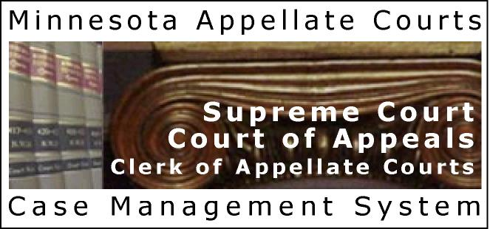
P-MACS

Minnesota Appellate Courts – Case Management System
(Public Version)
http://macsnc.courts.state.mn.us

Case Lookup
Instruction Sheet

Introduction/Special Notes 2
TCIS case limitations in P-MACS 3
Connecting to P-MACS: 4
Searching for Cases in P-MACS: 5
Case Information Search: 5
Participant Search 6
Viewing Cases in P-MACS 8
Viewing Party Information 9
Viewing Docket Information 9
Docket Entry Detail 10
Outgoing Document Docket Entries: 10
Troubleshooting & Support: 11

Introduction/Special Notes

P-MACS is a public-view version of MACS, the computerized case management system that the Minnesota Supreme Court and Minnesota Court of Appeals use to track and manage cases and other matters filed in those courts. P-MACS displays information about individual cases, including the title and file number, case participants, and dates and details of all docket entries.
P-MACS contains current appellate cases as well as data previously accessed via the prior case management system, known as TCIS. Basic case data from the TCIS system was converted to P-MACS, and all cases should be found in the new system.

- Use Online Help for explanation on how the application is used.
- The Help? Link will bring you to the general Help for P-MACS. The blue “I” button will bring you to the context sensitive Help/Information screens.
- Comments, suggestions, and questions regarding P-MACS are welcome. Please note that all comments and suggestions will be reviewed, but a personal response to all submissions may not be possible. Email to: pmacs.support@courts.state.mn.us
- For cases that were open in either the Court of Appeals or the Supreme Court on March 3, 2003 and later, P-MACS provides the following information about the case: case title, appellate case number, parties, attorneys, docket entries, and links to orders or opinions issued in the case after March 3, 2003. For cases that were archived before March 3, 2003, only case title, case number and abbreviated party information are available.
- For security reasons this site does not provide access to the live MACS database, and the data on this site is one day behind the live system. In addition, while court staff update case information daily and make every attempt to enter case information in a timely manner, there are occasional delays between receiving documents and entry of case information into the MACS database.
- While every attempt has been made to ensure that the information provided through P-MACS is accurate, there are no warranties ensuring accuracy.
- For most efficient viewing of the P-MACS, your screen resolution setting should be at least 1024x768.

To verify information obtained from this site, or to obtain appeal information not available on this site, please contact the Office of the Clerk of Appellate Courts (651) 296-2581.

TCIS case limitations in P-MACS

- Participants from TCIS cases will appear multiple times in P-MACS participant search results, each time with only one case attached. In situations where a participant was a TCIS organization or agency and also an attorney (for example, Minnesota Attorney General), only the attorney record has an address attached.
- TCIS cases that were archived at the time when P-MACS was activated contain limited information in P-MACS (Case Title, Case Number and abbreviated party information). In addition, names of participants in these cases are no more than 14 characters long. Participants of archived cases appear with all the words in their names in the Party Name field.
  - De-archiving of TCIS cases is not available through P-MACS
- Docket entries from TCIS may not correctly reflect P-MACS' more specific classifications. Also, many docket entry fields in TCIS were placed in the Comments field in P-MACS.
- Law firms in TCIS were listed as Pro Hac Vice attorneys, which were not transferred into P-MACS.

Connecting to P-MACS:

The URL for P-MACS is: http://macsnc.courts.state.mn.us
You will see informational text and are asked to click the Accept button, once you understand/accept this information.
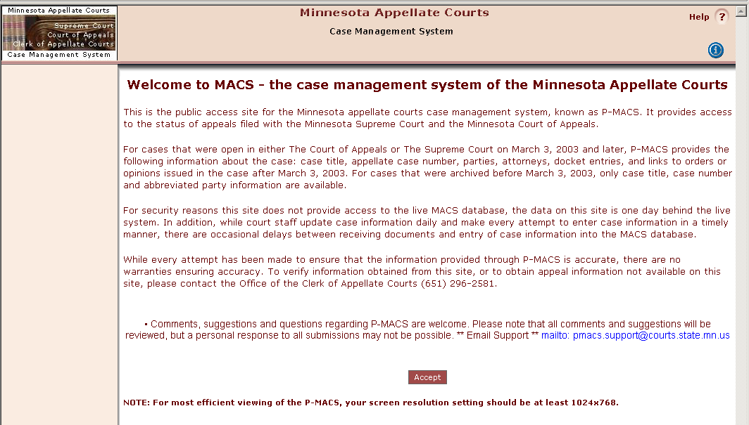

After you click the Accept button, you will be presented with the initial P-MACS System Search Screen.

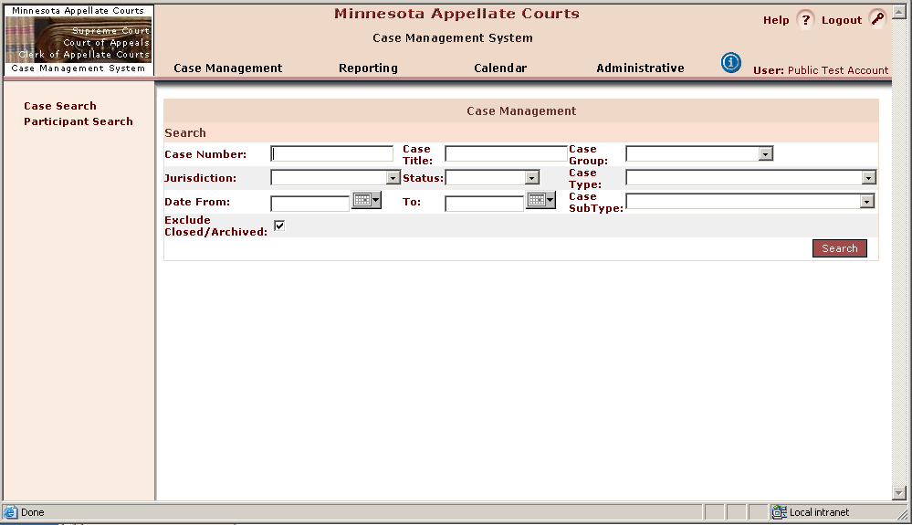

Searching for Cases in P-MACS:

Case Information Search:
You can enter any combination of search criteria on the main search page to filter the search.
If you only have a case number or partial case number, you can search by the last few digits (see example below). Enter the number, and press Enter (key) or click the Search button.
- % = is the wildcard character for searching in P-MACS
- Omit hyphens for ALL case number searches (MACS and TCIS case numbers)
- MACS case numbering format is as follows, example case number A05-1356
A = appellate court
05 = year of case filing in appellate courts
1356 = consecutive numbering as case is filed. Restarts at 0001 each year. In MACS, the consecutive case number always has four digits, even if it does not appear that way on a court document. Example: the first case of 2006, A06-1 on a court document, will appear as A060001 in MACS. In searching by case number, add zeroes as necessary to create a four-digit consecutive number after the two-digit year designation. Example: A05-23 becomes A050023 in MACS. Searching with the two-digit year and four-digit consecutive number is the most efficient way to search for a case by case number.
- A partial case number may be used for case number searches. For example, for case A051356, you can enter “356” in the case number field. Your results lists will include more cases, however, because all cases with “356” anywhere in the case number will be returned. You will need to select your case from the results list.
- TCIS appellate case number searches (only cases filed prior to 3/3/2003):
    - TCIS case numbers are 12 characters in length. In MACS, these case numbers always begin with 98, even though that will not appear on a court document. The TCIS case number format in MACS, using example case number C6-96-356, will appear in MACS as 98C69000356:
98 = system court designator
C6 = check-digits (always C followed by one digit or X)
96 = year of case filing in appellate courts
356 = consecutive numbering as case is filed. Restarts at 1 each year, expressed in MACS as six-digit number, so 356 becomes 000356.
    - Rather than attempting to enter the entire case number where characters could be mistakenly omitted, it is more efficient to enter the two-digit year designator and the six-digit consecutive number. For example, to search for case number 98C696000356, enter 96000356 for your search critiera. Again, you can search for just “356” but the results list will include more cases.
- If too many results are returned by your search, try entering more specific search criteria, i.e., a date range for the applicable filing date.
- Note that by default, the Exclude Closed/Archived check-box is selected. If you want to include closed and archived cases (that is, cases that are no longer open) in your search, UNCHECK this box.
- When search results are displayed, you can click on the arrows next to the column headings to sort results by that field.
To access a case, click on the case number (blue hyperlink) from the search results screen.
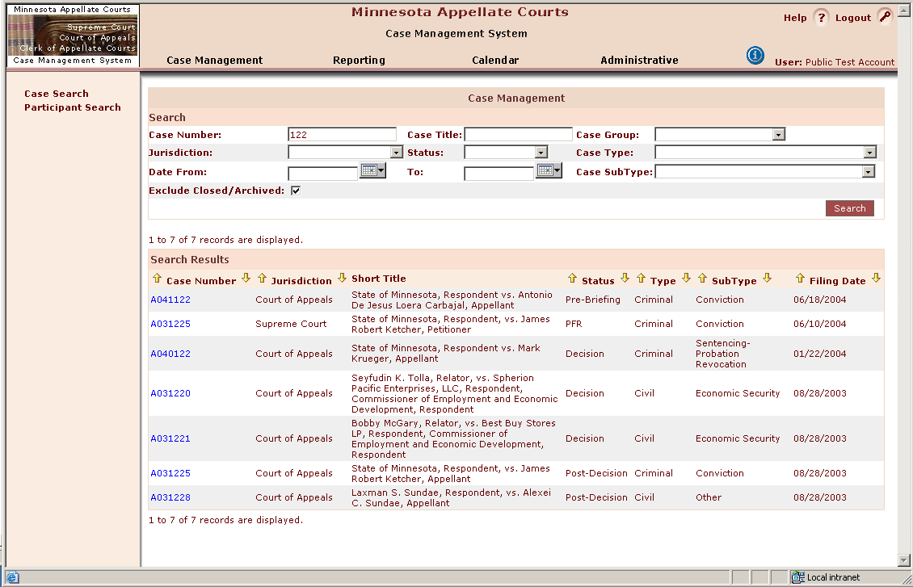

Participant Search
You can search for participants in a case that are a person, company or organization.
If a Sealed Name had been provided for a record, this search is conducted against the sealed name, rather than the full name on the record
To search for a participant's cases:
Click on the Participant Search link on the left margin.
Complete any of the name fields with at least a partial spelling of the last name and as much added information in the First & Middle name fields, as is applicable. You can leave any field blank if you don't know the full name, but you cannot leave all fields blank.
You may use the “%” as a wildcard at the beginning or end of a field, if you only have a partial or possible incorrect spelling for a search.

Click Search to return results.

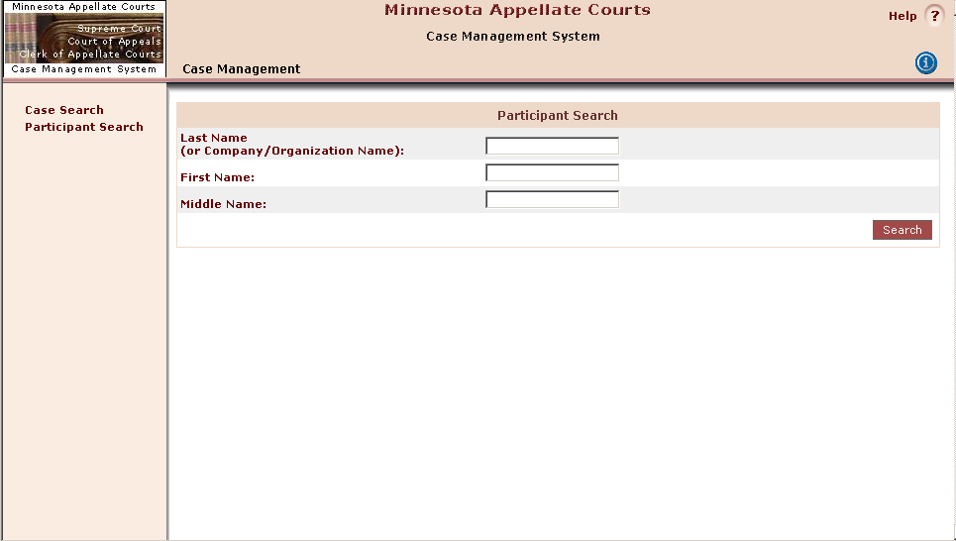

Example: Last Name, Smith; First Name J% (wildcard), click Search button
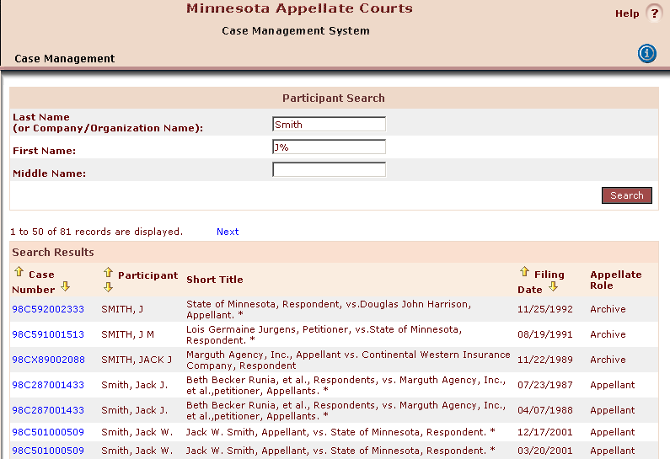
The search results are returned and you can sort the list by the columns that contain the up/down arrows next to the column heading.
The total number of cases returned in the query is listed at the top and bottom of the results screen (i.e., 1 to 50 of 81 records are displayed).

Viewing Cases in P-MACS
To view a case, click on the blue hyperlink on the Case Number.
You will then see the Case View screen (below) which gives you standard/basic case information and summary docket information.
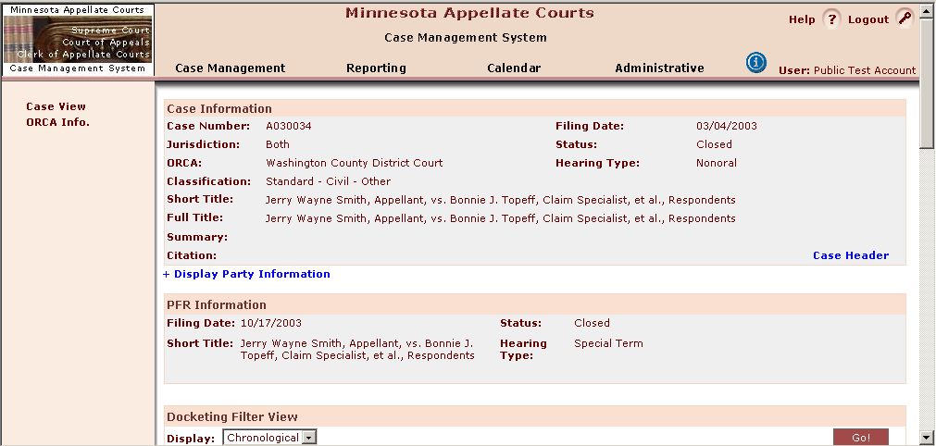
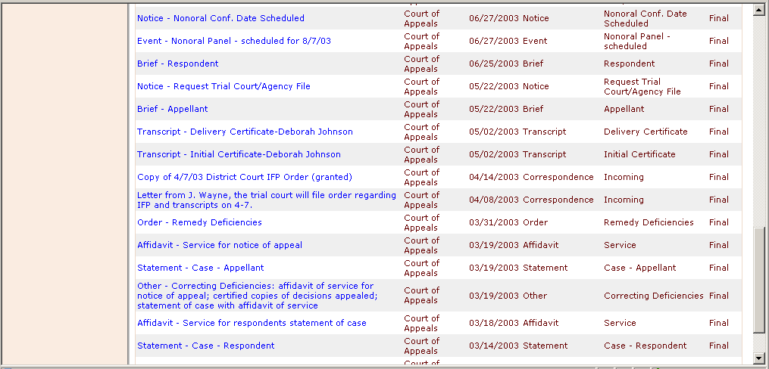
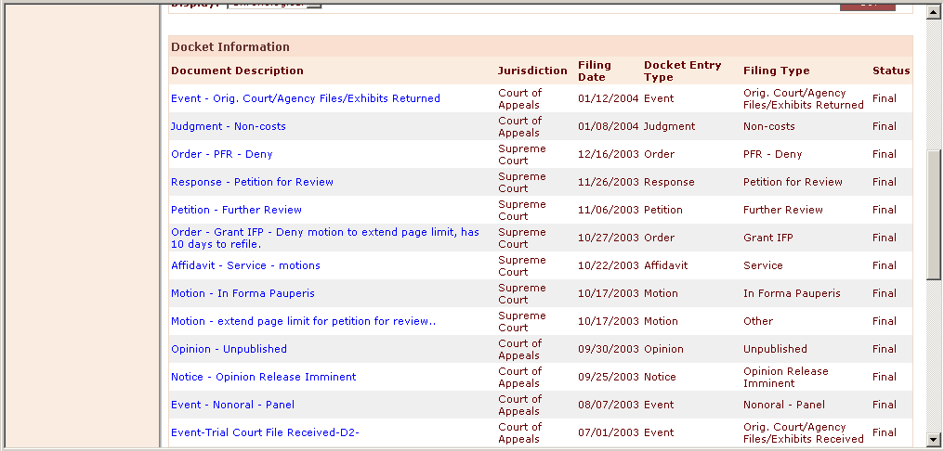

Viewing Party Information
To view party information, click on the “Display Party Information” link on the Case View screen. This will expand the section and the detail party/participant information will display. Parties are shown in relationship to the case (role) and their associated attorney.
Click on “Hide Party Information” to collapse this section.
For cases that are, or were, in both courts (i.e., original appeal to the court of appeals followed by a petition for review in the supreme court) it is necessary to select the proper jurisdiction to display the parties as they appeared in each court. The court of appeals is the default selection. To switch to the other jurisdiction, select from the drop-down list and then click “Switch” button.
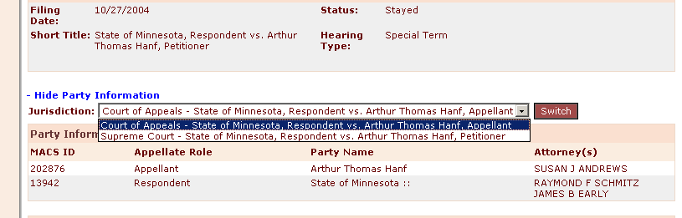

Viewing Docket Information
Docket entries, by default are shown in a Chronological View, listed by the Filing Date. You may also look at the docket entries based upon their relationships to each other by choosing the Threaded View and clicking the GO! button.
If the chosen case has many docket entries, you will need to scroll down to see all entries. You may then click on the specific docket entry hyperlink to see more detail.

Example of Threaded Docket View
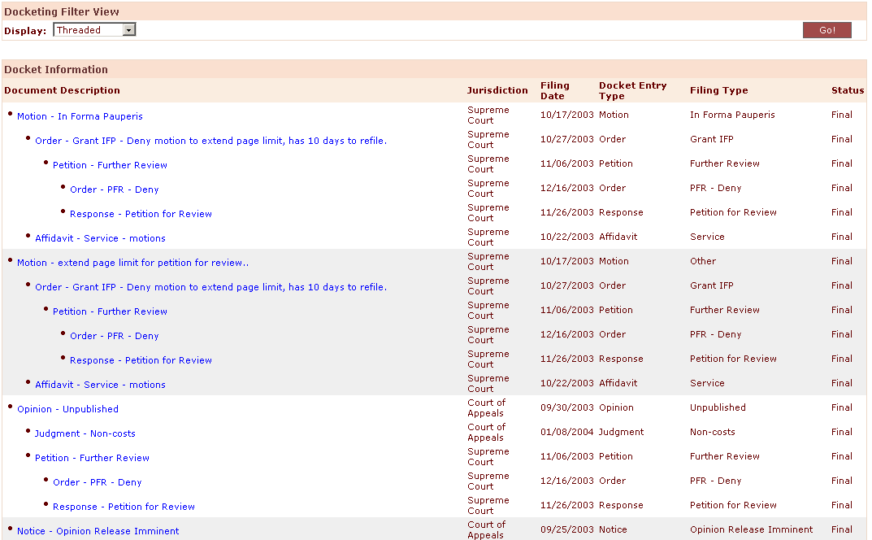

Docket Entry Detail
Clicking on a docket entry link will give you more detail relating to that specific action. Different fields of data are displayed, as applicable to the docket entry type.
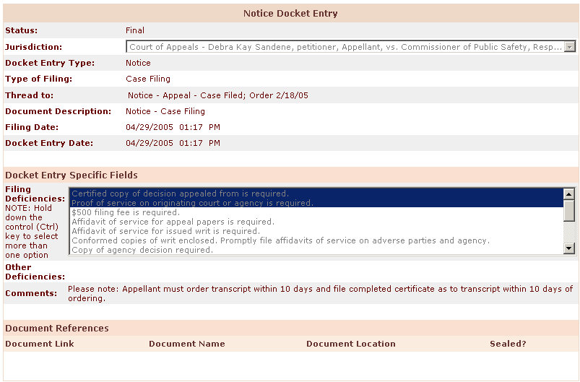

Outgoing Document Docket Entries:
Some Order and Opinion docket entries (after 3/3/2003) will have the associated document linked to the docket entry. To view the document, scroll down to the bottom of the Docket Entry Detail screen and you will find a Document References section.

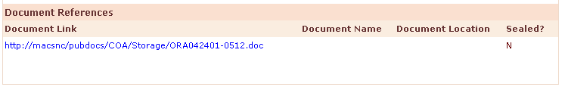
Click on the hyperlink to view the document. (These documents are only available in MS Word format.)

Troubleshooting & Support:
Reminder: P-MACS Data is copied to the public server each night. Data is one day behind the production system.
If you are looking for specific time-sensitive data, please contact the Office of the Clerk of Appellate Courts at 651-296-2581 directly.
While every attempt has been made to ensure that the information provided through P-MACS is accurate, there are no warranties ensuring accuracy. To verify information obtained from this site, or to obtain appeal information not available on this site, please contact the Office of the Clerk of Appellate Courts at 651-296-2581.
Comments, suggestions, and questions regarding P-MACS are welcome. Please note that all comments and suggestions will be reviewed, but a personal response to all submissions may not be possible.

Email address: pmacs.support@courts.state.mn.us

Mailing address:
Office of the Clerk of Appellate Courts:
25 Rev. Dr. Martin Luther King Jr. Blvd.
St. Paul, MN 55155

