

Code Of

Professional Responsibility

For Interpreters

In The

Minnesota State Court System

Prescribed and Ordered by

The Minnesota Supreme Court

September 18, 1995

C9-94-1898

CODE OF PROFESSIONAL RESPONSIBILITY FOR

INTERPRETERS IN THE MINNESOTA STATE COURT SYSTEM

PREAMBLE

Many persons who come before the courts are partially or completely excluded from full participation in the proceedings due to limited English proficiency, or a speech or hearing impairment. It is essential that the resulting communication barrier be removed, as far as possible, so that these persons are placed in the same position as similarly situated persons for whom there is no such barrier. As officers of the court, interpreters help assure that such persons may enjoy equal access to justice and that court proceedings and court support services function efficiently and effectively. Interpreters are highly skilled professionals who fulfill an essential role in the administration of justice.

APPLICABILITY

This code shall guide and be binding upon all persons, agencies and organizations who administer, supervise, use or deliver interpreting services within the Minnesota state court system.

Commentary

The use of the term “shall” is reserved for the black letter principles. Statements in the commentary use the term “should” to describe behavior that illustrates or elaborates upon the principles. The commentaries are intended to convey what the drafters of this code believe to be probable and expected behaviors. Wherever a court policy or routine practice appears to conflict with the commentary in this code, it is recommended that the reasons for the policy or practice as it applies to court interpreters be reviewed for possible modification.

CANON 1: ACCURACY AND COMPLETENESS

Interpreters shall render a complete and accurate interpretation or sight translation, without altering, omitting, or adding anything to the meaning of what is stated or written, and without explanation.

Commentary

The interpreter has a twofold duty:

1) to ensure that the proceedings reflect, in English, precisely what was said by a non-English speaking person, and

2) to place the non-English speaking person on an equal footing with those who understand English.

This creates an obligation to conserve every element of information contained in a source language communication when it is rendered in the target language.

Therefore, interpreters are obligated to apply their best skills and judgment to faithfully preserve the meaning of what is said in court, including the style or register of speech. Verbatim, “word for word” or literal oral interpretations are not appropriate when they distort the meaning of what was said in the source language, but every spoken statement, even if it appears non-responsive, obscene, rambling, or incoherent should be interpreted. This includes apparent misstatements.

Interpreters should never interject any statement or elaboration of their own. If the need arises to explain an interpreting problem (e.g. a term or phrase with no direct equivalent in the target language or a misunderstanding that only the interpreter can clarify), the interpreter should ask the court’s permission to provide an explanation. Spoken language interpreters should convey the emotional emphasis of the speaker without reenacting or mimicking the speaker’s emotions, or dramatic gestures. Sign language interpreters, however, must employ all of the visual cues that the language they are interpreting for requires--including facial expressions and body language, in addition to hand gestures. Judges, therefore, should ensure that court participants do not confuse these essential elements of the interpreted language with inappropriate interpreter conduct. Any challenge to the interpreter’s conduct should be directed to the judge.

The obligation to preserve accuracy includes the interpreter’s duty to correct any errors of interpretation discovered by the interpreter during the proceeding. Interpreters should demonstrate their professionalism by objectively analyzing any challenge to their performance.

The ethical responsibility to accurately and completely interpret includes the responsibility of being properly prepared for interpreting assignments. Interpreters are encouraged to obtain documents and other information necessary to familiarize themselves with the nature and purpose of a proceeding. Prior preparation is especially required when testimony or documents include highly specialized terminology and subject matter.

CANON 2: REPRESENTATION OF QUALIFICATIONS

Interpreters shall accurately and completely represent their certifications, training, and pertinent experience.

Commentary

Acceptance of a case by an interpreter conveys linguistic competency in legal settings. Withdrawing or being asked to withdraw from a case after it begins causes a disruption of court proceedings and is wasteful of scarce public resources. It is therefore essential that interpreters present a complete and truthful account of their training, certification and experience prior to appointment so the officers of the court can fairly evaluate their qualifications for delivering interpreting services.

CANON 3: IMPARTIALITY AND AVOIDANCE OF CONFLICT OF INTEREST

Interpreters shall be impartial and unbiased and shall refrain from conduct that may give an appearance of bias. Interpreters shall disclose any real or perceived conflict of interest.

Commentary

The interpreter serves as an officer of the court and the interpreter’s duty in a court proceeding is to serve the court and the public to which the court is a servant. This is true regardless of whether the interpreter is publicly retained at government expense or retained privately at the expense of one of the parties.

The interpreter of record should avoid any conduct or behavior that presents the appearance of favoritism toward any of the parties. Interpreters should maintain professional relationships with their clients, and should not take an active part in any of the proceedings. The interpreter should discourage a non-English speaking party’s personal dependence.

During the course of the proceedings, interpreters of record should not converse with parties, witnesses, jurors, attorneys, or with friends or relatives of any party, except in the discharge of their official functions. Official functions may include an informal pre-appearance assessment to include the following:

1. culturally appropriate introductions;
2. a determination of variety, mode, or level of communication;
3. a determination of potential conflicts of interest; and
4. a description of the interpreter’s role and function.

The interpreter should strive for professional detachment. Verbal and non-verbal displays of personal attitudes, prejudices, emotions, or opinions should be avoided at all times.

Any condition that interfered with the objectivity of an interpreter constitutes a conflict of interest and must be disclosed to the judge. The interpreter should only divulge necessary information when disclosing the conflict of interest. The following are circumstances that create potential conflicts of interest that must be disclosed:

1. the interpreter is a friend, associate, or relative of a party or counsel for a party involved in the proceedings;

2. the interpreter or the interpreter’s friend, associate, or relative has a financial interest in the subject matter in controversy, a financial interest in a party to the proceeding, or any other interest that would be affected by the outcome of the case;

3. the interpreter has served in an investigative capacity for any party involved in the case at issue;

4. the interpreter has previously been retained by a law enforcement agency to assist in the preparation of the criminal case at issue;

5. the interpreter has been involved in the choice of counsel or law firm for that case at issue;

6. the interpreter is an attorney in the case at issue;

7. the interpreter has previously been retained for private employment by one of the parties to interpret in the case at issue; or

8. for any other reason, the interpreter’s independence of judgment would be compromised in the course of providing services.

The existence of any one of the above-mentioned circumstances does not alone disqualify an interpreter from providing services as long as the interpreter is able to render services objectively. An interpreter may serve if the judge and all parties consent. If an actual or apparent conflict of interest exists, the interpreter may, without explanation to any of the parties or the judge, decline to provide services.

Should an interpreter become aware that a non-English speaking participant views the interpreter as having a bias or being biased, the interpreter should disclose that knowledge to the judge.

CANON 4: PROFESSIONAL DEMEANOR

Interpreters shall conduct themselves in a manner consistent with the dignity of the court.

Commentary

Interpreters should know and observe the established protocol, rules, and procedures for delivering interpreting services. When speaking in English, interpreters should speak at a rate and volume that enables them to be heard and understood throughout the courtroom. If an interpreter is not actively interpreting, the interpreter should not engage in any distracting activity in the courtroom such as reading newspapers or magazines or engaging in conduct that may call inappropriate attention to the interpreter. Interpreters should dress in a manner that is consistent with the dignity of the proceedings of the court.

Interpreters should avoid obstructing the view of any of the individuals involved in the proceedings, but should be appropriately positioned to facilitate communication. Interpreters who use sign language or other visual modes of communication must, however, be positioned so that signs, facial expressions, and whole body movements are visible to the person for whom they are interpreting.

Interpreters are encouraged to avoid personal or professional conduct, which could discredit the court.

CANON 5: CONFIDENTIALITY

Interpreters shall protect the confidentiality of all privileged and other confidential information.

Commentary

Interpreters must protect and uphold the confidentiality of all privileged information obtained during the course of their duties. It is especially important that the interpreter understand and uphold the attorney-client privilege that requires confidentiality with respect to any communication between attorney and client. This rule also applies to other types of privileged communications.

Interpreters must also refrain from repeating or disclosing information obtained by them in the course of their employment that may be relevant to the legal proceeding.

In the event that an interpreter becomes aware of information that indicates probable imminent harm to someone or relates to a crime being committed during the course of the proceedings, the interpreter should immediately disclose the information to the presiding judge. If the judge is not available, the interpreter should disclose the information to an appropriate authority in the judiciary.

CANON 6: RESTRICTION OF PUBLIC COMMENT

Interpreters shall not publicly discuss, report or offer an opinion concerning a matter in which they are or have been engaged, even when that information is not privileged or required by law to be confidential, except to facilitate training and education.

Commentary

Generally, interpreters should not discuss outside of the interpreter’s official duties, interpreter assignments, persons involved or the facts of the case. However, interpreters may share information for training and educational purposes. Interpreters should only share as much information as is required to accomplish their purpose. An interpreter must not reveal privileged or confidential information.

CANON 7: SCOPE OF PRACTICE

Interpreters shall limit themselves to interpreting or translating and shall not give legal advice, express personal opinions to individuals for whom they are interpreting, or engage in any other activities which may be construed to constitute a service other than interpreting or translating while serving as an interpreter.

Commentary

Since interpreters are responsible only for enabling others to communicate, they should limit themselves to the activity of interpreting or translating only, including official functions as described in the commentary to Canon 3. Interpreters, however, may be required to initiate communications during a proceeding when they find it necessary to seek direction from the court in performing their duties. Examples of such circumstances include seeking direction from the court when unable to understand or express a word or thought, requesting speakers to moderate their rate of communication or repeat or rephrase something, correcting their own interpreting errors, or notifying the court of reservations about their ability to satisfy an assignment competently. In such instances, they should make it clear that they are speaking for themselves.

An interpreter may convey legal advice from an attorney to a person only while that attorney is giving it. An interpreter should not explain the purpose or contents of forms, services, or otherwise act as counselors or advisors unless they are interpreting for someone who is acting in that official capacity. The interpreter may translate language on a form for a person who is filling out the form, but should not explain the form or its purpose for such a person.

While engaged in the function of interpreting, interpreters should not personally perform official acts that are the official responsibility of other court officials including, but not limited to, court clerks, pretrial release investigators or interviewers, or probation counselors.

CANON 8: ASSESSING AND REPORTING IMPEDIMENTS TO PERFORMANCE

Interpreters shall assess at all times their ability to deliver their services. When interpreters have any reservation about their ability to satisfy an assignment competently, they shall immediately convey that reservation to the appropriate judicial authority.

Commentary

If the communication mode or language variety of the non-English-speaking person cannot be readily interpreted, the interpreter should notify the appropriate judicial authority, which includes a supervisory interpreter, a judge, or another official with jurisdiction over interpreter matters.

Interpreters should notify the appropriate judicial authority of any environmental or physical limitation that impedes or hinders their ability to deliver interpreting services adequately, e.g., the courtroom is not quiet enough for the interpreter to hear or be heard by the non-English speaker, more than one person at a time is speaking, or principals or witnesses of the court are speaking at a rate of speed that is too rapid for the interpreter to adequately interpret. Sign language interpreters must ensure that they can both see and convey the full range of visual language elements that are necessary for communication, including facial expressions and body movement, as well as hand gestures.

Interpreters should notify the judge of the need to take periodic breaks in order to maintain mental and physical alertness and prevent interpreter fatigue. Interpreters should recommend and encourage the use of team interpreting whenever necessary.

Interpreters are encouraged to make inquiries as to the nature of a case whenever possible before accepting an assignment. This enables interpreters to match more closely their professional qualifications, skills, and experience to potential assignments and more accurately assess their ability to satisfy competently those assignments.

Even competent and experienced interpreters may encounter situations where routine proceedings suddenly involve technical or specialized terminology unfamiliar to the interpreter, e.g., the unscheduled testimony of an expert witness. When such situations occur, interpreters should request a brief recess in order to familiarize themselves with the subject matter. If familiarity with the terminology requires extensive time or more intensive research, interpreters should inform the judge.

Interpreters should refrain from accepting a case if they feel the language and subject matter of that case is likely to exceed their skills or capacities. Interpreters should notify the judge if they feel unable to perform competently, due to lack of familiarity with terminology, preparation, or difficulty in understanding a witness or defendant.

CANON 9: DUTY TO REPORT ETHICAL VIOLATIONS

Interpreters shall report to the proper judicial authority any effort to impede their compliance with any law, any provision of this code, or any other official policy governing court interpreting and translating.

Commentary

Because the users of interpreting services frequently misunderstand the proper role of the interpreter, they may ask or expect the interpreter to perform duties or engage in activities that run counter to the provisions of this code or other law, rules, regulations, or policies governing court interpreters. It is incumbent upon the interpreter to explain their professional obligations to the user. If, having been apprised of these obligations, the person persists in demanding that the interpreter violate them, the interpreter should turn to a supervisory interpreter, a judge, or another official with jurisdiction over interpreter matters to resolve the situation.

CANON 10: PROFESSIONAL DEVELOPMENT

Interpreters shall continually strive to improve their skills and knowledge and advance the profession through activities such as professional training and education, and interaction with colleagues, and specialists in related fields.

Commentary

Interpreters must continually strive to improve their interpreting skills and increase their knowledge of the languages they work in professionally, including past and current trends in technical terminology and social and regional dialects as well as their applicable within court proceedings.

Interpreters should keep informed of all statutes, rules of court and policies of the judiciary that govern the performance of their professional duties.

An interpreter should seek to elevate the standards of the profession through participation in workshops, professional meetings, interaction with colleagues, and reading current literature in the field.

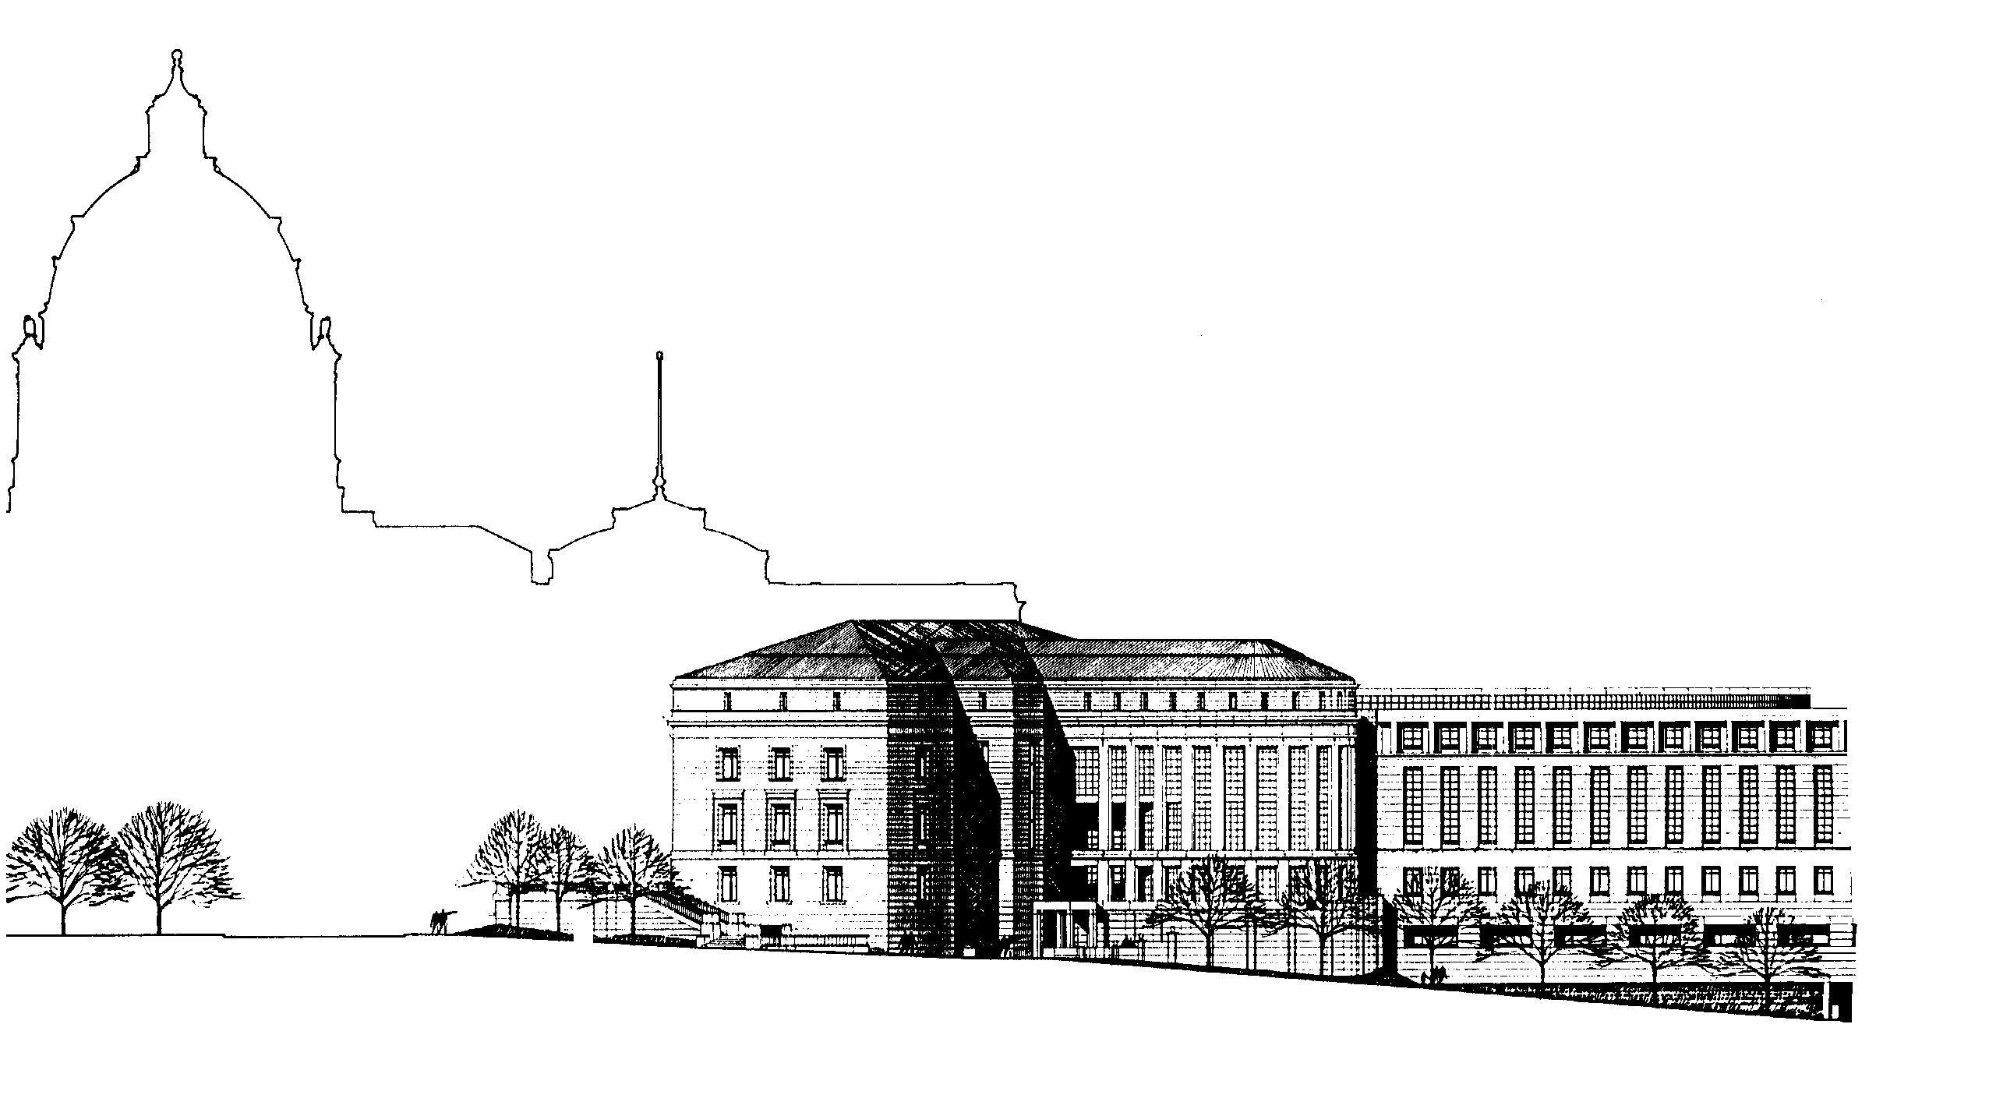

Direct Inquiries To:

Minnesota Court Interpreter Program

The Supreme Court of Minnesota
State Court Administration
140 Minnesota Judicial Center
25 Constitution Avenue

St. Paul, MN 55155-1500
Phone (651) 297-5300
Fax (651) 297-5636
Email: cip@courts.state.mn.us

