

Inside Straight:
The Third Branch

Welcome! The materials included here support "Inside Straight: The Third Branch," a fun and educational videotape about Minnesota’s court system. The video was produced by the court system’s Sesquicentennial Committee in celebration of the court system’s 150th anniversary. Sponsors of the project include KSTP-TV and Hubbard Broadcasting in the Twin Cities, the Roger Dell Foundation and Allied Vaughn.

Copies of the video were sent to the social studies departments at all Minnesota middle and high schools.

AUTHORS
JoEllen Ambrose, attorney and teacher, Champlin Park High School
Jennifer Bloom, Director, Minnesota Center for Community Legal Education, www.ccle.fourh.umn.edu
Jeff Lunde, teacher, Rochester Mayo High School
Victoria Newcome Johnson, attorney and law-related education consultant
Jim Pekarek, teacher, Minnetonka Middle School West
DISCLAIMER
The case materials written to support the videotape have been developed for educational purposes only. In some cases, the facts have been slightly altered to increase their educational value. These materials may not be used in any legal proceeding.

FORMATS
Each lesson is available on the web at http://www.courts.state.mn.us/video/inside/inside_straight.htm in 3 formats: Word, PDF, and Rich Text Format. Each document has been created with internal links (that is links that are within the document only) and external links (links that go to other web pages, to a site with the U.S. Constitution for example.)

Word: When you click the title of the unit (e.g., Amish Case) you will be downloading the Microsoft Word version. All links (internal/external) should be active.

PDF: To view this format of the lessons you will need to have Acrobat Reader installed on the computer (link provided). It does not require the use of any specific word processing software. The internal/external links will also work in the PDF format as it appears on the screen. A link to the Acrobat Reader is provided and the program is FREE.

Rich Text Format: This is for sites that don't use Word as their word processing software (e.g., Word Perfect). In this format the internal/external links will not work when you open up the document. However, we have included the web addresses in the
Resources sections of the units of study. With a little work, however, you can recreate the links, providing your word processing software has that capability.

CONTENTS

A Viewer’s Guide ………………………………………………………………………….1
This is a brief outline of the videotape, providing descriptions of scenes, discussion questions, additional background materials, and links to the lessons. Includes a student handout to be used while viewing the videotape.

Crack Cocaine Case (State v. Russell) ……………………………………………………...9
This lesson explores equal protection of the law through a Supreme Court case study
and discussion questions.

Sunday Closing Case (State v. Target Stores, Inc.)………………………………………..13
This lesson helps students look more closely at the language of a law as the court struggles with its application. Students will explore the importance of writing good laws.

Driveway Case………………………………………………………………………………23
This lesson explains the elements of adverse possession and asks the students to apply their knowledge to fact situations based on real cases. Includes maps to aid student understanding.

Amish Case (State v. Hershberger)………………………………………………………...40
This lesson asks students to participate in a mock appellate argument on the facts of the
Hershberger case. Students also learn about other cases in which the Minnesota Supreme Court has expanded rights and asks them to apply their knowledge to another case, using a simulation.

Selection and Election of Judges in Minnesota…………………………………………..63
Students will analyze desirable characteristics for judges, will learn the law concerning selection and election of judges, and will be asked to role play the governor in selecting a judge for the supreme court.

The Jury System…………………………………………………………………………….73
This lesson focuses on practical information about juries. It includes a questionnaire that can be used to peak their interest and then reviewed with a guest speaker. The questionnaire can also be used as an Internet research activity.

Learn More About………………………………………………………………………….
Includes middle and high school lessons on the Magna Carta.:
How were the American’s influenced by their English background? (Middle)……..80
What Were the British Origins of American Constitutionalism? (High)……………85
INSIDE STRAIGHT
THE THIRD BRANCH
A Viewer’s Guide and Student Worksheet

Viewer’s Guide
Student Worksheet

This guide provides a brief outline of the videotape “Inside Straight: the Third Branch.” In addition to descriptions of scenes from the videotape, additional background information is provided and links are made to other components of this curriculum. By clicking on the links, you will see the materials provided to help students develop a deeper understanding of the legal topic.

I. Video Title and Introduction

- Printed in screen:

“INSIDE …known only to insiders; private; thorough, complete.”
“STRAIGHT…not qualified; modified; accurate: properly arranged.”

- Discussion questions:

- Why do you think they gave the video this title? What does it mean?

- Rank the three branches of government in order of importance. How did you rank them and why? Discuss how the Constitution established the branches in order starting with the Legislative Branch in Article I, not getting to the Judicial Branch until Article III. Have students compare their order to that of the founders. The Founders often referred to the judicial branch of government as the “least dangerous branch.” What did they mean by this?

Alexis de Tocqueville said
“Scarcely any question arises in the United States which does not become, sooner or later, a subject of judicial debate.”

Is this statement consistent with “least dangerous branch?” What do you think of the role of the judiciary in solving today’s problems?

II. Football Analogy

A. Discussion question: How can football be compared to our legal system?

B. Rights are protected but they are not unlimited.
The girl mentions that she has three rights: the right to remain silent, protection against unreasonable search and seizure, and free speech.

Discussion: Ask students what other rights they have (see the United States Constitution and the Minnesota Constitution and Bill of Rights).

III. Purpose of Courts:

Discussion: What is the relationship between the police and the courts?
Answer: The police are a part of the executive branch. They enforce the law. The courts interpret the law. They decide if it was applied fairly (e.g. did the police follow the law during the arrest, etc.)

- Printed on screen:

“Make sure the laws don’t violate the Constitution.
Protect society
Preserve order
Make sure laws are applied to everyone. Fairly!”

IV. Cocaine Case: State v. Russell

See Cocaine Case Lesson

Discussion question: Would it be fair for schools to have different rules and consequences for cigarettes and chewing tobacco? (Perhaps ask students if there is a gender difference in the usage of these two products. Does that matter?)

V. The Sunday Closing Case: State v. Target

See Sunday Closing Case Lesson

The Fourteenth Amendment to the U.S. Constitution
Section. 1. All persons born or naturalized in the United States and subject to the jurisdiction thereof, are citizens of the United States and of the State wherein they reside. No State shall make or enforce any law which shall abridge the privileges or immunities of citizens of the United States; nor shall any State deprive any person of life, liberty, or property, without due process of law; nor deny to any person within its jurisdiction the equal protection of the laws.

VI. 1850’s case.

- Definition: “scalawag” is an informal term referring to a reprobate or a rascal. After the Civil War it referred to white southerners who cooperated with northern “carpetbaggers” during reconstruction. The term originally referred to an undersized or worthless animal. Information from The Grolier International Dictionary.

- Justices of the Peace.

Lay judges [justices of the peace] played a significant role in the administration of justice in Minnesota for more than 100 years. They initially presided over virtually all of the lower courts of the state. Only gradually were they displaced by lawyer professionals. This early reliance on lay judges was only natural, since there were few lawyers in the state. The first law schools did not open until the 1880’s; before that time, lawyers acquired their legal education through apprenticeship.

In the Minnesota Territory, there were only three professional law-trained judges, all appointed by the president. Sitting separately, they tried cases in each of the three judicial districts of the territory; sitting together, they formed the supreme court of the territory and heard appeals from one another’s cases. Everyday justice was provided in each of the counties by justices of the peace and probate judges, who usually were not lawyers.

For the Record

VII. Appeals

- Statistics: In 1998 there were 2 million cases in district court. 2044 of those cases went to the Court of Appeals.

- Levels of courts today as compared to 1850: Early in Minnesota history, cases heard by justices by the peace and probate judges were appealed to the district courts. Today the first level of courts are called district courts and cases heard at the district court level are appealed to the Court of Appeals or in limited cases (e.g., first degree murder) to the Supreme Court.

- Football analogy: sometimes two officials on the field might disagree. The referee is the final authority and settles disputes. When the district court and court of appeals are unable to resolve disputes, the Supreme Court has the final word.

The Driveway Case

See Driveway Case Lesson

IX. The Amish Buggy Case

See Amish Case Lesson

X. Involvement in the judicial system

Judicial Elections

Discussion: Federal judges keep their jobs for life until they retire, resign, are impeached (very rare), or die. Minnesota judges have to be reelected by the people. Which system do you think allows for a better judicial system?

Discuss the strengths and weaknesses of an election system: bad judges can be impeached, but how do people decide who the best candidate is in a judicial election? Judges can’t campaign on issues or be endorsed by a party. All they can run on is their previous record, reputation, and qualifications. To be impartial and fair, judges should not enter a case with a bias or a preconceived position.

Given this, how do you think a person can mount a case against a judge? Should the rules be changed to make elections for judges the same as for any other office? Should the rules be changed to give state judges their jobs for life?

See Selection of Judges Lesson.

- Jury Duty

Discussion: The students had a negative response to the words “jury duty.” Why? Ask if they know people who have been on a jury or “gotten out of it.” Discuss why people try to avoid jury duty. Is this a good or a bad thing? Should people who don’t want to sit on a jury have to? Why do we have juries? Why not just have judges decide cases at all levels of the courts?

See The Jury System

Magna Carta

- Chief Justice Kathleen Blatz said that, “Our system of law… began in England when the King and the people signed an agreement that government did not have unlimited power.” The agreement she is referring to is called the Magna Carta, which was signed June 15, 1215. The English King who signed the Magna Carta was King John brother of Richard the Lionhearted who has been made infamous as Prince John in many Robin Hood tails. English nobles who were fed up with King John’s abuse of their rights forced him into this compact.

See the Magna Carta Lesson in “Learning More About.”
Read the Magna Carta at www.nara.gov/exhall/charters/charters.html.

- As part of limiting the powers of the English monarch, the Magna Carta went a long way towards establishing the right to a trial by jury. One Minnesota Handbook for Jurors includes the following quotation from the Magna Carta on its first page:

No freeman shall be taken or imprisoned, or disseised, or outlawed, or banished or in any way destroyed nor will we pass upon him, nor will we send upon him, unless by the lawful judgment of his peers, or by the law of the land.
“To none will we sell, to none will we deny, or delay, right or justice.”

RESOURCES

Minnesota Court System www.courts.state.mn.us

Minnesota Center for Community Legal Education www.ccle.fourh.umn.edu

For the Record: 150 Years of Law & Lawyers in Minnesota, Minnesota State Bar Association, 1999

Case Studies
Cocaine Case: State v. Russell
Sunday Closing Case: State v. Target
The Driveway Case
Amish Case: State v. Hershberger
Student Worksheet Name _____________________________

INSIDE STRAIGHT

- What three rights does the girl in the video mention?

- What is the relationship between the police and the courts?

- Give one of the three main objectives of the court system described in the video.

- Why did Judge Alexander believe Minnesota’s cocaine laws were unfair?

- What amendment to the U.S. Constitution did the courts decide the Sunday sales laws violated?

- Give an example of the courts dealing with something other than unfair laws or lawbreakers.

- In the 1850’s case from Minnesota Territory history, what was the judge’s title?

- How many district court judges are there in Minnesota today?

- 72% of Minnesota’s cases deal with what?

- What is the purpose for the court of appeals?

- How do judges in Minnesota get and keep their jobs?

- What are the two easiest ways described by the Chief Justice for us to participate in the legal system?

- What two common kinds of participants in a trial are not present at the Supreme Court level?

State v. Russell, 477 N.W.2d 886 (Minn. 1991)

Objective: To better understand how courts make decisions that apply laws fairly to everyone.

Case Summary
Case Study
Discussion Questions

Supreme Court Case Study Guide

CASE SUMMARY
The Minnesota Supreme Court held that the statute that prescribed different penalties for possession of similar amounts of crack cocaine and powder cocaine violated the equal protection provision of the Minnesota Constitution. The statute provided that a person possessing three grams of crack cocaine was guilty of a third-degree offense, but it took possession of ten grams of powder cocaine to be guilty of a third-degree offense. The presumptive sentence for possessing three grams of crack cocaine was an executed 48 months imprisonment, but a conviction for possession of a similar amount of powder cocaine only called for a stayed 12 months of imprisonment with probation. The court concluded that there was not a rational basis to support the disparate treatment of crack cocaine—which all parties agreed was used much more heavily among African-Americans—and powder cocaine.

Information contained on these pages was developed by the Minnesota Center for Community Legal Education for use only as a teaching aid by Minnesota educators. The case summaries included in this unit are those of the author(s) and do not represent the position or opinion of the Minnesota Court system, justices, judges or employees.

CASE STUDY
State v. Russell, 477 N.W.2d 886, (Minn. 1991)

Facts: In 1989, the Minnesota Legislature passed a criminal law prohibiting cocaine drug use, which created separate categories and penalties for the use of crack cocaine as compared to cocaine powder use. Here is how the law was set up:

Minn. Stat. 152.023, subd. 2 Minn. Stat. 152.025

Level of Offense 3rd Degree 5th Degree

Crime Possession of 3 or more grams Possession of less than
of “crack” cocaine 10 grams of cocaine powder

Penalty up to 20 years in prison up to 5 years in prison

Sentencing Presumptive Sentence - Presumptive Sentence -
Guidelines executed 48 months imprisonment stayed 12 months of imprisonment and probation

The defendants in this case were five African-American men who were charged with possession of 3 grams of crack cocaine under Minn. Stat. 152.023, subd. 2. Defendants asked the trial court to dismiss the charges because the law had a discriminatory impact on black persons and therefore violated the equal protection guarantees of the federal and state constitutions.

Trial Court Decision: Judge Pamela Alexander was the trial court judge who agreed with the defendants. The trial court found that crack cocaine is used predominantly by blacks and that cocaine powder is used predominantly by whites. During the year 1988, statistics showed that of all the persons charged with possession of crack cocaine, 96.6 % were black. Of all persons charged with possession of powder cocaine, 79.6% were white. As a result a far greater percentage of blacks than whites face more severe consequences for possession of crack cocaine than their white counterparts who possess cocaine powder.

The trial court concluded that the law had a discriminatory impact on black persons and that there was no rational basis for the distinction between crack cocaine and cocaine powder in the law. Therefore the law did not apply fairly to all persons thereby violating the equal protection guarantees of the Minnesota Constitution.

Charges against the defendants were dismissed. However, the trial court did certify the question as to whether the statute is constitutional to the Minnesota Court of Appeals. Before the Minnesota Court of Appeals could rule, the Minnesota Supreme Court granted petitions by both the state and defendants to hear the case right away.

Minnesota Supreme Court: The issue before the Minnesota Supreme Court was whether the Minnesota cocaine law violated a guarantee of the Minnesota Constitution that all persons in similar situations are to be treated alike. In order to make distinctions in the law there must be a reasonable basis for doing so.

The Court looked to whether there was a reasonable basis for the distinction between users of crack cocaine and users of powder cocaine. It concluded there was no good basis for the different categories. First, the legislature justified the 3 gram crack cocaine and 10 gram powder cocaine level as the levels at which street-level dealing, not merely using, took place. So the purpose of the classification was to facilitate prosecution of “street level” drug users. The Court found insufficient evidence to support this and found the distinction to be arbitrary.

Second, the legislature based the law on the fact that crack cocaine tended to be more addictive than cocaine powder thereby justifying different treatment. The Court was not persuaded and felt it was not so much the type of cocaine used as the method of ingestion (sniffed or smoked) that created the greater danger. Powder cocaine could be dissolved in water and injected intravenously achieving the same effect on the body as smoking crack cocaine. So the greater danger of crack cocaine is not a valid justification if powder cocaine could produce the same results.

Not only was there no reasonable basis for the different categories in the law, the Court also concluded that the categories had no relevance to the purpose of the law. Without more evidence that 3 grams of crack cocaine included only drug dealers, the statue could be arbitrarily punishing personal users in a more harsh way. Also it doesn’t seem fair that someone who has 10 grams of powder cocaine, which could be easily converted into more than three grams of crack, should be punished only for 5th degree possession of cocaine.

The Minnesota Supreme Court affirmed the trial court’s decision that Minnesota Statute Sec. 152.023, subd. 2 (1) (1989) violated the Minnesota Constitution’s guarantee that all laws are to treat people fairly.

Although the Minnesota Constitution has no specific language guaranteeing equal protection of the law, Justice Simonett explained in a concurring opinion that equal protection is read into the

Constitution as an “unenumerated” constitutional right. Minn. Const. Art. 1, Sec. 16 states “The enumeration of rights in this Constitution shall not deny or impair others retained by and inherent in the people.” Article 1, Sec. 2 provides “No member of this state shall be disenfranchised or deprived of any of the rights or privileges secured to any citizen, thereof, unless by the law of the land or the judgment of his peers.” One of the inherent rights secured to a free people by Section 2 is the inherent right to “equal and impartial laws which govern the whole community and each member thereof.” Put another way, persons similarly situated are to be treated alike unless a sufficient basis exists for distinguishing among them.
DISCUSSION QUESTIONS
State v. Russell, 477 N.W.2d 886, (Minn. 1991)

1. Follow Supreme Court case study format (see attached)

2. Does it appear that the Minnesota Legislature intended for the law to have a discriminatory impact? Do you think the intent of the legislature should make a difference in how the court views the law? Even if there is no intent to discriminate obvious in the wording of the law, should the court look at the impact of the law as it is enforced?
(The dissenting opinion felt the court should review a law only if it can be shown the legislature had a discriminatory purpose as a motivating factor in its decision.)

3. How do you think the court would rule on a DWI law that had more severe penalties for drivers who got intoxicated on beer as compared to those who drank wine? Would that be a similar case as this one?

4. Can you think of other examples where a law or public policy treats people differently as it is carried out?
State v. Target Stores, Inc., 156 N.W.2d 908 (1968)

Objective: To understand the role of the court in protecting citizens’ rights to due process of law and to understand how the court looks to precedents when deciding cases.

Case Summary
Case Study
Activity: What makes a good law?
Procedure
Supreme Court Study Guide

More Sunday Laws

Resources

CASE SUMMARY
Target and Shoppers City challenged the state’s Sunday-closing law. That law prohibited the sale of certain products by certain sellers on Sundays. The Supreme Court held that “the state has broad constitutional power to establish a common day of rest, repose, recreation, and tranquility” and that the statute did not, therefore, violate the First Amendment. But the court ultimately held that the statute violated the due process clause of the Fourteenth Amendment because it was too “vague and uncertain in its statutory scheme and criminal consequence.” According to the court, the statute did not define what products could and could not be sold on Sundays with enough specificity to put merchants on notice of the consequences of certain sales.

Information contained on these pages was developed by the Minnesota Center for Community Legal Education for use only as a teaching aid by Minnesota educators. The case summaries included in this unit are those of the author(s) and do not represent the position or opinion of the Minnesota Court system, justices, judges or employees.

CASE STUDY
State v. Target Stores, Inc., 156 N.W.2d 908 (1968)

In 1967, the Minnesota Legislature enacted a law prohibiting the sale of certain items on Sundays. Criminal penalties were included for violations of the law. The classes of items restricted included:
Cameras; musical instruments including pianos and organs, record and other recordings; phonographs and tape recorders; radio receivers and television receivers; jewelry; clocks and watches; furs; furniture and other home furnishings; home appliances; footwear; wearing apparel of all kinds; luggage; lawn mowers and other power driven or manually operated machinery and equipment; hardware and tools; paints, varnishes and wallpaper, and painting and wallpaper tools and supplies; lumber and other building materials and supplies; floor coverings.
However, certain exceptions were also made. Sales not restricted by the 1967 law included the sale of items not included in the above list, sales of items at places of entertainment and recreation if the item was to be used at that place; sales by retailers whose business is ‘seasonal;’ and sales at a state or county fair.

Although the legislature did not declare a purpose of the law, ostensibly the legislature was following in the tradition of other Sunday closing laws, the purpose of which are to promote a day of rest for the citizenry. However, the new suburban discount stores read the law as an attempt to suppress competition and favor the downtown stores which preferred to be closed on Sunday.

Target, the defendant, and amicus curiae (friend of the court) Shoppers City claimed that the law was unconstitutional on several grounds. First, the defendant claimed that the law discriminated against suburban discount stores and singled out only retail merchants, exempting certain commodities and sellers of commodities from restriction, in violation of the Equal Protection clause of the Fourteenth Amendment. Second, the Minnesota Civil Liberties Union (amicus) argued that the law effectively helped to ‘establish religion’ or to ‘prohibit the free exercise of religion’ which violated the First Amendment. And finally, the law was too vague and could not reasonably inform a person of the potential criminal consequences of his/her acts, which is a violation of the Due Process clause of the Fourteenth Amendment. In summary, the defendants argued that the law was discriminatory, unequal in its treatment of people, violated the separation of church and state, and was too vague.

The opinion of the Minnesota Supreme Court, written by Justice Peterson, drew heavily from the precedents established by four landmark U.S. Supreme Court decisions issued in 1961 collectively referred to as the “Sunday Closing Cases.”

These cases provided the basis for the court to dismiss the assertion that the law in question violated the separation of church and state. Peterson wrote:
We hold, on the controlling authority of the United States Supreme Court in the Sunday Closing Cases, that the state has broad constitutional power to establish a common day of rest, repose, recreation, and tranquility; and we hold on the same authority that the exercise of that power in the instant case does not offend against the First Amendment.

The U.S. Supreme Court held that the states certainly had the power to designate a day of rest in the interest of the public good. Chief Justice Warren, writing in McGowan v. State of Maryland, one of the Sunday closing cases, said, “To say that the States cannot prescribe Sunday as a day of rest…because centuries ago such laws had their genesis in religion would give constitutional hostility to the public welfare…” In other words, even though the practice of resting on Sunday may have its origins in a particular religion’s practice, this should not currently prevent states from establishing a day of rest on the same day for non-sacred reasons.

The discrimination and unequal treatment arguments were also dismissed by the Minnesota court on bases provided by the McGowan decision. Justice Warren, in McGowan, wrote:
…[T]he Fourteenth Amendment permits the States a wide scope of discretion in enacting laws which affect some groups of citizens differently than others. The constitutional safeguard is offended only if the classification rests on grounds wholly irrelevant to the achievement of the State’s objective. State legislatures are presumed to have acted within their constitutional powers despite the fact that, in practice, their laws result in some inequality. A statutory discrimination will not be set aside if any state of facts reasonably may be conceived to justify it.

Finally, the question of vagueness was tackled. Here the Minnesota court abandons the Sunday Closing Cases noting that none of them addressed the issue of vagueness. Instead the opinion refers to a U.S. Supreme Court statement from Connally v. General Const. Co., which declares the principle essential to determining whether a law is too vague and therefore violates the due process of law:
…[A criminal] statute which either forbids or requires the doing of an act in terms so vague that men of common intelligence must necessarily guess at its meaning and differ as to its application, violates the first essential of due process of law.
Restated, this principle requires that a law be clear enough that all people of average intelligence would easily agree about the law’s meaning and how it is to be applied. When a law punishes certain behavior, then due process requires that those behaviors be obviously described so people can easily understand how to avoid the punishment. If people could easily be confused as to what behaviors the law prohibits, the law violates the due process requirement.

In the Minnesota court’s opinion, Peterson quoted an earlier Minnesota ruling in State v. McCorvey, “A criminal statute must be definite enough to give notice of the conduct required to anyone who desires to avoid its penalties…”

The court held that the law in question did not pass this test for clarity. Peterson wrote “…the vagueness and uncertainty in the designation of restricted commodities does not afford clear warning to a potential defendant of conduct which may result in severe penal sanctions…” Examples were provided to illustrate this ambiguity, including the following:
A merchant might well be in doubt whether portable outdoor barbecue grills, with or without motor-driven rotisserie units, are either unrestricted or are restricted as being within such classifications as ‘home appliances,’ ‘furniture and other home furnishings,’ or ‘lawn mowers and other machinery and equipment.’

Therefore, the law prohibiting the sale of certain restricted commodities on Sunday was declared unconstitutional because the court was not convinced that reasonable people could easily discern which specific items were restricted and which were not. Without that clarity, the law violated the Due Process clause of the Fourteenth Amendment of the U.S. Constitution.

This case did not address other laws that specifically prohibited Sunday activity such as the prohibition on Sunday car sales and the operation of commercial trucks in cities. These laws remained the law in Minnesota until the Minnesota Legislature repealed many of them during the approximately 20 years after this case. In some cases, such as Sunday car sales and liquor sales, the laws limiting sales continue to exist today.
ACTIVITY: WHAT MAKES A GOOD LAW?

This activity helps students think about the court’s role in the application of laws. What does the court do when it encounters a law that is not written clearly enough to be understood?

PROCEDURE
- Ask students to list characteristics of good laws. Their lists will include characteristics such as the following:
  - Laws should be worthwhile
  - Laws should be fair
  - Laws should be consistently applied
  - Laws should be understandable
  - Laws should be able to be followed
  - Laws should be enforceable

- Using their characteristics of good laws, ask them to analyze some rule or laws. You can begin with some silly rules to help them practice the application of the criteria. Some suggestions include
  - No swimming in Minnesota lakes
  - Dancing on the water not allowed
  - No flimming on the flam
  - Boys cannot drive motorcycles
  - All persons must be asleep before 12 midnight

- Ask students to try to think of existing or proposed laws that do not have the characteristics of good laws. For example, the legislature passed a law that required slow drivers to keep to the right. The governor vetoed the law. Appling the characteristics above, discuss whether or not the law was a good law.

- Focus the students’ attention on the characteristic “laws should be understandable.” What does this mean? Understandable to whom? Why is this important? What happens if one cannot understand the rule or law? Is a law or rule that is not understandable fair? Why or why not?

- Read the CASE STUDY State v. Target Stores, Inc. Have students complete the Supreme Court Case Study Guide to help them understand the case. Under the facts section, ask them to look closely at the words in the law and try to identify items that may or may not be covered by the law. This will help them understand what is vague about the law.

- Optional Activity: Help students think about how laws change over time. Ask them to research the Sundays closing laws referred to in the case: Minn. Statute Section 168.275 (sales of cars), Minn. Statute Section 221.191 (operation of trucks on Sundays) to find out what has happened to them. The statutes are available on line at www.leg.state.mn.us/leg/statutes.htm.

- For fun, have students review “More Sunday Laws.”

SUPREME COURT CASE STUDY GUIDE
State v. Target Stores, Inc., 156 N.W.2d 908 (1968)

1. What is the name of the case?

2. What are the facts of the case?

- What happened?

- Who was involved?

- What did the law say?

- Why did they challenge the law?

- How did the trial court rule?

- Which facts are important? Why?

- What additional facts would you like to have?

3. What is the constitutional or legal issue?

- What part of the Minnesota Constitution or U.S. Constitution is involved?

- What question is the court being asked to answer? This is often referred to as the “legal issue.”

4. What are the arguments?
- What are the reasons why the Legislature passed a law regarding the sale of items on Sundays?

- What arguments did the owners of Target make?

5. What is the Supreme Court’s decision?

6. How do you feel about the decision?

7. What was the impact of the decision?

8. Why do you think some Sunday Closing laws still exist?

Adapted from “Supreme Court Case Study Guide” from Teaching about Court Cases, Minnesota Center for Community Legal Education, 1999, reprinted with permission.

MORE SUNDAY LAWS

(Do not assume that any of these laws are still active or currently enforced.)

- It was once illegal in Boston, Massachusetts to take a bath on Sunday.

- In Memphis, Tennessee it’s illegal to sell teddy bears or yo-yos on Sunday.

- It is against the law in Detroit, Michigan for a man to scowl at his wife on Sunday.

- Sneezing or burping is illegal during a church service in Omaha, Nebraska.

- It is against the law in Nebraska to quarrel with your wife on Sunday.

- On Sunday in Cicero, Illinois, it is illegal to be humming on the streets.

- It is illegal to talk in church in St. Louis, Missouri.

- In the state of Louisiana it is illegal to whistle in church.

- In Kulmont, Pennsylvania it is illegal to hold prisoners in jail on Sunday.

- In Georgia it is a misdemeanor to bathe on Sunday in a stream or pond in the view of a road leading to a church.

- In Arkansas the law prohibits playing cards on Sunday.

- It is illegal to play dominoes on Sunday in Alabama.

- A 1942 Mississippi law outlaws on Sunday, “any games, tricks, ball-playing or any kind, juggling, sleight of hand, or feats of dexterity, agility of body, or any bear-baiting or any bull fighting, horse racing, or cock fighting, or any such like show or exhibit whatsoever.” Violators were fined $50 (in 1942 money).

- A Missouri law reads, “Every person who shall be convicted of horse racing, cock fighting, or playing at cards or games of any kind, on the first day of the week, commonly called Sunday, shall be deemed guilty or a misdemeanor, and fined not exceeding $50.00.”

- In Ohio circuses and theatres may not perform on Sunday.

- Also in Ohio it is illegal for anyone over 14 to be engaged in, “sporting, rioting, quarreling, hunting, fishing, or shooting on Sunday.”

- In England a person may not recite Shakespeare on Sunday, but if he uses gestures, it’s OK; nor can he wear a kilt on the stage unless it is part of his weekday dress.

- In London, England it is illegal to kiss a girl on Sunday.

- In Manchester, England city council members must attend church every Sunday.

- A Seventeenth Century British law forbid anyone to work on Sunday.

- In Somerset, England you must not wear the same cloths on Sunday as you wear on weekdays.

- In Yorkshire, England you must have Yorkshire pudding with roast beef on Sundays and holidays.

- A person in British Columbia can be set publicly in stocks for three hours for attending a symphony concert, running a three-legged race for money, or hiring a bicycle on Sunday.

- In the Philippines a law prohibits eating rice on Sunday.

- No one may take heated baths on Sunday in Teruel, Spain.

Sources:

Hyman, Dick. The Columbus Chicken Statute and More Bonehead Legislation.
Lexington, Massachusetts: The Stephen Greene Press, 1985.

Hyman, Dick. More Crazy Laws. New York: Scholastic Inc., 1992.

Bereson, Ray. Great American Blue Laws (poster). Berkeley, CA: Celestial Arts, 1976.

RESOURCES

Sunday Laws:
Hyman, Dick. The Columbus Chicken Statute and More Bonehead Legislation.
Lexington, Massachusetts: The Stephen Greene Press, 1985.

Hyman, Dick. More Crazy Laws. New York: Scholastic Inc., 1992.

Bereson, Ray. Great American Blue Laws (poster). Berkeley, CA: Celestial Arts, 1976.

Minnesota Legislature www.leg.state.mn.us

Teaching about Court Cases, Minnesota Center for Community Legal Education,
www.ccle.fourh.umn.edu/lessons.html

The Driveway Case

Objective: To better understand how courts analyze and decide a case using “elements.”

Case Summary
Case Study
Case Map
What Do You Think?
1.Open Use Case
Map
Answer
2. Exclusive Use Case
Map
Answer
3. Hostile Use Case
Map
Answer
4. Actual Use Case
Map
Answer
5. Continuous Use Case
Map
Answer

CASE SUMMARY

The case of “Who owns the Driveway” in the Inside Straight video has facts that are similar to many cases heard by the courts. In these cases, one person believes the property is hers and acts like it belongs to her (uses it, plants trees on it, etc.) while another person claims rights to the property because of the legal description of the property. The legal description describes the boundaries of the property that someone owns. The courts look at six elements in deciding who actually owns the property. 1) Was the property used for at least 15 years? 2) Was the use open, obvious? 3) Was the use exclusive? 4) Was the property used in a hostile way? 5) Was the use continuous? 6) Was the use actual?

Information contained on these pages was developed by the Minnesota Center for Community Legal Education for use only as a teaching aid by Minnesota educators. The case summaries included in this unit are those of the author(s) and do not represent the position or opinion of the Minnesota Court system, justices, judges or employees.

CASE STUDY

Driveway Case

The girl in the driveway case says that her family won the case in the Minnesota Court of Appeals because her family proved two things:
1) That they used the driveway for over fifteen years; and
2) That they made improvements to the driveway. They had receipts showing that they had paid for paving it.
The legal theory that allowed the girl's family to become the legal owners of the driveway in question is called adverse possession. When you want to get control of a piece of real property which you don't actually own, you can try to adversely possess it. You do this by acting as though the property really does belong to you. There are certain ways to do this in order to win. You must "possess" or use the land for at least fifteen years, like the family in the driveway case. You must also be open about your use of the property. That is, your use must be obvious.
The driveway case family certainly was "open" about their use. Look at the driveway case map. You can see that the girl's family drove right in front of their neighbor's house probably every day for as long as the daughter can remember. And, the girl's family blacktopped the dirt road eighteen years ago. In doing this, they weren't hiding their use of the driveway. They were very "open" about it. Their use was obvious.
The fifteen-year requirement and the need to be "open" about the use of the property are only two of six things (or elements as they are legally called), which must be proven to win an adverse possession case. This means that the girl's family must have also proven four other things about their use of the driveway.

They must have proven that their use was exclusive.
Exclusive means you use the property in a way that excludes others. On the driveway case map, you can see that the driveway that goes on the neighbor's property leads to the main road in front of the two houses. The driveway is not used by everyone who drives on the main road, but is used only, or exclusively, by the girl's family and their guests. (You can never adversely possess public property because others use the land with you so your use of it is never exclusive.)

They must have proven that their use was hostile.
Hostile use does not mean that you are an angry, mean user of the property. It simply means that you use the property in a way that claims your exclusive ownership as against everyone else. When the girl’s family blacktopped the driveway, that act was “hostile,” or contrary, to the rights of their neighbors.

They must have proven that their use was continuous.
Continuous means that the adverse possessor’s use was not interrupted in any way for the fifteen years. The girl in the driveway case said her family used the driveway "for as long as she could remember" and there were no claims that her family stopped their use of it at any time during the fifteen-year requirement.

They must have proven that their use was actual.
Actual has to do with the nature of the possession. If, in the driveway case, the girl's family only used the driveway a few times a year for the full fifteen years, their use was "continuous," but not actual. This is the hardest element to understand, but should become more clear as we go through some cases.

The fifteen-year requirement for adverse possession is mandated by Minnesota Statute 541.02, which addresses the recovery of real estate.

541.02 Recover of real estate, 15 years
No action for the recovery of real estate or the possession thereof shall be maintained unless it appears that the plaintiff, the plaintiff's ancestor, predecessor, or grantor, was seized or possessed of the premises in question within 15 years before the beginning of the action.

Such limitations shall not be a bar to an action for the recovery of real estate assessed as tracts or parcels separate from other real estate, unless it appears that the party claiming title by adverse possession or the party's ancestor, predecessor, or grantor, or all of them together, shall have paid taxes on the real estate in question at least five consecutive years of the time during which the party claims these lands to have been occupied adversely.

The provisions of paragraph two shall not apply to actions relating to the boundary line of lands, which boundary lines are established by adverse possession, or to actions concerning lands included between the government or platted line and the line established by such adverse possession, or to lands not assessed for taxation.

The remaining elements that must be proven in order to prevail in an adverse possession claim are defined and explained by Minnesota case law.
Before discussing Minnesota cases which address the elements required by adverse possession, it is important to note that if an owner of real property registers his or her title to the property by using the Torrens Title System, which results in a certificate of title to the land, that title cannot be affected by adverse possession. This is covered by Minnesota statute.

508.02 Registered land subject to same incidents as unregistered; adverse possession excepted
Registered land shall be subject to the same burdens and incidents which attach by law to unregistered land. This chapter shall not operate to relieve registered land or the owners thereof from any rights, duties, or obligations incident to or growing out of the marriage relation, or from liability to attachment on mesne process, or levy on execution, or from liability to any lien or charge of any description, created or established by law upon the land or the buildings situated thereon, or the interest of the owner in such land or buildings. It shall not operate to change the laws of descent or the rights of partition between cotenants, or the right to take the land by eminent domain. It shall not operate to relieve such land from liability to be taken or recovered by any assignee or receiver under any provision of law relative thereto, and shall not operate to change or affect any other rights, burdens, liabilities, or obligations created by law and applicable to unregistered land except as otherwise expressly provided herein. No title to registered land in derogation of that of the registered owner shall be acquired by prescription or by adverse possession.

Driveway Map
Neighbor’s Property Girl’s Family House
 
                                                                         
Main Road
Contested Property
1. WHAT DO YOU THINK?

Hick owned property on Ruth Lake next to Bend's property on Gull Lake. Hick also owned a narrow strip of property over Bend's land that gave him access to Gull Lake. (See the Open map.)
Starting in 1958, Bend built a house and a garage which he located on Hick's narrow strip of land. Bend also poured a concrete patio and retaining wall at the beach, installed a stone barbeque and planted shrubs and trees. All these improvements were on Hick's land near Gull Lake, but Hick did not object to them.
In 1993, Bend claimed adverse possession of the strip of Hick's land near Gull Lake. The court found that Bend possessed Hick's property for the required fifteen years. The court also found that Bend's possession was exclusive, hostile, continuous and actual. The only difficult requirement was whether Bend's possession of Hick's land was "open."
Hick argued that he could not see the improvements from his Ruth Lake property so they were not "obvious" to him. Therefore, Bend's possession of Hick's land was not "open" and adverse possession should be denied. Do you agree?

Open Map

Ruth Lake
Hick’s Property Bend’s Property
Contested Property
Gull Lake
2. WHAT DO YOU THINK?

In 1892 Rick built a store in Austin Minnesota that was 72 x 22 feet in size. A 22 x 22 foot lot directly behind the store was used by the store for parking. However, it belonged to Sam.
In 1930, Sam built a wall behind the store, on his lot, which cut off access to the alley for the store's employees and customers. (See Exclusive Map.) Rick sued Sam for adverse possession of the lot. The court found that Rick used the lot for the required fifteen years. It also determined that Rick's use of the lot was open, continuous and actual. But, did Rick use the lot in an "exclusive" and in a "hostile" way? What do you think?

Exclusive Map
Alley
 
                                                    

Brick Wall

           

Parking Lot
Contested Property

                                            

3. WHAT DO YOU THINK?

Starting in 1942, Earl and Pete owned property next to each other. In 1936, six years before Pete bought his land, Earl planted shrubs and hedges and also placed stone monuments and heavy urns with flowers in them on some of the land that would eventually be owned by Pete. (See Hostile Map.)
Earl had also created a parking area on the land eventually owed by Pete with a stone walkway to Earl's house. Earl and Pete shared this parking area. They also shared a clothes pole on this strip of land and were neighborly about the use of the area.
In 1972, Earl sued for adverse possession of the strip of land belonging to Pete. The court found that Earl's use of the land was open, exclusive, continuous and actual for at least fifteen years. However, was his use of the area "hostile"? What do you think?

Hostile Map
Earl’s Property Pete’s Property
Shared Parking Lot
Contested Property
4. WHAT DO YOU THINK?

Stan inherited lakeshore property in 1963. In 1969, Urban purchased the lot next door and used it as a summer home. Urban immediately started using a strip of land near the lake owned by Stan. Urban stored his dock on it and allowed his children and grandchildren to play on it. In 1970, Urban planted trees and bushes on it. In 1975, Urban converted his property to a year round home and moved in. In 1981, Urban built a tin storage shed on a concrete slab on this strip of land. At this time, he also offered to buy the piece of property from Stan. Stan refused and asked him to remove the shed. (See Actual Map.)
In 1989, Stan sued to recover his piece of property by the lake. Urban claimed he acquired it by adverse possession. He claimed that for at least fifteen years he had used it in an open, exclusive, hostile, continuous and actual manner. Stan claimed that Urban's use of the property was not "actual" because he did not "actually" take over the property until he built the storage shed on it in 1981, only eight years ago - not enough time to adversely possess. Before that, Stan argued Urban only used the property in an occasional and sporadic manner, such as in the summer for boat storage or when Urban had company with children who played on the land. What do you think? Has Urban proved adverse possession?

Actual Map
Stan’s Property Urban’s Property
Lake
Contested Property
Storage
Shed
(1981)
5. WHAT DO YOU THINK?

In 1863 Eddie took a look at Carl's land in upper Duluth. In 1864 he removed bushes on the land and in 1866 and 1867 he cut timber and saved it to build a house that he finished in 1870. It was a story and a half dwelling enclosed by a fence with shrubbery and apple trees. Eddie also planted raspberry, gooseberry and currant bushes. (See Continuous Map.) He lived on Carl's land until 1881. Then he rented it out, but he always had the key to the place, paid taxes and made improvements on it.
In 1890, Carl sued to get his land back claiming Eddie abandoned the property when he moved out. The court ruled that Eddie's use of the land was open, exclusive, hostile and actual for at least fifteen years. But was it continuous? What do you think?

Continuous Map

Lake Superior
Carl’s Property

Carl’s property that Eddie built on
WHAT DO YOU THINK ANSWERS
1. Open Use Case.
Adverse possession was proven by Bend. The court found that Bend's use of the land was "open" because "open" means visible to the immediate surroundings. People could see Bend's improvements. He wasn't trying to hide his use of the land. Hick lost possession of the strip of land near Gull Lake.

Based on Hickerson v. Bender, 500 N.W. 2d 169 (Minn Ct of Appeals 1993).

2. Exclusive Use Case

Rick won. He became the owner of the lot by adverse possession. His use of the lot was “exclusive” because even though more than one person used it; all the people had a similar reason for using it—to access his store. The court ruled that “exclusive” doesn’t mean “use” by one person only, but “use” that is separate from the entire community.

The court also found that Rick’s use of the lot was “hostile” to the owner of the lot. This was proven by Sam’s own actions in building the wall to stop Rick’s store traffic. This showed Sam did not like Rick’s use of the lot. It was “hostile” to Sam’s possession of the land.

Based on Merrick v. Scheuder 228 N.W. 755 (Mn. 1930).

3. Hostile Use Case.

Earl won by adverse possession. He got the land because the court found that his use of it was "hostile." "Hostile" possession does not refer to a personal fight or negative attitude. It only means that the adverse possessor acts as though he is claiming exclusive ownership of the land as against the world. Earl certainly was doing that by making so many improvements to the land he ultimately claimed as his.

Based on Ehle v. Prosser, 197 N.W.2d 458 (Minn. 1972).

4. Actual Use Case

No adverse possession. Stan gets his property back. The court agreed that sporadic use and upkeep of the piece of property was not sufficient to constitute "actual" possession. The court agreed with Stan and stated that it wasn't until Urban built the shed that his possession became actual, triggering the 15-year period needed for adverse possession. And since only eight years passed between the construction of the shed and the lawsuit, that element of adverse possession was not proved by Urban.

The court also held that since Urban had offered to buy the disputed property from Stan, Urban had broken the "continuity" of his adverse possession claim by acknowledging Stan's ownership of the land.
Based on Standard v. Urban, 453 N.W.2d 733. (Minn. Ct. of Appeals 1990)

5. Continuous Use Case

Carl lost. Eddie secured the land by adverse possession even though he did not live there all the time. The court ruled that actual residence and continuous occupancy is not required to show continuous use. The fact that Eddie kept up the property and continued to "rule" over it was enough "continuity" for adverse possession.

Based on Costello v. Edson, 46 N.W. 299 (Minn. 1890).

State v. Hershberger, 462 N.W.2d 393 (Minn. 1990)

Objective: To understand that under the Minnesota Constitution the Minnesota Courts can offer protections that are greater than the rights protected by the U.S. Constitution.

Case Summary
Case Study

Discussion Questions
Moot Court Activity
Introduction
Moot Court Procedure
Student Instructions
Drawings from case
Teacher Notes for Discussion Questions

Learning More

Ascher v. Commissioner of Public Safety
Friedman v. Commissioner of Public Safety
Elli Lake v. Wal-Mart Stores

The Slaughterhouse Case: Application of the Minnesota Constitution

Procedure
Case Study
Guide for Analysis

Resources

CASE SUMMARY
Amish residents were given traffic citations for failing to display slow-moving vehicle symbols on their buggies. The case was before the Minnesota Supreme Court on remand from the United States Supreme Court to be considered in light of the U.S. Supreme Court’s holding in Employment Div., Dep’t of Human Resources of Oregon v. Smith, 110 S. Ct. 1595 (1990). In Smith, the U.S. Supreme Court held that a law of general application, one that is not intended to regulate religious belief or conduct, is not invalid if the law incidentally infringes on religious practices (e.g., state can prohibit use of peyote despite the fact that the drug is used during some Native American religious ceremonies).
The Amish alleged that their religious beliefs prohibited them from displaying the symbols required by the statute that they were cited for violating. The Minnesota Supreme Court recognized “that individual liberties under the state constitution may deserve greater protection than those under the broadly worded federal constitution.” It concluded that regardless of the effect of the Smith decision, the state had failed to show that there was not a less-restrictive alternative to displaying the slow-moving vehicle symbols. Such a showing is required under the Minnesota Constitution in light of the conclusion that the defendant’s reason for disobeying the statute was a sincere religious belief. The charges against the Amish for disobeying the statute were dismissed.

Information contained on these pages was developed by the Minnesota Center for Community Legal Education for use only as a teaching aid by Minnesota educators. The case summaries included in this unit are those of the author(s) and do not represent the position or opinion of the Minnesota Court system, justices, judges or employees.

CASE STUDY
State v. Hershberger, 462 N.W.2d 393 (Minn. 1990)
Amish families from Ohio began to arrive in Fillmore County, Minnesota in 1973-74. As a religious community, they adopted a simple lifestyle, traveling by horse and buggy. At first, there were few problems with the Minnesota law requiring an orange and red triangular slow-moving vehicle sign to be displayed on buggies and wagons. Younger Amish, conscious of their position as newcomers and anxious to fit into their new community, tended to use the required sign. Some Amish preferred to display a black triangle outlined in white as a compromise. Others refused to use any sign. They believed the bright colors of the sign and the symbol itself would put their faith in “worldly symbols” rather than in God. Instead, they outlined their buggies with silver reflective tape. If stopped and tagged, Amish drivers usually pled not guilty. Routinely, they were found guilty and then paid the fines.
Concerns were raised by people living in the area. Occasional accidents involving slow-moving vehicles showed the need for such signs to protect public safety. In 1986, Minnesota law was changed to allow the black triangle with a white outline. Many Amish agreed to this compromise. But in 1987, when the law was changed again to require the orange triangle to always be carried in the wagon and used at night or in poor weather, the conflict grew.
Amish who refused to carry the sign began to be ticketed, fined, and sentenced to community service or jail time. Initial fines were $20 - $22, and first time jail sentences were seven days. Jail sentences would not have to be served if there were no additional tags within six months. Soon, repeat offenders began to appear back in court within the six-month period, refused to pay fines, and were required to serve time in jail.
In December 1988, Mr. Hershberger and thirteen others appeared before a judge for violation of the sign law. They asked the court to dismiss the traffic citations explaining their refusal to display the sign was based on their sincere religious beliefs and that the sign law punished them for their beliefs through fines and jail time. They wanted to practice their religion without interference from government as guaranteed in the First Amendment. They believed the law should allow an alternative that would not violate their religion - the use of silver reflective tape.
The judge refused to dismiss the citations, pointing out that the Amish community was divided on whether or not their religion prohibits display of the sign. Because of this, it did not appear to the judge that the religious belief was sincere. The judge also felt that highway safety was a more important consideration. However, the judge did ask the Minnesota Court of Appeals to consider the constitutional questions, which were then forwarded to the Minnesota Supreme Court. The Minnesota Supreme Court found that the law violated the Free Exercise Clause of the U.S. Constitution. As a result, the trial court’s decision to refuse to dismiss the charges was set aside and all charges against the Amish were dismissed.
The State appealed to the U.S. Supreme Court. The U.S. Supreme Court agreed to consider the case. At the same time, the court was considering a free exercise of religion case arising out of religious use of peyote. In this case, Employment Division, Department of Human Resources of Oregon v. Smith (1990), the Supreme Court significantly changed First Amendment free exercise analysis. The court held that a law of general application, which does not intend to regulate religious belief or conduct, is not invalid because the law incidentally infringes on religious practices.
The U.S. Supreme Court remanded (sent back) the Hershberger case to the Minnesota Supreme Court for reconsideration, applying the new standards decided under Smith. In addition to the Smith decision interpreting the U.S. Supreme Court, the Minnesota Court also had to consider the protections offered by Article 1, Section 16 of the Minnesota Constitution.

Issue
Does Minnesota law requiring the slow-moving vehicle sign violate the rights of the Amish to free exercise of religion guaranteed in the Minnesota Constitution and the U.S. Constitution?

Points of Law
Under Article I, Section 16 of the Minnesota Constitution, individuals are provided the following protections.
Freedom of conscience; no preference to be given to any religious establishment or mode of worship. The enumeration of rights in this constitution shall not deny or impair others retained by and inherent in the people. The right of every man to worship God according to the dictates of his own conscience shall never be infringed; nor shall any man be compelled to attend, erect or support any place of worship, or to maintain any religious or ecclesiastical ministry, against his consent; nor shall any control of or interference with the rights of conscience be permitted, or any preference be given by law to any religious establishment or mode of worship; but the liberty of conscience hereby secured shall not be so construed as to excuse acts of licentiousness or justify practices inconsistent with the peace or safety of the state, nor shall any money be drawn from the treasury for the benefit of any religious societies or religious or theological seminaries.

The First Amendment to the U.S. Constitution reads, “Congress shall make no law respecting an establishment of religion, or prohibiting the free exercise thereof. . . .” The amendment’s guarantee of freedom of religion contains two parts: (1) the establishment clause, and (2) the free exercise clause.
Under the establishment clause, the state may not treat one religion more favorably than others so as to make it appear that the government is supporting that religion as the state-approved religion. The clause has also been interpreted to forbid government from aiding religion in general over non-religion.
Under the free exercise clause, the state may not restrict the free exercise of religious beliefs either directly or by imposing burdensome conditions on these beliefs.
There is a balance that must be struck between the two clauses. In protecting the free exercise of one religion, it is easy for the government to seem to be favoring (establishing) that religion. For example, if it makes an exception and says that people whose religious beliefs prohibit violence do not have to be soldiers, people with other beliefs might think the government is treating the first religion more favorably.
As with other First Amendment freedoms, the Constitution’s protection of religious beliefs must be balanced against the important needs of society as a whole. That means that the importance of a religious activity to a particular religion must be balanced against the harm to society that the activity can cause. For instance, although public dancing with poisonous snakes may be important to a religious group, the danger that such an activity poses to the public could allow the state to prevent it without running afoul of the free exercise clause.

The Court’s Decision
In comparing the language of the Minnesota Constitution with the language of the First Amendment to the U.S. Constitution which says “Congress shall make no law respecting an establishment of religion, or prohibiting the free exercise of ...,” the Court said “This language [the Minnesota Constitution] is of a distinctively stronger character than the federal counterpart." Accordingly, government actions that may not constitute an outright prohibition on religious practices (thus not violating the First Amendment) could nonetheless infringe on or interfere with those practices, violating the Minnesota Constitution. The state Bill of Rights expressly grants affirmative rights in the area of religious worship while the corresponding federal provision simply attempts to restrain governmental action.”
The Minnesota Supreme Court, in interpreting the protections of the Minnesota Constitution, chose to use the standards that had been used by the U.S. Supreme Court prior to Smith: that the state must demonstrate (1) a compelling state interest in the goal of the law and (2) that there is no less restrictive alternative to the action required or prohibited by the law.
“Only the government's interest in peace or safety or against acts of licentiousness will excuse an imposition on religious freedom under the Minnesota Constitution. . . Rather than a blanket denial of a religious exemption whenever public safety is involved, only religious practices found to be inconsistent with public safety are denied an exemption. By juxtaposing individual rights of conscience with the interest of the state in public safety, this provision invites the court to balance competing values in a manner that the compelling state interest test . . .articulates: once a claimant has demonstrated a sincere religious belief intended to be protected by Section 16, the state should be required to demonstrate that public safety cannot be achieved by proposed alternative means.”
The Court ruled that the state failed to demonstrate that the alternative signs did not protect public safety, and therefore the application of the Minnesota law to the Amish defendants violated their freedom of conscience rights protected by the Minnesota Constitution.
DISCUSSION QUESTIONS
State v. Hershberger, 462 N.W.2d 393 (Minn.1990)

- Should the sincerity of one’s religious beliefs be examined by the court? Must everyone practicing the religion hold the same beliefs? How would the court know if an individual was being sincere?

- Does the government regulation burden the exercise of the religion? In what way?

- Is the government regulation justified? Is the state’s concern for safety of the public using the highways a legitimate state interest? Is there a less restrictive way of accomplishing the goal of public safety? Should the constitutional protection require that the government use the least restrictive alternative?
MOOT COURT ACTIVITY

INTRODUCTION

In some cases, individuals who have taken their dispute to court do not agree with the decision of the court. They might feel that the court erred in ruling on the admission of evidence or in the application of the law. They might feel that the evidence presented did not support the decision. For whatever reason, people often consider appealing their case to a higher court. When legal grounds for the appeal exists, such as the reasons presented above, an appeal might be wise. In other cases, where there is no legal basis, appeals are a waste of time and money. Lawyers help their clients decide if an appeal is warranted.
Cases are appealed to appellate courts. In Minnesota, most cases are appealed to the Minnesota Court of Appeals. A limited number of cases are appealed directly to the Minnesota Supreme Court. Cases on appeal are different than trials. The judges on the court listen to arguments presented by the lawyers representing the parties in the case. There are no witnesses. There is no jury. Instead, the judges review what happened at the trial, listen to the arguments of the lawyers (presented during an oral argument and/or in a written brief), and decide the case.
Students learn about the appeal process through moot court simulations. By developing and presenting an argument to the judges, students develop an understanding of appellate procedure as well as constitutional issues argued. The format is adaptable to any trial court decision that has grounds for appeal or as a reenactment of Supreme Court decisions. Students can research prior case law as precedent for the issue before the court or simply apply their understanding of the law to the case. However the simulation is used, students will have the opportunity to prepare and present arguments that support their side of the case before judges on an appellate court.

MOOT COURT PROCEDURE

- Begin the class session by asking, “Who decides if a trial has been fair?” “Who has the last word in deciding what the Constitution means?” “What is meant by a court of last resort?” “What is a higher court?

- Explain background on appellate procedure:
  - A case begins in a trial or district court. It is here where witnesses testify, lawyers ask questions, and judges or juries make decisions.
  - A trial court is said to have original jurisdiction because it hears a case for the first time.
  - If a person who loses a case in a trial court wishes to appeal a decision, he or she would take the case to a court with appellate jurisdiction.
  - There are no jury trials in appellate courts. Rather, they are courts of review, which determine whether or not the rulings and judgment of the lower court are correct.
  - The party who brings the suit to the reviewing court is referred to as the petitioner or appellant. The petitioner argues that the lower court erred in its judgment and seeks a reversal of the lower court’s decision. The party who won at the lower court must now argue against the setting aside of the judgment. This party, the respondent or appellee, wants the appellate court to affirm or agree with the lower court’s decision.
  - The first step in the appellate process, after the filing of a Notice of Appeal, is the submission of briefs by each party. Each brief identifies the facts of the case, the issues of fact and law, how the trial court ruled, and legal arguments using case law that will persuade the appellate court to affirm or reverse the lower court.
  - After the briefs are completed, oral arguments might be scheduled to answer questions the judges might have. Unlike trial court procedure where many witnesses testify in court, oral arguments are only presented by attorneys. Each lawyer is given a limited amount of time (usually 30 minutes) to present their argument before a panel of judges. The petitioner argues first because their client has brought the appeal to the higher court. Respondent’s argument will immediately follow. Before petitioner begins, he or she may reserve time for a rebuttal following the respondent’s argument. Judges frequently interrupt the attorneys to ask clarifying questions.
  - Following the oral argument, judges meet together and discuss the merits of the case. Judges will vote, and the majority viewpoint becomes the judgment. A judge for the majority will write the majority opinion. Those judges who disagree with the majority may write a dissenting opinion.

- Select a case for the moot court. (A case on religious freedom including discussion of law for students and notes for teachers is provided.) Review the background and facts of the case. Identify which parties are the petitioner and respondent. Determine each side’s position before the appellate court. Clarify the issues in the case by listing arguments for each side. Do not provide the Court’s decision in the case until after the students have completed their moot court.

- Divide the class into attorney teams of four to six students and assign to each team the position of petitioner or respondent. They will prepare arguments to support their positions and present these to a court of several (up to nine) justices. Each side is allowed four minutes for its presentation. (SEE INSTRUCTIONS FOR ATTORNEYS)

- For each case, an uneven number of justices should be selected including a chief justice. The group of justices can change for each case or can serve as the court for all appellate arguments. They will listen to the attorney arguments and interrupt to ask questions. After oral arguments, the chief justice will lead a five-minute conference in which justices present their views of the case. Each justice will try to persuade the others to agree with his or her interpretation of the case. At the end of the conference, the justices take a final vote. The chief justice may assign a justice to present the decision of the court to the class. (SEE INSTRUCTIONS FOR JUSTICES)

- Remaining students might serve as law clerks in helping justices understand the case. (In Minnesota, judges on the Court of Appeals and the Supreme Court each have law clerks that help research the law and develop the opinions.) Assign each clerk to a particular justice. They will meet together during preparation time and discuss the case. (SEE INSTRUCTIONS FOR LAW CLERKS.) As an alternative, select second attorney teams to present additional arguments.

- Depending on the purpose of the activity, preparation time will vary. A complex case requiring additional research may be an outside assignment. A simpler “self-contained” case need only take fifteen minutes of preparation time as students work together.

- Conduct the Moot Court Activity.
  - Room Set-Up. Justices should be seated together in a row facing the class. Attorneys can present their arguments by standing in front of the court or seated as a group.
  - Oral Argument. (15 minutes) Have one student announce that court is in session and have students rise as the justices enter the room. The chief justice will open court by announcing the name of the case. He or she will then ask the petitioner’s attorneys to begin their four-minute argument. At any time, the justices may ask questions. Attorney teams should answer questions before continuing the argument. Respondent’s attorney will follow. (You may adapt format by allowing a rebuttal by petitioner. This offers student attorneys a second chance to make their argument after they become comfortable with the format.) After oral arguments, the chief justice adjourns the court.
  - Follow-Up Conference (5 minutes) Justice conferences are done in private. However, for this activity a “fishbowl conference” will allow the class to observe the discussion. Justices sit in a circle in the middle of the room with the rest of the class forming an outer circle where they can easily hear and see the discussion. The chief justice will ask each justice for his or her view of the case. He or she will then facilitate an open discussion before calling for a final vote.

- Debrief the Moot Court activity. Encourage all students to participate in the discussion. Questions that facilitate discussion include:
  - Do you agree or disagree with the decision of the court? Compare the class’s decision with the actual case.
  - What attorney arguments were most convincing to you? Why?
  - Were the questions asked by the justices helpful to the process?
  - What do justices consider in deciding how to vote on a case?
  - Did you change your mind about the case after listening to the attorney arguments? After the Judge’s conference?
  - Why are appellate courts important in our judicial system?
INSTRUCTIONS FOR ATTORNEY TEAMS

Organize your argument in outline form including the following information:

- A clear, brief statement of your position and at least two arguments or reasons why the court should adopt your position.
  - If you represent the petitioner your position is that the lower court made a wrong decision. Why? Your argument may focus on whether or not a law is constitutional, trial procedure was fair, or actions by government officials were proper.
  - If you are representing the respondent your position is that the lower court made the right decision. Why? Defend the lower court’s position as well as counter the charges made by the other side.

- Facts from the case that support each argument with an explanation of how each fact supports it.

- Explanations of any Supreme Court decisions that support your arguments.

- Request for action (uphold trial court or reverse trial court)

Use this outline in your four-minute presentation. Decide which team member(s) will present the information.
Finally, assign at least one team member to answer the justice’s questions. He or she should prepare by carefully reviewing the case materials.

Oral Argument:
Begin your argument by saying:

“May it please the court, my name is _________________________________ and I represent ________________________________ in this case.”

Then continue with your argument. Be prepared to stop when a justice asks a question. The attorney team member assigned to questions should answer. Continue presenting your case until the next question is asked. Try to conclude your argument by restating the action you would like the court to take. Remember that your time may be taken up with answering questions.

INSTRUCTIONS FOR JUSTICES

To prepare for oral arguments, justices should meet with their assigned clerk and review the case. What is unclear to you? What facts do you want clarified? Does a position need more explanation? Together develop questions to be asked by justices during oral arguments. Remember justices can interrupt attorney presentations to ask questions.
Justices and clerks can also review previous court decisions that relate to the issue presented in the case. The court tries to follow previous decisions in order to promote consistency and stability in the legal system. Should the court follow its earlier decisions (precedent) or should the court abandon precedent and create new rules? As a justice, you must decide this case.

ROLE OF CHIEF JUSTICE

During the Moot Court Hearing you may:

- Extend the time limits of an attorney’s presentation if you or another judge feels it is necessary.

- Maintain order in the courtroom by insisting that only one individual speak at any one time and that all statements by the attorneys be directed to the court and not to the attorneys representing the other side in the case.

At the follow-up conference:

- Insist that each judge be initially allowed to express his or her views regarding the case without any comments or questions from the other judges.

- Provide the judges with the opportunity to question the positions of the other judges and convince them of the merits of their own views.

- Take a formal poll of the judges and assign one judge to be in charge of presenting the court’s majority opinion. If a dissenting opinion exists, provide dissenting judges an opportunity to present their opinions.

INSTRUCTIONS FOR LAW CLERKS

Law clerks are responsible for such tasks as reading all the appeals filed with the court, writing memos summarizing the key issues in each case, and helping prepare court opinions by doing research and writing drafts.
In this activity, law clerks should read carefully all documents about the case and any relevant Supreme Court decisions. You will discuss the case with your assigned justice and help him or her prepare questions to be asked during oral arguments.

DRAWINGS FROM CASE

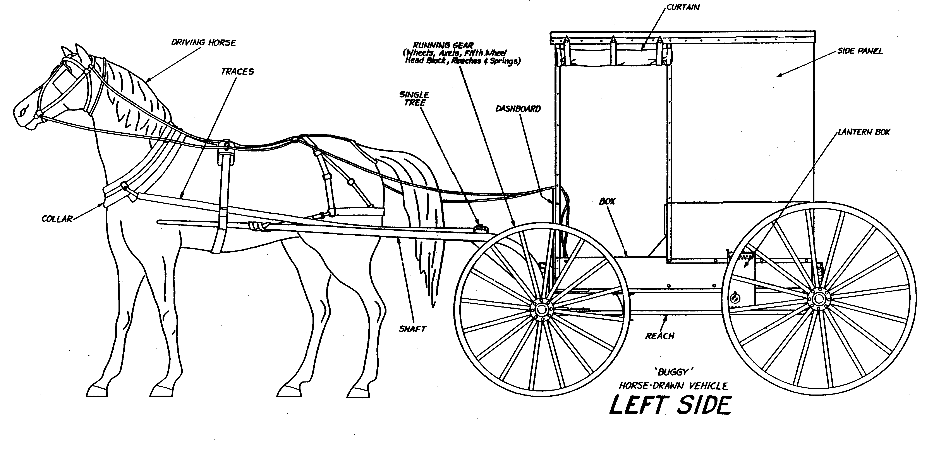

Exhibits from trial: State of Minnesota v. Eli A. Hershberger
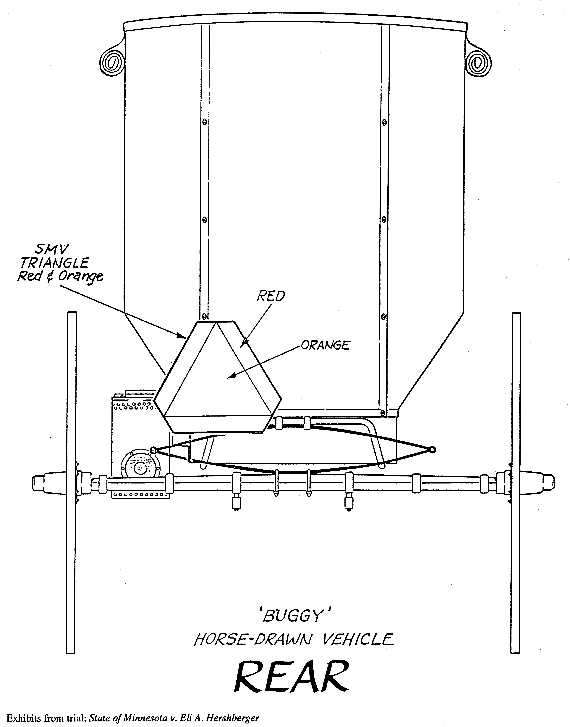
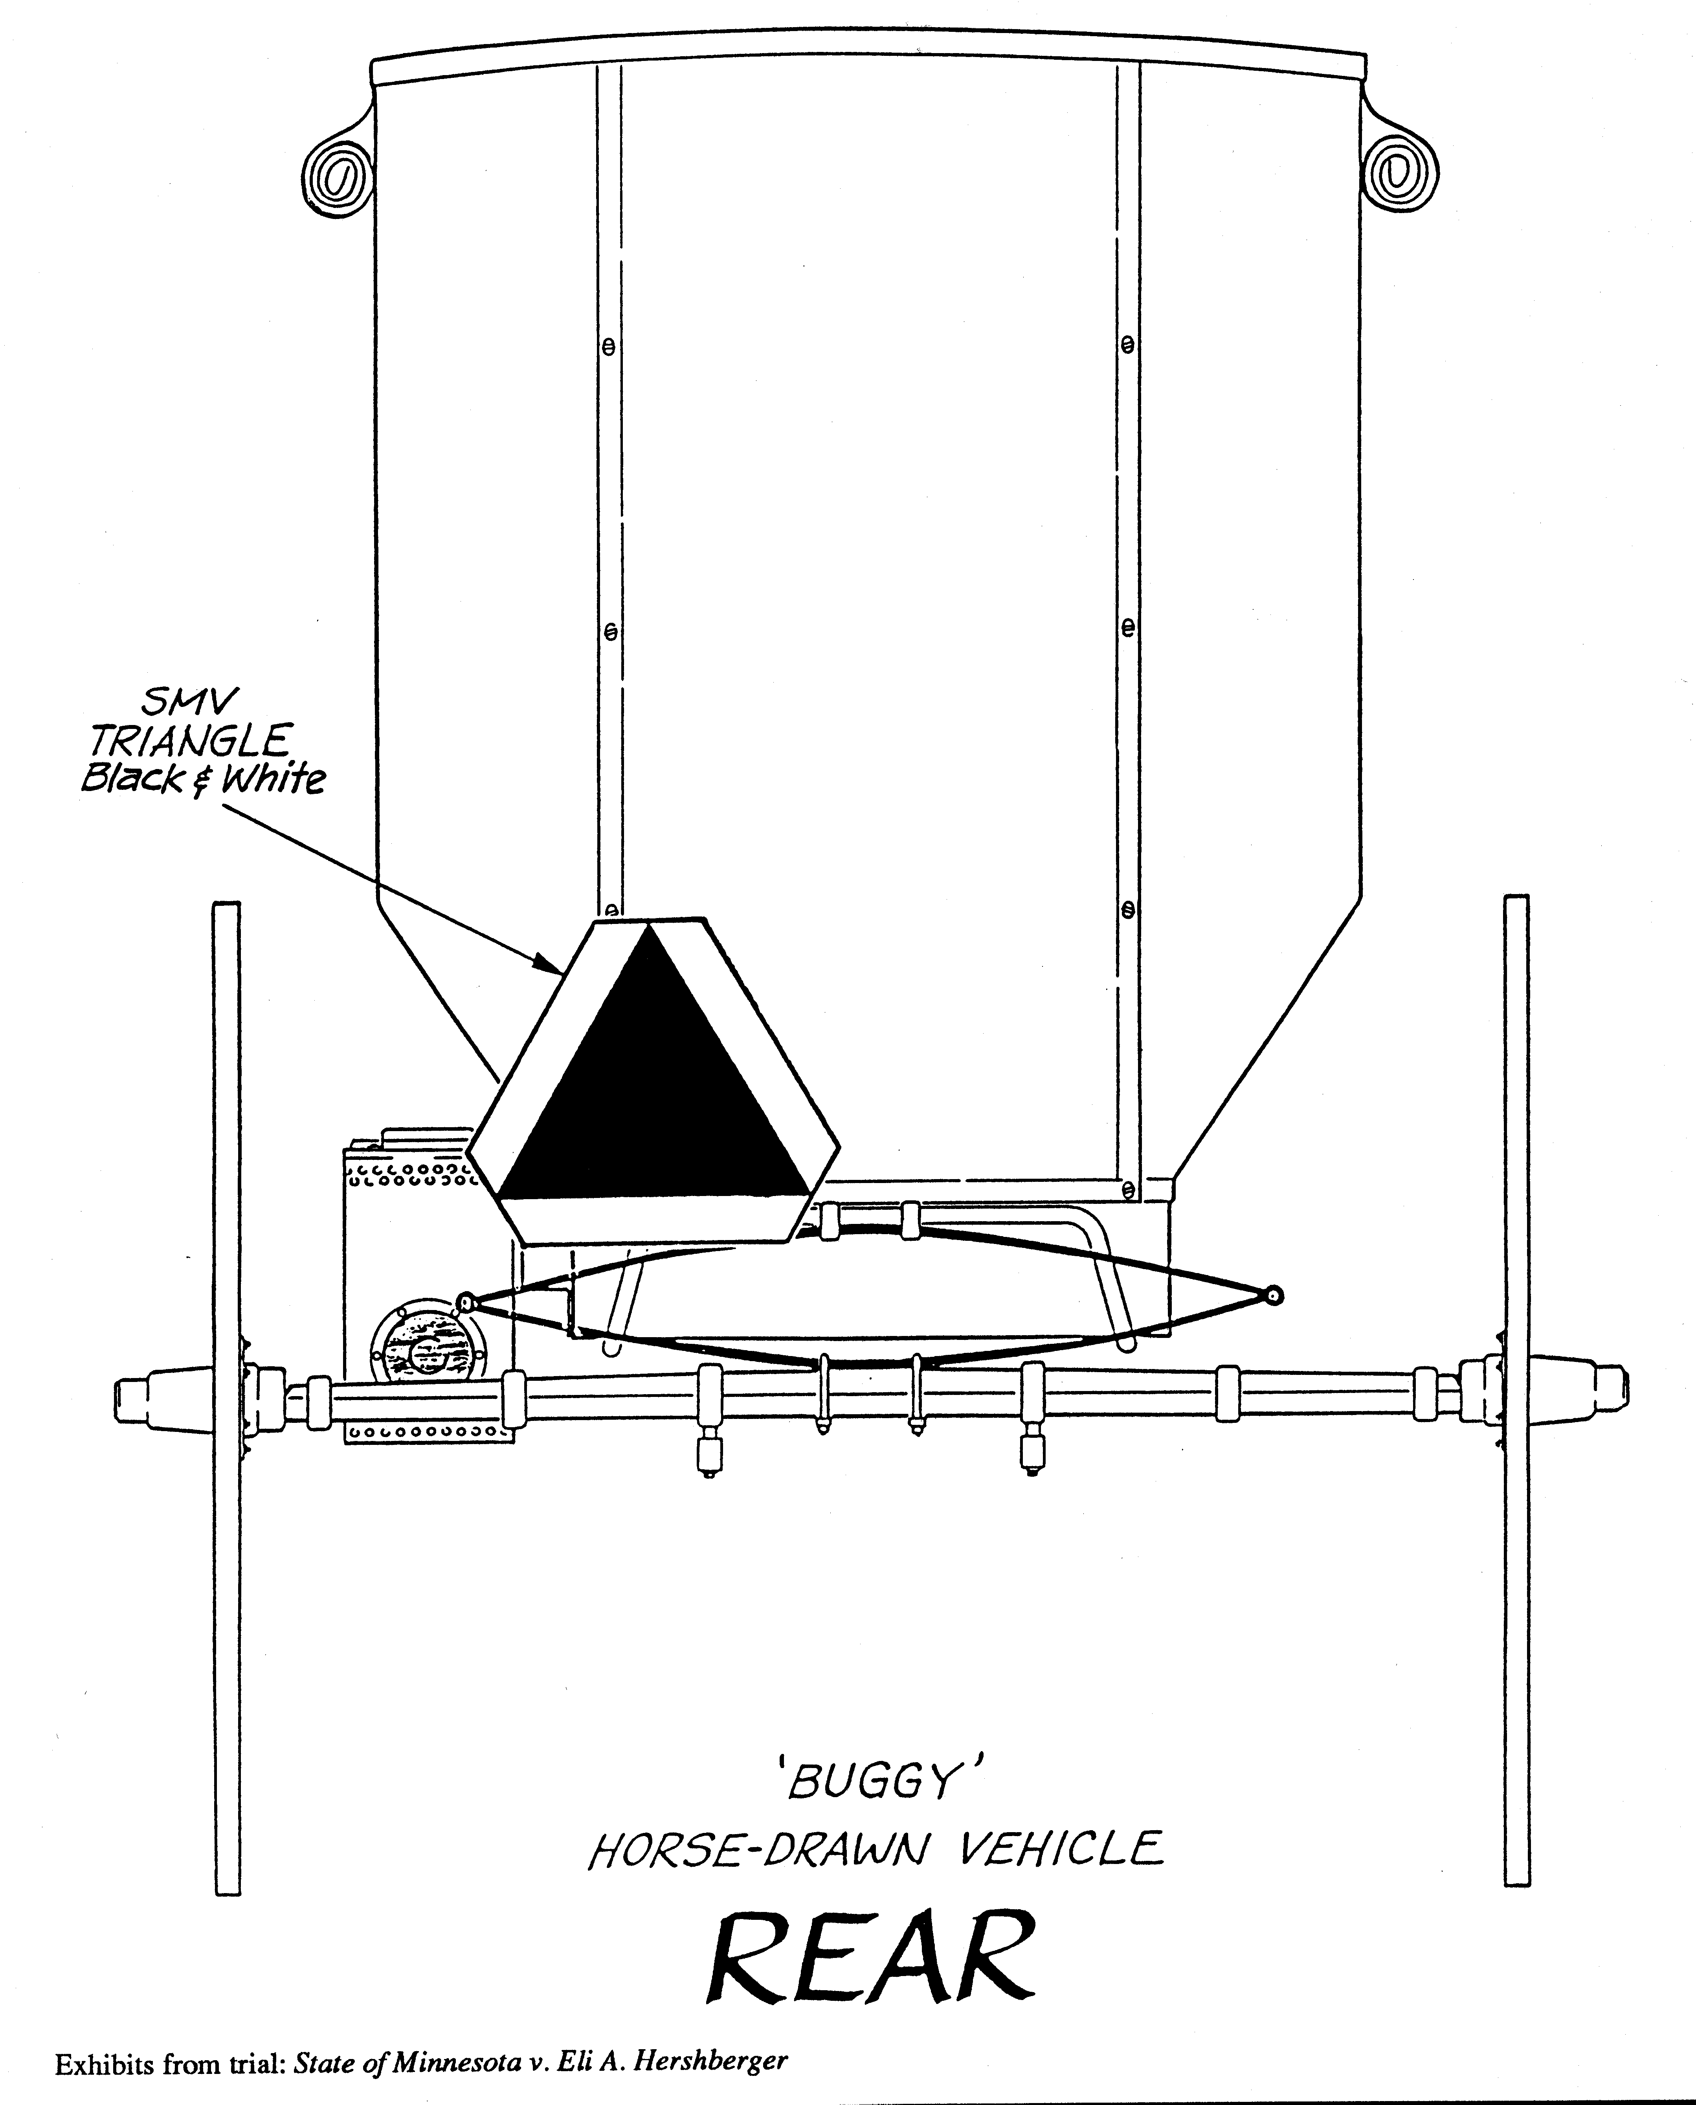

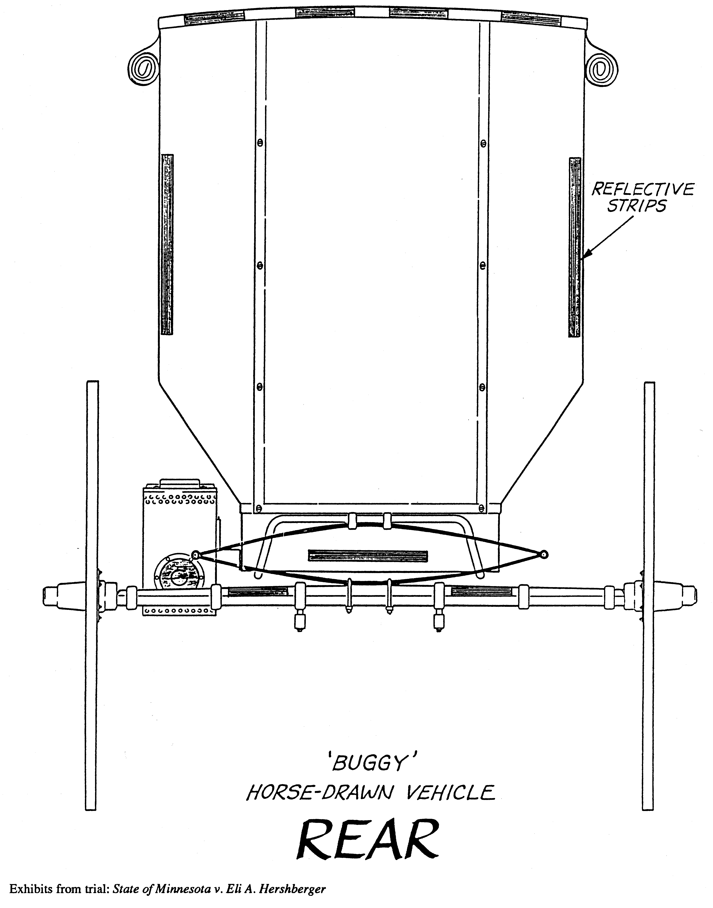

TEACHER NOTES FOR DISCUSSION QUESTIONS

- Should the sincerity of one's religious beliefs be examined by the court? The Minnesota Supreme Court and the United States Supreme Court have held that it has never been a requirement to demonstrate that the sincerity of one’s religious belief is uniformly agreed to by the religious community of which the individual is a member. Instead, the focus is to be on whether the individual claiming First Amendment protection has a sincere religious belief. (The willingness to go to jail probably demonstrates sincere religious belief.)

- Does the government regulation burden the exercise of the religion? When a statute imposes criminal sanctions including fines and jail time on those who do not obey, it is a substantial burden. In this case, the Amish face a choice of either following their religious beliefs by refusing to adopt “worldly symbols” bearing “loud colors” and suffering the consequent criminal sanctions, or rejecting those beliefs in order to obey the law.

- Is the government regulation justified? This is the critical issue. Under current United States Supreme Court decisions interpreting the United States Constitution, the government need only show a good reason for the regulation for it to be found constitutional. Under current decisions by the Minnesota Supreme Court interpreting the Minnesota Constitution, the government is required to have a compelling governmental interest, which cannot be served by a less intrusive alternative. The Minnesota Constitution offers individuals more religious protection. In a decision by the Minnesota Supreme Court regarding the Amish case presented here, the Court ruled that the Minnesota law violates the Amish’s right under the Minnesota Constitution to freely practice their religion.

Portions of this lesson were taken from Fairness and Freedom: Courts as a Forum for Justice, Minnesota Center for Community Legal Education. Permission granted to reprint for educational use.
LEARNING MORE: The Minnesota Supreme Court upholds rights
State courts must follow the United States Supreme Court in matters of federal constitutional law. However, they are free to interpret their own law to provide greater protection for individual rights than what is required by the U.S. Constitution.
In the video “Inside Straight: The Third Branch,” the case of Minnesota v. Hershberger is discussed as a time when the Minnesota Supreme Court found that the Minnesota Constitution in Article 1, Sec. 16 offered greater protection of religious beliefs than those provided by the First Amendment's free exercise clause in the U.S. Constitution. In Hershberger, Minnesota's slow-moving sign law as it applied to the Amish was a violation of their religious beliefs.
Have there been other cases when our state constitution has been interpreted to offer us greater protection of our individual rights? Below is a discussion of three such cases.
Ascher v. Commissioner of Public Safety, 519 N.W.2d 183 (Minn. 1994).
This case arises from a roadblock conducted by police, which stopped all cars at a certain intersection, to investigate further the possibility of drivers being intoxicated. During the four-hour sobriety checkpoint, 975 vehicles were delayed an average of two minutes and 14 DWI (Driving While Intoxicated) arrests took place which is 1.4% of the total stops. One of the arrested drivers, Ricky Ascher, argued that the road block violated his constitutional right to be protected from an unreasonable search or seizure guaranteed in the Minnesota Constitution, Art.1, Sec.10.
The language of Art. 1, Sec. 10 is identical to Ascher's Fourth Amendment rights in the U.S. Constitution, "The right of the people to be secure in their persons, houses, papers, and effects against unreasonable searches and seizures shall not be violated; and no warrant shall issue but upon probable cause, supported by oath or affirmation, and particularly describing the place to be searched and the person or things to be seized." But in 1990, the U.S. Supreme Court held that temporary roadblocks did not violate the Fourth Amendment because the state's interest in stopping drunk driving was greater than the minimal intrusion to drivers by such short stops. Michigan Dept. of State Police v. Sitz, 496 U.S. 444 (1990). Ascher asked the Minnesota Supreme Court to use its independent authority to interpret the very same provision in the Minnesota Constitution as offering greater protection of Ascher's individual right to be secure from unreasonable seizures.
The Minnesota Supreme Court agreed with Ascher and found the temporary roadblocks did violate the Minnesota Constitution, Art. 1, Sec. 10. The Court said it has long required police to have an objective individualized articulable suspicion of criminal wrongdoing before subjecting a driver to an investigative stop. The state of Minnesota failed to persuade the Minnesota Supreme Court that there was enough reason to depart from the requirement of individualized suspicion and subject drivers to the intrusion of a sobriety checkpoint. Even though the U.S. Supreme Court had been so persuaded, the Minnesota Supreme Court did not follow and found independent grounds to rule the roadblocks a violation of the rights of Minnesota citizens.
Friedman v. Commissioner of Public Safety, 473 N.W.2d 828 (Minn. 1991)
This case asked the Minnesota Supreme Court to interpret when an accused person has the right to be represented by counsel. Minnesota Constitution, Art. 1, Sec.6 states, "the accused shall enjoy the right to a speedy and public trial by an impartial jury . . . and the assistance of counsel in his defense."
The circumstance involved a driver who had been stopped and arrested after failing a preliminary breath test. At the police station the driver had to wait for an intoxilyzer test and during that wait had asked to speak with her attorney. She was not allowed to do so. She was then informed that refusal to take the intoxilyzer test would result in suspension of her license for one year. Her response was interpreted as a refusal and her license was suspended for one year. She challenged the license suspension arguing that she should have been able to consult with an attorney prior to deciding whether to take the intoxilyzer test. The court was asked to decide at what point during a DWI proceeding does the right to an attorney begin.
The Court was again faced with language in the state constitution that is identical to language in the sixth amendment of the U.S. Constitution. But will the same words be interpreted in the same way? It was noted by the Minnesota Supreme Court that a number of states have interpreted their own constitutions to grant a more expansive right to counsel to those accused of crimes than the right afforded by the sixth amendment of the federal Constitution.
The Minnesota Supreme Court concluded after reviewing Minnesota's lengthy and historic recognition of human rights, human dignity, and the procedural protection for rights of the criminally accused, that the detention of drivers suspected of driving while under the influence is a criminal proceeding invoking the right to counsel. Therefore the point at which an individual is asked by law enforcement officials to undergo a blood alcohol test is a critical stage in the criminal process and that Article I, Section 6 of the Minnesota Constitution guarantees an individual in such a situation the limited right to counsel within a reasonable time before submitting to testing.
Elli Lake v. Wal-Mart Stores, C7-97-263, ____ N.W.2d _____ (Minn.1998)
In this case, the Minnesota Supreme Court found a new right for Minnesota citizens. The basis for the right is not found in the Minnesota Constitution but rather in "common law," a term that refers to the body of law evolving over time from judicial precedent rather than legislative enactment. The Court finds a right to privacy in Minnesota for causes of action in tort for intrusion upon seclusion, appropriation, and publication of private facts. The tort of false light publicity is not included in the right to privacy.
The facts of the case will explain these rights more clearly. During a vacation in Mexico two young women had their photograph taken while they were naked in the shower together. Upon their return home they brought five rolls of film to their local Wal-Mart store and photo lab. When they received their developed photographs along with the negatives, an enclosed written notice stated that one or more of the photographs had not been printed because of its "nature."
Several months later an acquaintance of the women alluded to the photograph and questioned their sexual orientation. They were told later that a Wal-Mart employee had shown them a copy of the photograph. Nearly a year later, they realized that one or more copies of the photograph were circulating in the community.
The women filed suit against Wal-Mart and an unidentified employee alleging the four traditional invasion of privacy torts - intrusion upon seclusion, appropriation, publication of private facts, and false light publicity. Because Minnesota law had never adopted these rights the district court dismissed the case. After the Minnesota Court of Appeals affirmed the district court's dismissal, the case was then appealed to the Minnesota Supreme Court.
The Minnesota Supreme Court decided that three parts of the common law tort known as "invasion of privacy" would be adopted. The Court accepted: 1. intrusion upon seclusion which occurs when one "intentionally intrudes, physically or otherwise, upon the solitude or seclusion of another or his private affairs or concerns. . .if the intrusion would be highly offensive to a reasonable person," 2. appropriation which protects an individual's identity and is committed when one "appropriates to his own use or benefit the name or likeness of another," and 3. publication of private facts which occurs when one "gives publicity to a matter concerning the private life of another. . . if the matter publicized is of kind that (a) would be highly offensive to a reasonable person, and (b) is not of legitimate concern to the public.”
Prior to this case, Minnesota had been one of only three states not yet recognizing any of the four privacy torts. The Court in joining the other states described the right to privacy as an integral part of our humanity; one has a public persona, exposed and active, and a private persona, guarded and preserved. The heart of our liberty is choosing which parts of our lives shall become public and which parts we shall hold close. The girls in this case have alleged a type of privacy interest worthy of protection.
THE SLAUGHTERHOUSE CASE: APPLICATION OF THE MINNESOTA CONSTITUTION TO A CASE STUDY
This activity will help students understand the basis for the protection of religious freedom and the Minnesota Supreme Court’s analysis in religion cases and will apply this analysis to a recent problem facing a Minnesota community when religious rights and city interests collide.
PROCEDURE

- Ask students to review the Minnesota v. Hershberger case. What were the facts? Issue? Result? How did this case expand individual protection of religious practice under the Minnesota Constitution, Article 1, Section 16?
- Have students read the CASE SUMMARY: The Slaughterhouse Case and complete the Guide for Analysis. The dilemma described is a real case adapted from newspaper articles. Divide the students into three groups. One group prepares the arguments to be made by Lee in asserting that his religious rights have been infringed upon by the city of Hugo. The second group would prepare arguments defending the city's actions as non-discriminatory but necessary in promoting public safety and health. The third group will act as judges and decide the case. Students will work together to strengthen their case but will present in different groups. The last group's preparation would be an understanding of the Hershberger case, a closer look at the Minnesota Constitution and the Court's test (outlined in the case summary), which they will need to apply to this particular case.
- Re-divide the groups into new groups of three: one Lee lawyer, one city attorney and a judge. The judge will ask Lee to present his case first and then follow with the city's arguments. The judge may want to ask questions as the lawyers discuss their case. The judge will want to decide the case telling the reasons for their decision.
- Share group results with the class. What were important factors taken into consideration by the judges? What other solutions might resolve the conflict? How can the city of Hugo accommodate the religious beliefs of Lee and still have a safe and healthy community?
CASE SUMMARY: The Slaughterhouse Case

Seng Lee operates a slaughterhouse on a 20-acre farm in Hugo, Minnesota that serves the needs of many Asian and African immigrants who practice traditional animal sacrifice as a part of their religious ceremonies. Tong Vang Xiong, a Hmong shaman (a spiritual leader in the Hmong community), slaughters a pig at Lee's slaughterhouse as a part of a necessary ritual for a pregnant woman. Such a sacrifice ensures that the baby has a safe passage through the birth canal and that its soul will have a safe journey to earth. Another family on Lee's property lights a fire outside to boil blood from a cow that had been slaughtered in order to pay back a blessing. Pao Yang is at the slaughterhouse waiting for a cow to be sacrificed because his grandfather died and a cow is needed to accompany him to the other side. Ever since Lee bought the farm and business last year, it has become an important place for people to practice their religion.
The city of Hugo sees the slaughterhouse from a different point of view. The city claims that Lee's farm violates a city-zoning ordinance and has taken Lee to court. The lawsuit says Lee is illegally operating a custom slaughterhouse in an agricultural zone. The city also believes the slaughterhouse is a nuisance to those property owners nearby. Nuisance is when someone uses their own property in such a way that it interferes with their neighbors’ use and enjoyment of their own property. Neighbors who live along the rural road are concerned about traffic on weekends where an estimated 200 carloads of people come to Lee's property each Saturday. Complaints have also been made about improper disposal of manure and carcasses, the runoff of bloody water, the sounds of dying animals and the smell of burning hair. The slaughterhouse had been in operation since 1992 but ever since Lee bought it last year, business has increased dramatically. City officials say the reason for the lawsuit is because of land use and not because of the Hmong culture.
Lee disagrees. He is counter suing claiming that the city's actions are based on religious discrimination. "I sacrificed everything to do this," Lee said. "Now they are telling me I can't do it. At first I thought it was zoning, then they said it was a nuisance. Now, I understand. It's different. We're different. The city of Hugo is mostly white and here are these Asians and Africans. People are afraid that the value of their property will go down."
The Minnesota Supreme Court has adopted a 4-part test to review a person's claim that their religious rights have been infringed on or interfered with by government action. The Court will ask:

- Is the objector's belief sincerely held?
- Does the state regulation burden the exercise of religious beliefs?
- Is the state interest in the regulation overriding or compelling? (Only state interests in peace or safety or against acts of licentiousness, loose and lawless behavior, will be considered) and
- Is the state regulation the least restrictive means for advancing its compelling interest? In other words, if there is any other way to regulate that would be less burdensome to religious rights then the state should use it.
Information contained on these pages was developed by the Minnesota Center for Community Legal Education for use only as a teaching aid by Minnesota educators. The case summaries included in this unit are those of the author(s) and do not represent the position or opinion of the Minnesota Court system, justices, judges or employees.

GUIDE FOR ANALYSIS

- How would Lee's attorneys answer each of the above questions? Convince the court that Lee's religious rights have been infringed.

- What arguments would Hugo's city attorney use in response?

- How should the court decide?

RESOURCES

Minnesota v. Hershberger, 462 N.W.2d 393 (Minn. 1990)
Hill-Murray Fed'n of Teachers v. Hill-Murray High School, 487 N.W.2d 857 (Minn. 1992)
Minneapolis Star Tribune www.startribune.com

- Slaughterhouse dispute//The controversy in Hugo pits the food and religious needs of immigrants against city zoning ordinances and state regulations, 03-19-2000, pp 01B.
- Slaughterhouse that caters to Asians, Muslims ordered to close, 05-07-2000, pp. 01B.
- Hugo will vote on zoning for slaughterhouses, 06-03-2000, pp. 04B.
- Hugo prohibits custom animal slaughter//The vote will officially close a Hmong Slaughterhouse, where animals were sacrificed for religious reasons, 06-06-2000, pp 01B.
- Hugo vote leaves slaughterhouses in limbo//Fate hinges on when businesses were established, 06-07-2000, pp 01B

Fairness and Freedom: Courts as a Forum for Justice, the Minnesota Center for Community Legal Education, www.ccle.fourh.umn.edu/Fairness.html

Selection and Election of Judges in Minnesota

Objective: To better understand the process by which judges are selected and the role of judicial independence in our system of government

The Basics
Some Questions
Judicial Independence
The Appointment Process
The Election Process
Student Study Guide
Choosing a Judge Activity
Procedure
Student Handout: Judicial Selection Process
Student Handout: You Decide
Resources

THE BASICS: A quick review of judge selection in Minnesota
There are two basics kinds of courts, and they operate very differently. The trial courts are where witnesses testify, evidence is presented, and a jury or judge determines the facts and outcome of a case. In Minnesota we also call these District Courts. An appeals court will hear a case if one side or the other claims that the process used in the trial court did not follow the law. Only lawyers testify during an appeal. In Minnesota we have two levels of appeal, the Court of Appeals and the Minnesota Supreme Court. So in all, we need 257 District Court judges, 16 Court of Appeals judges, and 7 Supreme Court justices. (Other special courts also exist as part of the executive branch)
According the Minnesota Constitution, all of these positions are to be filled by election, and the term of office is six years (Article VI, section 7). But the constitution also provides that the governor may appoint a judge when a vacancy occurs (Art. VI, sec. 8). By far the majority of judges who leave the bench do so at some time during their term, thus allowing the governor to appoint a successor. Therefore, most judges first get the job by being appointed. Once appointed, however, the judge must run for election in the next general election if he or she wants to keep the position. This means that every six years, someone can challenge a sitting judge in the election, so the citizens ultimately have the responsibility of keeping or replacing a judge. This also means that judges have to conduct an election campaign.

(For more information, visit the Minnesota State Court System website, or view a document entitled The Minnesota Judiciary: A Guide for Legislators by the House Research Department.)

SOME QUESTIONS

Given the process in Minnesota, some questions need to be addressed:

- If the governor appoints a judge, can the governor simply appoint people who are friends and who might favor the governor’s point of view on the law? What process does the governor use?

- How do I as a voter make a good decision about a judge; how should I choose?
- If a judge has to run a campaign, could someone influence that judge by giving money to the campaign?

- During a campaign, can a judge seek votes by promising to make certain rulings?

JUDICIAL INDEPENDENCE

These questions center on a critical concept called “Judicial Independence.” Understanding this concept is vital to understanding the importance of the selection process for judges.

From the American Judicature Society’s (AJS) web site, this explanation of judicial independence is available:

Judicial independence is a concept that expresses the ideal state of the judicial branch of government.

The concept encompasses the idea that individual judges and the judicial branch as a whole should work free of ideological influence.

Scholars have broken down the general idea of judicial independence into two distinct concepts:

1) Decisional independence - Decisional independence refers to a judge’s ability to render decisions free from political or popular influence based solely on the individual facts and applicable law.

2) Institutional, or branch, independence. - Institutional independence describes the separation of the judicial branch from the executive and legislative branches of government.

The AJS also identifies what they see as threats to judicial independence. (Among other interesting information, you can also order a free “Judicial Independence” button.)

So how are judges selected in Minnesota so as to maintain Judicial Independence?

THE APPOINTMENT PROCESS
In the past, judges were appointed by the governor pretty much at will. Governor Albert Quie (1979-1983) and Governor Rudy Perpich (1983-1990) used commissions to assist them in their selection of judges. In 1991, the legislature established the Judicial Merit Selection Commission. Its role is to recruit and evaluate candidates to fill district court judgeships. The commission must evaluate candidates on the following criteria: integrity, maturity, health (if job related), judicial temperament, diligence, legal knowledge, ability, experience, and community service. The exact composition of the commission can be found at http://www.courts.state.mn.us/cio/jud_select.doc, but basically the majority of the 49 commissioners are appointed by the governor and the rest by the Supreme Court.
There are two limitations to note about this commission. First, it is employed only in the selection of the 257 trial court judges. The 16 Appeals Court and 7 Supreme Court positions are still handled independently by the governor. Also, the commission can forward a list of nominees for consideration, but the governor still makes the appointment and so can choose to ignore the commission’s recommendations.

THE ELECTION PROCESS
The citizens of Minnesota hold ultimate authority over whether a judge will remain on the bench through the election process. But judgeship elections are very different from standard political elections.
Dating back to the turn of the 20th century, judicial elections must be nonpartisan according to Minnesota law. This means that candidates cannot be identified as having a political party affiliation during the campaign or on the ballot.
The Supreme Court has also instituted rules concerning the activities of judicial candidates. They cannot seek endorsements from political parties, nor personally solicit money for their campaign or for any other reason. The rules also restrict what they can say during a campaign. For example, candidates cannot state their views on disputed legal issues, or imply how they might rule on certain types of cases. The Minnesota Code of Judicial Conduct includes other restrictions.
Candidates can campaign, and voters can base decisions on the same criteria that the Merit Selection Commission uses (integrity, maturity, health (if job related), judicial temperament, diligence, legal knowledge, ability, experience, and community service).
Judicial elections are held at the same time as general elections; November of even-numbered years.

Selection and Election of Judges in Minnesota

STUDENT STUDY GUIDE
Name ________________________

- What are the three types of courts in Minnesota?

- What is the total number of judgeships in Minnesota?

- What is the term of office for all judges in Minnesota?

- How do most judges first become a judge?

- Summarize the questions raised in part II. Use 2-5 words to identify the main idea of each question.
A.

B.

C.

D.

6. If a judicial system has judicial independence:
A. On what grounds does a judge make a decision?

B. What kinds of things should not influence a judge’s decision?

- Now think about the four questions raised earlier. How does the selection and election process in Minnesota attempt to address those questions and maintain judicial independence?

A.

B.

C.

D.
CHOOSING A JUDGE ACTIVITY

PROCEDURE

- Introduce activity by asking students to pretend that they are the governor and that a judicial vacancy has occurred in one of the district courts. Ask the students whom they would choose to be the new judge. (Answers will range from "my best friend" to "a highly respected lawyer.")

- Explain to students that under Minnesota law, a Commission on Judicial Selection, consisting of lawyers and non-lawyers who are appointed by the governor's office and the Supreme Court, makes recommendations for vacancies occurring in the district courts. The governor may select from the recommended individuals but is not required to do so. (These individuals will be lawyers. All judges in Minnesota must be lawyers.) This procedure is not used for vacancies occurring in the Court of Appeals or in the Supreme Court. For these vacancies, the governor may use whatever procedure he or she wishes. Most often, the governor creates a committee to help identify judge candidates.

- Ask students to read the first half of the Student Handout: JUDICIAL SELECTION PROCESS. Discuss the questions presented.
  - Should the new judge be a friend? Governors can appoint persons they know. Is this a good idea? Why or why not?
  - Should an independent group make recommendations to the governor? What are the
advantages? (No appearance of partisanship.) What are the disadvantages? (Will the independent group make quality recommendations? What is to prevent them from recommending friends?)
  - If an independent group is to decide, who should belong to the group? Lawyers? People who are not lawyers?

- Have students, working independently or in small groups, read the Student Handout: JUDICIAL SELECTION PROCESS and select the characteristics that they think are required, recommended, undesirable, and unnecessary. Discuss as a large group.
  - Remind students that the Commission on Judicial Selection makes recommendations for district (trial) court judgeships. Should the characteristics of an Appeals Court or Supreme Court justice be different?
  - Have students complete the last task on the Student Handout: JUDICIAL SELECTION PROCESS and write a profile of the ideal candidate for a Supreme Court Justice position.
  - Optional Activity: Based on the profile and criteria the students established earlier, have students write interview questions that would allow them to fairly assess how well a candidate fits their profile.

- Instruct students that they are the governor. A vacancy has recently occurred in the Supreme Court. The Supreme Court is currently comprised of six judges (seven when all positions are filled), two are women and four are men. There is one African American on the Supreme Court. Most of the members of the court will be retiring in the next ten years. (In Minnesota, judges must retire when they reach the age of 70 years old.)

- Distribute Student Handout: YOU DECIDE. Working in small groups, have students select one of the five candidates to appoint to fill the vacancy. Ask students to defend their selections by referring to the criteria established earlier.

- Optional Activity: Select five students to role play the candidates and perform an interview with a student portraying the governor. The questions used in the interview should come from those written earlier.

Portions of this lesson were taken from Fairness and Freedom: Courts as a Forum for Justice, Minnesota Center for Community Legal Education. Reprinted with permission.
Student Handout: JUDICIAL SELECTION PROCESS

Judges in the Minnesota court system are elected to six-year terms. However, most often judges will retire in the middle of their terms. When this happens, the state's governor has the authority under the Minnesota Constitution to appoint replacements. A replacement judge is then up for election the first election that occurs at least one year after the date of appointment. This gives the judge an opportunity to become familiar with the job and provides the people with enough information to evaluate the judge during the election. A judge who is running for election does not declare a political party because judges are non-partisan.
The selection process used by a governor is often the subject of controversy. Should the new judge be a friend? Should an independent group make recommendations to the governor? If so, who should belong to the group? Lawyers? People who are not lawyers? What personality traits and experiences should be viewed as important?

You have been appointed to an advisory group that will be recommending persons to the governor. Read the characteristics listed below and categorize them under the most appropriate heading: essential requirements, desirable qualities, undesirable qualities, and unnecessary qualities

1. female
2. old and wise
3. Republican
4. pro peace
5. fair
6. radical
7. determined
8. youthful
9. pro environment
10. collegial
11. good campaigner
12. aggressive
13. self-reliant
14. honest
15. good looking
16. clear thinker
17. concise writer
18. child of immigrant
19. male
20. single parent
21. good health
22. conservative
23. humane
24. traditional
25. well educated
26. Democrat
27. liberal
28. controversial
29. judicial experience
30. family-oriented

31. supports welfare
32. handicapped
33. trustworthy
34. risk-taker
35. helpful
36. religious
37. loyal
38. brilliant mind
39. eminent legal scholar
40. good fundraiser
41. trial attorney
42. U.S. Citizen
43. independent thinker
44. strict constructionist
45. eloquent speaker
46. supports abortion
47. supports foreign aid
48. opposes school prayer
49. member of a minority group
50. opposes higher taxes
51. civil rights activist
52. holder of public office
53. business background
54. community-minded
55. distinguished lawyer
56. follows party line
57. middle-of-the-road
58. tough on crime
59. DWI conviction

Essential Requirements | Desirable Qualities | Undesirable Qualities | Unnecessary Qualities

Write a profile of the ideal candidate for a Supreme Court justice position. List the elements (criteria) of the profile in order of importance.

Student Handout: YOU DECIDE

You are the governor of Minnesota. Under the Minnesota Constitution, you have the power to appoint judges to fill vacancies. A vacancy has occurred in the Supreme Court. A list of five finalists is on your desk. You must decide which person to appoint to the position.

Candidate 1: Sue Johnson
Sue has been a lawyer for 25 years. She is 53 years old. She is active in the area of family law (child custody and support, divorce, adoption). She grew up in a small town in southern Minnesota and now practices in a neighboring town. Sue has been the chair of several community organizations and has received the volunteer of the year award in her town. She has also been named as a WCCO Good Neighbor.

Candidate 2: Byron Wright
Byron is the county attorney for one of the heavily populated counties. In this role, he is often quoted in the media as he tries to solve many serious crimes including murder. Because he spends all of his time working, he has little time for volunteer work. However, he is very active in his church. Before beginning his 6 years as county attorney, he worked for the public defender's office for 15 years. Byron is 46 years old.

Candidate 3: Stephen Blum
Stephen is a lawyer in private practice in Minneapolis. The areas of law he works in most often are environmental and agricultural law. Stephen has been practicing law for 31 years. He spends much of his spare time representing poor people and people who feel that their First Amendment right to practice their religion has been infringed. Stephen is 58 years old.

Candidate 4: Tibetha Cunningham
Tibetha is an African American lawyer in St. Paul. Although she has only been practicing 10 years, she has developed a reputation for being a top personal injury lawyer (representing people who have been injured). She spends most of her time in the courtroom trying cases. She is active in the Minnesota Women Lawyers' Association and actively recruits other women of color to go to law school. Tibetha is 46 years old.

Candidate 5: Bouy Hey
Bouy is a lawyer who has been practicing for 11 years. He lives in a community with other Southeast Asians. He escaped from Cambodia in the 70s and settled in Minnesota where he went to college and law school. Bouy has devoted his practice to helping other Asians in their efforts to get jobs, buy houses, educate their children, and live happy lives. Bouy is very well respected in his community and has become the spokesperson for the Southeast Asians. Bouy is 49 years old.
RESOURCES

Minnesota Courts System www.courts.state.mn.us

The Minnesota Judiciary: A Guide for Legislators www.house.leg.state.mn.us/hrd/pubs/judiciary.pdf
American Judicature Society www.ajs.org

Minnesota Code of Judicial Conduct www.northstar.state.mn.us/ebranch/judstnds/canon2.html
For the Record: 150 Years of Law & Lawyers in Minnesota, Minnesota Bar Association, 1999, available at most county law libraries

Minnesota Constitution www.house.leg.state.mn.us/cco/rules/mncon/preamble.htm

Fairness and Freedom: Courts as a Forum for Justice, Minnesota Center for Community Legal Education, www.ccle.fourh.umn.edu/fairness.html

THE JURY SYSTEM

Objective: To more fully understand the duties of jury service as an active form of citizenship and the role of the jury in the trial process.

The Basics: Jury System in Minnesota
The Right to a Jury Trial
Qualifications for Jury Service
Jury Selection
Types of Juries
Choosing a Trial Jury
Role of the Jury
Miscellaneous
Teaching Strategy
Student Jury Questionnaire

Jury Questionnaire Answers

Resources

THE BASICS: Jury System in Minnesota

The Right to a Jury Trial
The right to a jury trial is a fundamental right provided in the U.S. Constitution and binding on the states through the Fourteenth Amendment. In the words of Sir William Blackstone, the eminent 18th century English legal scholar, the trial by jury is “. .the grand bulwark of our liberties . . .the most transcendent privilege which any subject can enjoy or wish for.”
Article III, Section 2, clause 3 of the Constitution provides that the “trial of all Crimes, except in Cases of Impeachment, shall be by Jury. . .” The Sixth Amendment reinforces this right by stating that “in all criminal prosecutions, the accused shall enjoy the right to a speedy and public trial, by an impartial jury of the State and district wherein the crime shall have been committed. . .” The Seventh Amendment preserves the right of trial by jury in civil suits.
The Minnesota Constitution, Article I, Section 4 guarantees a jury trial in the state court system.
The right of the defendant to fair legal process includes having his or her fate determined by “a jury of peers,” meaning representative members of the community. However, this right is dependent on those citizens who participate in the process. Jury service provides citizens with one of the few opportunities to actively participate in the workings of their government.

Qualifications for Jury Service in Minnesota Courts
A person is qualified for jury service if he or she is 18 years old or over; if he or she is a citizen of the United States and a resident of Minnesota and the county in which the court is located. A person must also be able to read or speak English and be physically and mentally capable of rendering jury service.
A person is ineligible for jury service if he or she has not completed sentence or parole after a felony conviction, has already served on a jury within the last four years, or is a judge.
Persons cannot be excluded from jury service on the basis of race, national origin, gender, religious belief or income.
An eligible juror may be excused from jury service by the judge or jury commissioner if their ability to perform jury duties is impaired or if performing such duties would be a continuing, extreme hardship to them. Jury service can more easily be deferred or postponed for reasonably short periods of time for reasons such as temporary health problems, vacation plans, employment conflicts, to arrange for child care, or pre-scheduled medical appointments.

Jury Selection
Names of potential jurors are drawn at random from a jury source list compiled from voter registration, drivers license, and state identification lists. The jury source list is intended to represent a fair cross-section of the community.
Citizens selected for jury service and qualified to serve form a jury panel. Several types of trial juries may be chosen from the jury panel.

Types of Juries
Citizens may serve on several types of juries in the Minnesota court system. A Grand Jury may be called at the request of the county attorney for the purpose of issuing an indictment or formal charge in limited number of cases (first degree murder, political cases). A grand jury has 16-23 jurors and 12 jurors must agree on finding an indictment. Grand jurors serve for a term of several months.
A Petit Jury is used in civil and criminal trials. A criminal jury will consist of twelve persons if the sentence for the crime charged is more than one year of confinement (felony). A jury of six persons will serve if the penalty is one year or less of confinement. All criminal cases require a unanimous jury decision in reaching a verdict.
A jury in a civil case consists of six persons. Verdicts in civil cases should be unanimous, except that a civil jury may return a verdict, after six hours of deliberation, with which five of the six jurors agree.

Choosing a Trial Jury
Voir Dire (pronounced vwar deer) refers to the jury selection process for a particular trial. The goal is to select a fair and impartial jury through the elimination of jurors who may be prejudiced. During voir dire examinations, jurors are questioned first by the judge, then by each attorney. If a juror is even distantly related to the complainant or the accused, has previously sued the defendant in an unrelated civil matter, has been otherwise connected with either party in some business transaction, or cannot be fair and impartial for other reasons, he or she may be challenged for bias or “cause.”
In addition, the respective attorneys may exclude jurors they do not want, without having to show that the jurors are disqualified through cause. The attorney does this through a “peremptory” challenge. However, the number of peremptory challenges available to each attorney is limited.

Role of the Jury
The jury has the responsibility of deciding the facts at issue in a trial. For example, did Bill really drive through a red stoplight and cause the accident? The jurors will listen to the lawyer’s opening statements, direct and cross examination of witnesses, and the closing arguments of each side. They must listen and observe closely the testimony presented. After the judge instructs the jury as to the law and the issues of fact to be reached, they retire to consider the verdict.
During deliberations jurors will consider, examine, and weigh all the evidence in the case with the sole power to decide disputed questions of fact and to put their conclusions in a verdict. In a criminal case, a jury might be sequestered or separated from the public over night and if the case is particularly sensational, the jury may be sequestered for the length of the trial.
During a trial, jurors are not to talk to anyone about the case or listen to anyone else talk about the case outside of the courtroom.

Miscellaneous Information
Petit Jury service will usually last for 10-15 court days unless it takes longer to complete a particular trial. Jurors are reimbursed for travel expenses and are paid a small daily rate.

TEACHING STRATEGY

Ask students to imagine that their parents have received a summons to report for jury service. What questions would they have about being on a jury? Brainstorm questions and list on board. Sample questions may include:
  - How are people selected for jury service? Who picks them? Why are large numbers of people called for jury service and some never actually hear a case? What types of juries are there? How many people actually sit on a trial jury? How are they selected?
  - What is the job of a juror? Do they get paid? Should a juror prepare? What do they actually do during a trial? How do they make their decisions?
  - Why is the jury system important? How does it make the legal process fair?

- Ask students to answer the Jury Questionnaire to the best of their ability. After they have tried to answer the questions,
  - review the questions providing the correct answers and additional important information (see THE BASICS: The Jury System in Minnesota). Instruct students to complete the right hand column or
  - instruct students to conduct research on the web to find out the correct answers. Most counties have web pages that provide jury information. (See Hennepin County’s jury service web page at www.co.hennepin.mn.us/courts/Jury/joadminplan.htm.

- Optional Activity: In small groups, have students create brochures or posters to share important information about jury service. Sample titles could include: “Ten Facts All Jurors Should Know,” “Tips for Jurors,” “Make the Most of Your Day in the Jury Box,” or “Jury Service: Penalty or Privilege.”

STUDENT JURY QUESTIONNAIRE

What do YOU think? Correct Answer/Notes

How many people are on a jury

panel to decide a serious criminal

case?

What is it called when you are

notified to show up for jury duty?

Who may jury members discuss a

case with while a trial is in progress?

What is the title for the leader of

the jury?

What percentage of jurors must

agree on the verdict in a civil case?

How much are jurors paid?

Can lawyers and police officers

be called to jury duty?

How old do you have to be to be

called to jury duty?

Are businesses required to provide paid leave to employees on jury duty?

What does “sequestering” the

jury mean and when does it happen?

For each of the following cases, circle True or False

What do YOU think? Correct Answer/Notes
A. If you will probably lose a lot of money by being absent from your job to sit on a jury, the court will excuse you from jury duty.
True False
B. If the jury agrees that the defendant broke a law, but they feel it is an unfair law, the jury is still expected to find the defendant guilty.

True False
C. Lawyers and judges prefer jury members who know little to nothing about the case going into the trial.

True False
D. Lawyers may excuse prospective jurors from the panel for no reason at all.

True False
E. Jury members must remain silent during the trial.

True False
F. Jury members should feel free to inspect the scene of a crime on their own time when the court is in recess.

True False
G. Jury members should not play cards or read magazines while any discussion of the case is going on.

True False
H. Higher courts rarely overturn jury verdicts.

True False
I. A person can get out of jury duty by demonstrating that it is against their religion.

True False

JURY QUESTIONNAIRE ANSWERS

- 12

- Being Summoned.

- Nobody – not even each other.

- Jury Foreperson

- 100%. This is called a “true verdict.” If after 6 hours a true verdict cannot be reached, 5/6 of the jury members may return a “five-sixth verdict.” In criminal law, all 12 jurors must agree.

- $30 per day.

- Yes, but not judges.

- 18

- No, but many companies pay the difference between the salary and the jury stipend.

- Sequestering the jury means keeping the jury separated from people outside of the court system. The jury is sequestered during jury deliberations in a criminal trial and during the entire trial if it is a sensational case.

- False – the court may excuse you if you pose to lose an unusual amount of money. This is very rare.

- True – people should expect laws to be enforced consistently. It is the legislature’s job to change unfair laws.

- True – if it is believed that a prospective jury member already has an opinion about the case, it would be an unfair trial and such people are excused from the jury. This is why it is very difficult to put together a jury for high profile cases that have had extensive news coverage.

- True – each side may excuse a limited number. These are called peremptory challenges.

- True – However, if a jury member cannot hear a witness, she should feel free to mention this to the judge.

- False – juries should only tour a crime scene when ordered by the court. Jurors may cause a mistrial by touring on their own.

- True

- True

- False
RESOURCES

Rules of Civil Procedure for Minnesota District Courts.

Minnesota Rules of Criminal Procedure.

Fourth Judicial District Court Judicial Administration Plan www.co.hennepin.mn.us/courts/Jury/joadminplan.htm

Additional lessons: Follow-up lessons include “Voir Dire Process” and “You Decide: A Jury Simulation,” Fairness and Freedom: Courts as a Forum for Justice, available from the Minnesota Center for Community Legal Education. www.ccle.fourh.umn.edu

How were the American’s influenced by their English background?
Middle School Level: Unit Two, Lesson 5

American’s knowledge of British government
Purpose of Lesson
This lesson describes the growth and development of constitutional government in England. It discusses the limitations that were placed on that government over a period of many centuries. It will help you to understand the background of the basic ideas of constitutional government in the American colonies.

When you have finished this lesson, you should be able to describe the struggles for power between the English monarch (king or queen) and the Parliament (legislature). You should also be able to explain how these struggles led to a system of separated powers and representative government.
Terms to know
Feudalism/feudal system
Royalty
Monarch/monarchy
Nobility
Common people
Magna Carta
Representative government
Parliament
English Bill of Rights

The American colonies had been ruled by the British government for over 150 years before the American Revolution. As a result, Americans knew quite a bit about the British government. The men who wrote our Constitution were greatly influenced by their experiences with the British government. They were also influenced by their knowledge of its history. Understanding what they knew is important to understanding why they wrote the Constitution as they did.
The feudal system
English history goes back many centuries before the discovery of America. For much of that time, England was made up of a number of kingdoms, each with its own ruler. Then in 1066, William the Conqueror invaded England and became its king. He then began a new system of government known as feudalism.
Under the feudal system, the people in England belonged to one of the following three groups.
Royalty. This group included the monarch (king or queen) and his or her family. A government ruled by a monarch is called a monarchy.

Nobility. This group included the “lords” and “ladies” who held titles such as earl, duke, duchess, and baron. They worked for the king and made it possible for him to control all of England.

Common people. The group included such people as knights (soldiers of the king), merchants, and peasants (people who worked the land). The peasants were often called serfs because they were not free and could not leave the area in which they worked.

England’s land all belonged to the king or queen. There was too much land for a king or queen to rule alone. So, they gave some of the responsibility for governing the kingdom to the nobility. Under the feudal system, the nobles were allowed to control parts of the land and the people who lived there. In exchange, they pledged their loyalty to the king and fought for him. You will see how his sharing of power by royalty with the nobility eventually led to a government that represented more of the people.

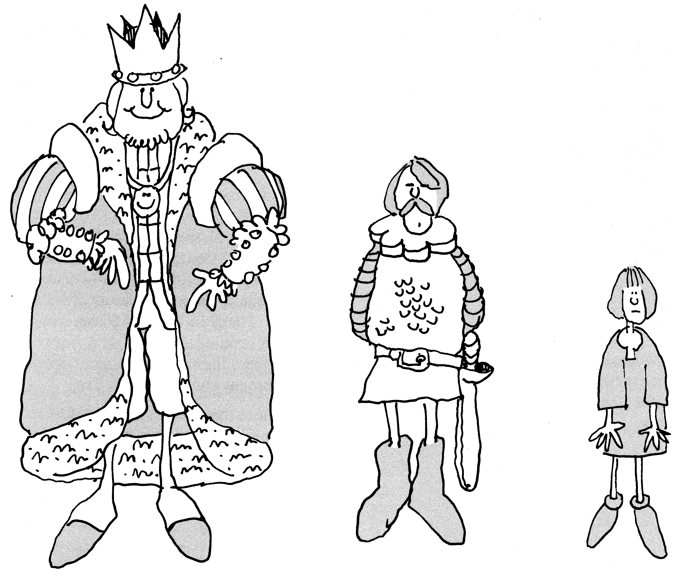
How does this drawing illustrate the distribution of power in the feudal system?

The Magna Carta
Under the feudal system, it became a custom or tradition for the royalty to share some of its powers with the nobility. As a result, the nobles became used to having certain rights and powers. When King John tried to take back some of these rights, the nobles rebelled.
The nobles were powerful enough to force the king to sign an agreement with them. This agreement, signed by King John in 1215, became known as the Magna Carta or Great Charter. It said that the nobles would obey the king only as long as he protected their rights.
The Magna Carta was a major step in the growth of English constitutional government. It contained two very important ideas.
* Governments are based on an agreement or contract between the ruler and people to be ruled. In the case of the Magna Carta, this was a contract between the king and the nobility.

Most of the people in England were not a part of this agreement. But it was an early step in establishing the idea that government should be based on a contract which includes all the people. You may recognize this as the same idea as the social contract discussed hundreds of years later by the natural rights philosophers.

A government by contract means that both sides of the agreement are responsible for fulfilling its terms. In the Magna Carta, the king was responsible for not depriving the nobility of their rights. The nobility, in turn, was responsible for supporting the king and obeying the laws of England

A government by contract also includes the idea that if either side breaks the contract it is no longer valid
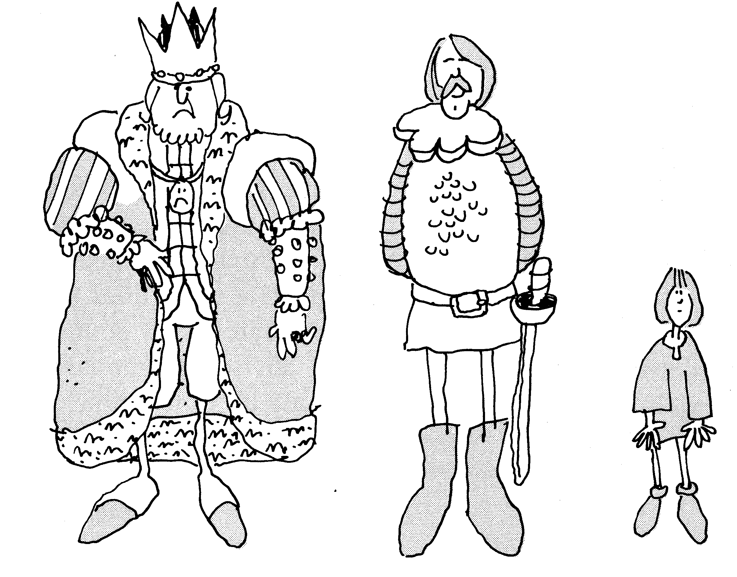
What changes occurred in the distribution of power when the Magna Carta was signed?
* The Magna Carta also includes the idea of the rule of law. This means that both the government and the governed must obey the law. The law limits the powers of the government. For example, the king could not take away the property of a noble without following agreed-upon procedures and rules.

The rule of law also meant that if the king broke the laws, the nobles had the right to overthrow him. They could place a new king on the throne. This idea became part of the natural rights philosophy. It is also included in our Declaration of Independence.

The early English customs and traditions and the Magna Carta protected certain basic rights. These rights were not given to all the people of England. Men who owned property were given far more rights than other people. Men without property, and women and children had fewer rights. However, the Magna Carta was an important step in protecting the rights of the people and limiting the power of the government.

The establishment of Parliament

Important changes in the English government resulted in the establishment of other basic ideas you have studied. These are the separation of powers and the beginning of representative government. In 1258, the nobles forced King Henry III to create a new council called Parliament to advise the monarch. Parliament was made up of two houses which represented the most powerful groups in the kingdom. The House of Lords represented the nobles. The House of Commons represented people who owned large amounts of land but were not members of the nobility.
For hundreds of years after the creating of Parliament, the royalty, nobility, and commons struggled for power. No one group was able to control all the power for very long. The struggle became so intense during the 17th century that a civil war resulted. The nobles won and in 1649, Parliament ordered the execution of the king. By the time of the Glorious Revolution of 1688, the balance of power had shifted in favor of Parliament.

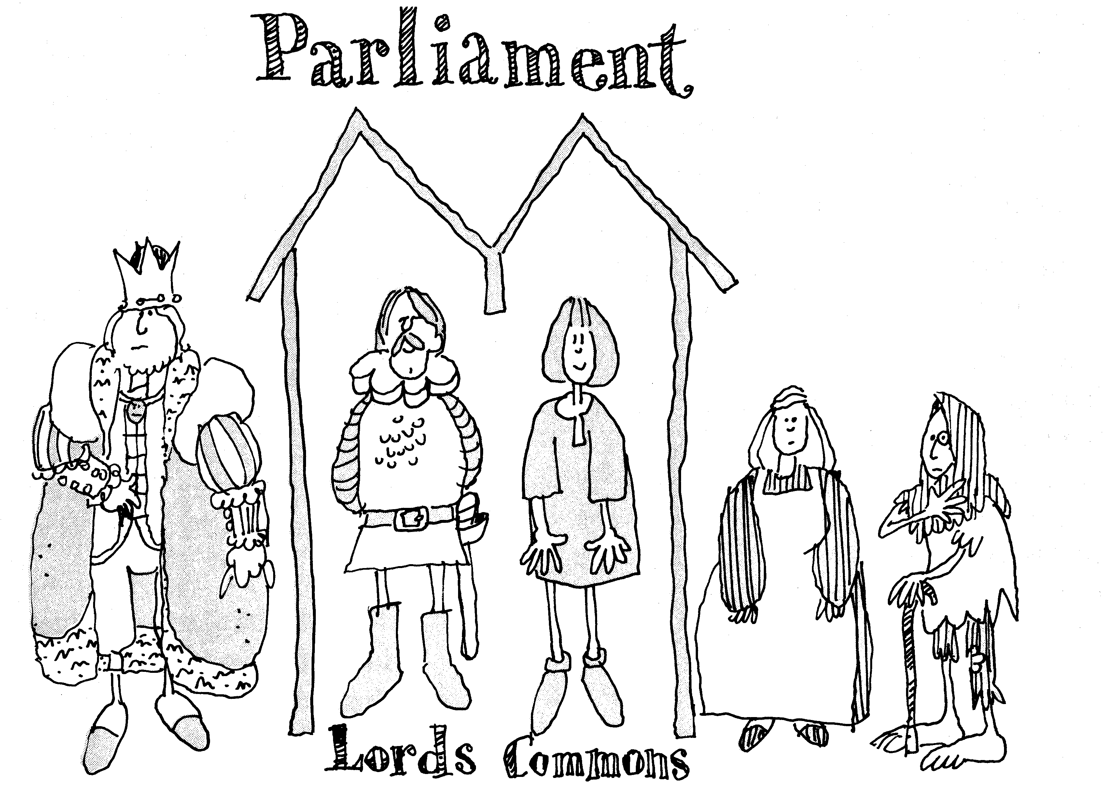
Who benefited most from the creation of Parliament?

The English Bill of Rights
In 1689, Parliament passed an important law, the English Bill of Rights. This law gave certain rights to Englishmen and further limited the powers of the monarch. The Bill of Rights gave Parliament the balance of power in the English government.
What did the Bill of Rights guarantee? It said that elections to Parliament must be free and that the people have the right to keep and carry weapons. It said that kings and queens were not allowed to
- collect taxes without the consent of Parliament
- interfere with the right to free speech and debate that went on in Parliament,
- maintain an army in times of peace (since it might be used to take over the government).
- require excessive bail or administer cruel punishment for those accused or convicted of crimes,
- declare that laws made by Parliament should not be obeyed.
By the end of the 17th century, the British government became increasingly limited in what it could do. During this same period, the government was establishing colonies in North America. The colonists brought with them the English system of constitutional government.

Problem solving
Your class should be divided into small groups to answer the following questions. When your group has completed its answers, it should share them with the rest of the class.

The Magna Carta was written in 1215 and the English Bill of Rights was passed in 1689. During the more than 400 years between these documents, many changes occurred in the English government. Review what you have read about these two documents and discuss the following questions.

1. How was the Bill of Rights different from the Magna Carta?

2. What basic rights that you think are important were not included in either of these two documents?

Reviewing and using the lesson
1. How and why did the feudal kings in England share their power?

2. What were some of the basic ideas included in the Magna Carta?

3. Parliament won a struggle with the king in 1689, when the English Bill of Rights was adopted. Which parts of the English Bill of Rights do you think the Framers might have included in our Constitution? Explain your answers.

4. Four ideas that were very important to the Framers were limited government, representative government, the balance of power, and separation of powers. Give examples of these ideas from English government.

Reproduced with permission. We the People…Unit 2, Lesson 5. Copyright 1998. Center for Civic Education. Calabasis, California. For more information about We the People and other CCE programs call 800.350.4223 or check out their web site at http://www.civiced.org.

To obtain a free classroom set of We the People, contact Debra Berghoff at the Minnesota Center for Community Legal Education, 612/624.8112 or bergh004@umn.edu. Visit our web site at http://www.ccle.fourh.umn.edu for more information about We the People in Minnesota.
What Were the British Origins of American Constitutionalism?
High school level: Unit 1, Lesson 5

Purpose of Lesson
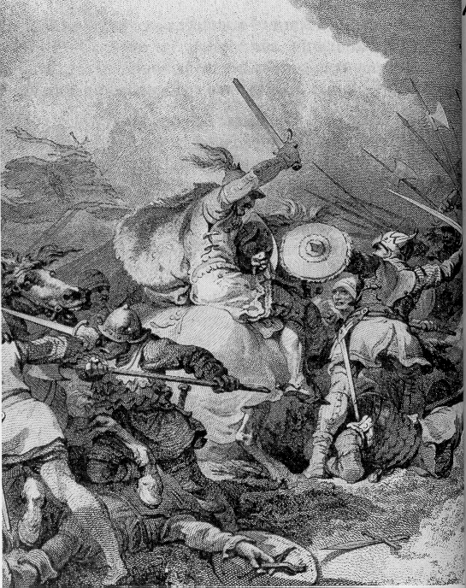
This lesson describes how some basic rights of Englishmen were established and why they were important to the American colonists. You examine English government in its early stages from the ninth through the thirteenth centuries, known as the feudal period. You also examine the initial development of the English constitution. Finally, you learn about the Magna Carta and its importance to the Founders.
How did feudalism change power relationships between people.

Terms to Know
Charter  Contract  Custom  Common law  Due process of law  Feudalism  Magna Carta  Monarch | Manor and manoralism  Parliament  Rights of Englishmen  Royal charter  Subject  Tenet  Vassal

How did English government begin?
For several centuries after the fall of the Roman Empire, England was divided among a number of tribes, each ruled by its own leader or “king.” These early kings were selected by councils of advisers because they were the strongest and most powerful members of their tribes. For many years these tribes were at war with each other. Eventually all the tribes of England became united under one king. Christianity increased the authority of kingship by teaching that kings were “anointed by God” and that all the people governed by the king were subject to his rule—which is why they were called “subjects.”
England was too large for one person to rule because quick and efficient means of communication and travel did not exist. Most kings had to let people in local areas tend to their own affairs according to customs that had developed over the years.
What was feudalism?
A major change in the way England was ruled took place on October 14, 1006, when William the Conqueror, the leader of the Normans (from Normandy in France), invaded England and defeated King Harold at the Battle of Hastings. William introduced a new system of feudalism to control the conquered land.
Feudalism is not easy to define because it varied greatly in different times and different places. Generally, feudalism was a form of political organization in which a lord gave land to other men in return for their personal allegiance and for military and other service. The men who received land from the lord were known as his vassals—they served their lord and were entitled to be protected by him.
Feudalism is important to the development of constitutional government

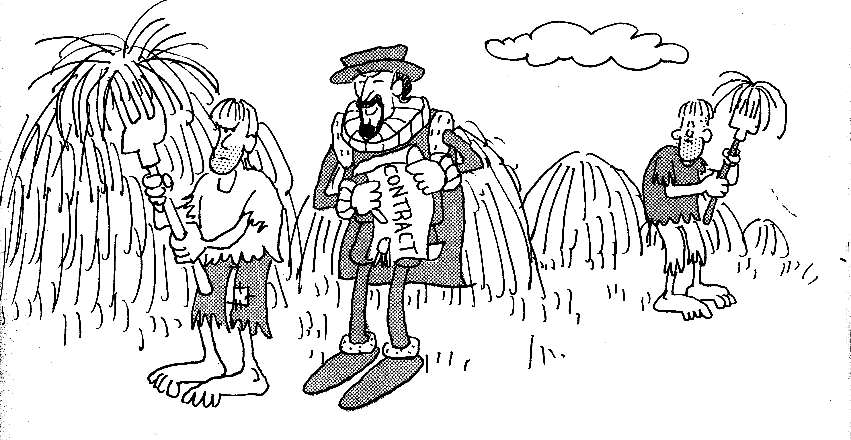
How did feudalism change the way people were governed?

because of its ideas about contracts. Feudal government depended on a series of agreements or contracts between lords and vassals. Each contract included mutual rights and responsibilities. Thus, feudalism introduced the idea of government based on a contract—those in power pledged to respect the rights of the people who gave them allegiance.
The basis of this feudal system was land use. Parcels of land were divided into self-contained farms or manors. Peasants were legally required to remain on the land and in that sense were part of the property enjoyed by the owner or “lord” of the land. Even peasants, however, enjoyed certain customary rights on the manor. For this reason, the system of manorialism as well as feudalism helped to develop ideas about the fundamental rights of Englishmen.

What do we man by the “rights of Englishmen”?
The rights of Englishmen had been established slowly over centuries of British history. They were certain basic rights that all subjects of the English monarch—king or queen—were believed to have. They were fundamental in the sense that they could not be changed or violated.
The Founders began their lives as loyal subjects of the British Crown, proud to enjoy the rights of Englishmen. This privilege, they believed, set them apart from the other peoples of the world.
Centuries of respect gave these rights a special status. They included
- the right to a trial by jury
- security one’s home from unlawful entry
- no taxation without consent

The historical sources of these rights are customs and law. They were confirmed by royal charters and became part of English common law. The common law consists of the accumulated legal opinions of judges explaining their decisions in specific court cases. These decisions provide guidelines or precedents for later judgments. The English common law provides the historical foundation of our American legal system.

What is the British constitution?
Unlike the U.S. Constitution, the British constitution did not exist before the creation of a government. The constitution of Great Britain is not a single written document. Instead it is made up of the common law, acts of Parliament, and political customs and traditions.
Three great historical documents are important in the development of the British constitution and the rights of the British people. These are the Magna Carta (1215), the Petition of Right (1628), and the English Bill of Rights (1689).
These documents were written during times of great conflict. Much of English history is the story of a bloody struggle for power between the most important groups in society. These groups were the royalty, nobility, and the clergy. By the thirteenth century, the struggle was mainly between royalty and the Parliament. Parliament was originally a council of nobles created to advise the monarch. It soon became the branch of government that represented the most powerful groups in the kingdom.
For hundreds of years, Parliament and the monarch struggled for power. During these conflicts, English subjects were jailed, tortured, and executed. Kings and queens defeated in battle were imprisoned and beheaded. Because of these conflicts, several important legal documents were written that limited the power of the monarch in order to protect the rights of other groups. These documents were important not only in English history, but they also had a great influence on the Founders. One of the most important of these documents is described below.

What was the Magna Carta and why is it important to us?
The first great landmark of British constitutionalism and one of the great charters of human liberty originated as a quarrel between a feudal lord and his vassals. One of William the Conqueror’s successors, King John, tried to take back some rights and powers of his barons. This was the title of nobility given to principal vassals. The result was a war between the barons and their king, a war that the barons won.
With the support of the church and others, the barons, in June 1215, forced John to sign the Magna Carta—Great Charter—confirming certain traditional rights and, by implication, promising not to violate them again. Most of the rights in question were feudal privileges, enjoyed only by the feudal nobility.
The tenets—principles or doctrines—of the Magna Carta were very important in the later development of constitutional government:

Government should be based on the rule of law. The Magna Carta was perhaps the most important early example of a written statement of law limiting the power of a ruler. It expresses the idea of limited government by requiring the king to govern according to established rules of law. The Magna Carta, for example, states that no free man could be imprisoned or punished “except by the lawful judgment of his peers and by the law of the land.” “Judgment of his peers” did not originally mean trial by jury as we understand it. this statement, however, did explain the principle of due process of law, whereby no government could take action against those it governed except by settled and generally agreed on procedures and rules.

Certain basic rights may not be denied by government. In limiting the power of the king, the Magna Carta also expressed the idea that established rights of the governed could not be violated. Most of the rights guaranteed in the Magna Carta belonged only to the feudal nobility. The Magna Carta did, however, secure some rights for others in
English society. The king, for example, promised to respect the “ancient liberties and free customs” of London and other towns.

Government should be based on an agreement or contract between the ruler and the people to be ruled. This agreement in the Magna Carta was between the king and a very limited number of his subjects. It did not include the majority of the English people. It did, however, express the feudal principle of drawing up an agreement between parties as a basis for legitimate government. Government by contract meant that if either side broke the agreement, the agreement would no longer be valid.
Later generations also would discover in the Magna Carta the seeds of other important constitutional principles. For example, the American colonists found in King John’s promise not to levy certain feudal taxes without the consent of “our common counsel of the kingdom” the principle of no taxation without representation and consent.
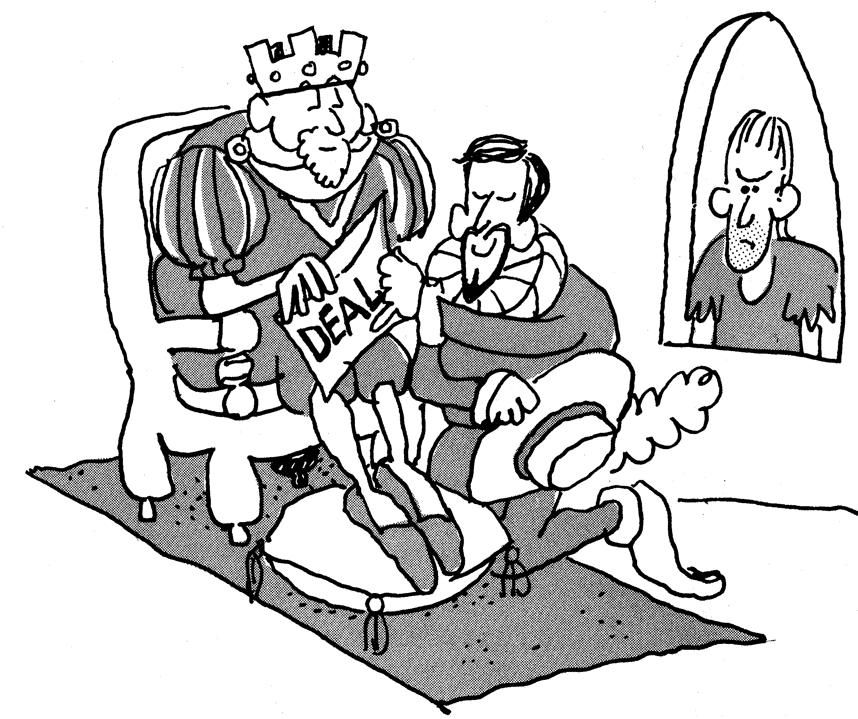
Critical Thinking Exercise
Analyzing and Evaluating Specific Rights
People have fought and died to establish such rights as those described in this lesson. It is often difficult, however, to understand their importance from merely reading about them. By examining specific rights more closely and discussing your opinions about them, you may be able to gain a greater appreciation of their meaning and importance. Let’s examine more closely some of the provisions of the Magna Carta.
Did the Magna Carta protect the rights of all Englishmen? Why?
Two parts of the Magna Carta, Articles 39 and 40, contain some of the most important principles of modern constitutionalism. Working in small groups, read and discuss these provisions. Then develop responses to the questions that follow. Be prepared to explain you answers to the class.

Article 39: No freeman shall be taken or imprisoned or disseised (dispossessed] or banished or in any way destroyed, not will We proceed against or prosecute him, except by the lawful judgment of his peers and by the law of the land
Article 40: To no one will we well, to none will we refuse or delay,…justice.

1. What rights are listed in Articles 39 and 40?
2. How do these rights limit the power of the king?
3. Why would the English nobles want to place such limits on the power of the king?
4. What values and interests are protected by these statements?
5. What events in the United States or other nations can you identify in which one or more of the above rights have been upheld or violated?

What do you think?
1. In what ways might the rights in Articles 39 and 40 be relevant to you today?
2. Do you think the declaration of these rights alone is enough to protect individuals from unfair and unreasonable treatment by their government? Why or why not?
3. At Runnymede in England, where King John signed the Magna Carta, there are three monuments. One is a tribute to U.S. President John Kennedy. Another is the Magna Carta memorial erected by the American Bar Association. In addition there is one honoring the British Commonwealth airmen who died in World War II. Why do you think the Magna Carta might be especially important to Americans?

Reviewing the Using the Lesson
1. What is meant by the “rights of Englishmen”? How were these rights established?
2. What is the common law? How does it develop?
3. What was feudalism and how did it contribute to the development of constitutional government?
4. What is the Magna Carta? How was it created? How did it contribute to the development of constitutional government?
5. What ideas in the U.S. Constitution or in your state constitution can you trace back to the Magna Carta?

Reproduced with permission. We the People…The Citizen and the Constitution, Unit 1, Lesson 5. Copyright 1995. Center for Civic Education, Calabasas, California. For more information about We the People or other CCE programs call 1.800.350.4223 or visit their web site at http://www.civiced.org.

To obtain a free classroom set of We the People, contact Debra Berghoff at the Minnesota Center for Community Legal Education, 612/624.8112 or bergh004@umn.edu. Visit our web site at http://www.ccle.fourh.umn.edu for more information about We the People in Minnesota.

