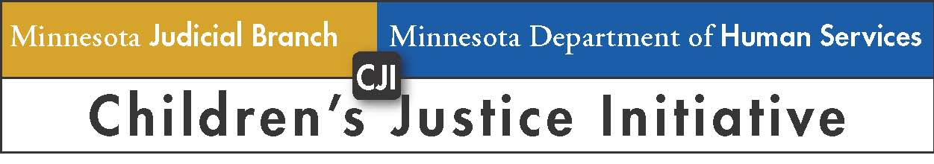

Hon. Robert Blaeser Indian Child Welfare Excellence Award

About the Award
The Hon. Robert Blaeser Indian Child Welfare Excellence Award is presented annually by the Children’s Justice Initiative (CJI) to an individual or group who during the past year (October 2022 through September 2023) has demonstrated excellence in Indian child welfare advocacy by:
- Making a significant contribution toward achieving full compliance with the Indian Child Welfare Act (ICWA) and the Minnesota Indian Family Preservation Act (MIFPA); and/or
- Improving the well-being of American Indian children and families who experience the child welfare system.
Individual nominees may be involved in child welfare in any role, including judges, court administration, county attorneys, social services workers, attorneys for children and parents, guardians ad litem, tribal representatives, or others who work to improve outcomes for American Indian children and families. Nominees may also include groups such as CJI Teams, county child welfare agencies, or other groups.

Nominations Criteria
The following criteria will be considered when reviewing nominations for an individual or group who has demonstrated excellence in Indian child welfare advocacy:
- Commitment to achieving full compliance with the Indian Child Welfare Act (ICWA) and the Minnesota Indian Family Preservation Act (MIFPA);
- Proactive collaboration with state and tribal justice partners;
- Leadership of a project or policy improving the child welfare system for American Indian children;
- Engagement of American Indian youth and parents with lived child welfare experience in developing or implementing a new program or policy so it is built or implemented “with” children and parents rather than “for” them; and
- Creation or implementation of new plans, protocols, practices, or strategies to achieve improved outcomes for American Indian children and families.

Detailed Nomination Criteria
- The work described in the nomination must be recent and activities should have occurred within the past calendar year (October 2022 through September 2023);
- Nominations should provide specific and detailed examples of how the nominee has demonstrated excellence in improving child welfare for American Indian children and/or compliance with ICWA and MIFPA;
- Nominations should clearly explain how the nominee’s actions produced better results/outcomes for American Indian children and families; and
- Self-nominations will not be accepted.

Process and Timeline for Submitting Nominations
Nomination forms must be submitted no later than 5:00 pm on Wednesday November 8, 2023. Completed nomination forms must be timely submitted to CJI@courts.state.mn.us. The Children’s Justice Initiative plans to present the award to the recipient(s) at the final 2023 meeting of CJI ICWA Subcommittee on November 29, 2023.

Selection of Award Recipient(s)
The Co-Chairs of the CJI ICWA Subcommittee will select the award recipient(s).

Inaugural Award Recipient
The inaugural award was be presented to an individual who has demonstrated a lifelong and ongoing commitment to improving the welfare of American Indian children and families. The Honorable Robert Blaeser was selected to have the award named after him and chosen to be the first recipient of the award in recognition of his:
- unwavering support for and zealous advocacy in creating and sustaining Minnesota’s first ICWA Court in Hennepin County to better serve American Indian children and their families experiencing the child welfare system;
- unparalleled leadership in collaborating with state and tribal Judicial Branch justice partners to implement the requirements of the ICWA and MIFPA;
- life-long commitment to ensuring compliance with the ICWA and MIFPA; and
- ongoing commitment to improving outcomes for American Indian children and their families.

Judge Blaeser’s Indian child welfare advocacy excellence has been demonstrated as evidenced by his:
- Service as Chief Judge of the White Earth Nation Tribal Court;
- Service as Presiding Judge of the Hennepin County, Minnesota, Juvenile Court;
- Trail blazing role as both an attorney and judge who co-founded the Minnesota American Indian Bar Association;
- Role in revolutionizing the handling of foster care cases involving Indian children in Hennepin County Juvenile Court;
- Advocacy in helping to ensure tribal court jurisdiction was recognized; and
- Implementation of specialized Guardian’s ad Litem (GALs) in ICWA cases, including recruiting native attorneys to volunteer as GALs for ICWA cases.

Nomination Form: Hon. Robert Blaeser Indian Child Welfare Excellence Award
Nomination forms must be submitted no later than 5:00 pm on Wednesday November 8, 2023. Completed nomination forms must be timely submitted to CJI@courts.state.mn.us.

- Name, title, agency/organization, phone, and email address of individual or group making this nomination.

- Name, title, and agency/organization of individual or group you are nominating. If nominating a group, please include the names of all individuals in the group (or attach an organization chart).

- Consistent with the “nominations criteria” in the overview, please describe the exceptional achievements, accomplishments, and contributions from the past year (October 2022 through September 2023) that demonstrate excellence in Indian child welfare advocacy and make the individual or group nominee the best candidate to receive this Award.

- Consistent with the “nominations criteria” in the overview, please detail the impact and outcomes on American Indian child welfare associated with the nominee’s achievements, accomplishments, and contributions. To the extent possible, include any data or metrics that have improved as a result of the nominee’s efforts. Please also describe any impact and outcomes to court customers as well.

- Describe the long-term impacts of the nominee’s actions. How will the nominee’s contributions over the past year create a long-term improvement in advocacy for American Indian children?

