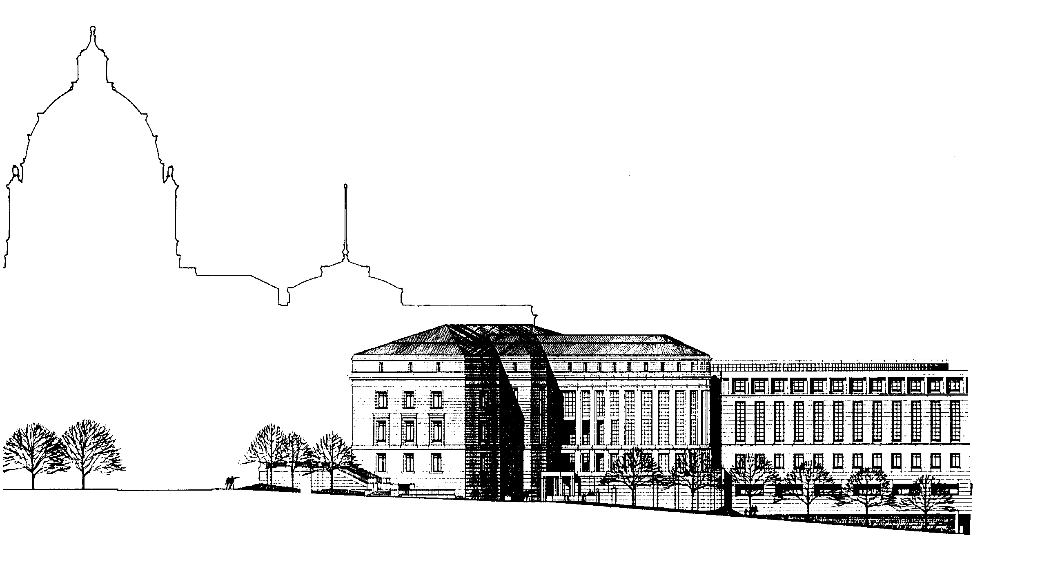
LEGAL SERVICES GRANT PROGRAMS

STATE COURT ADMINISTRATOR’S OFFICE
25 Rev. Dr. Martin Luther King, Jr. Blvd.
Saint Paul, Minnesota 55155
www.mncourts.gov/lsac
651-284-4379

MEMORANDUM
TO: Potential LSAC Grant Applicants
FROM: Bridget Gernander, Executive Director
RE: FY18-19 Grant Application Guidelines
DATE: December 15, 2016
The Legal Services Advisory Committee (LSAC) intends to award grants for the two-year period from July 1, 2017 to June 30, 2019 (FY18-19).
Where Does the Money Come From?
LSAC will distribute approximately $5,000,000 per year in grant funds from four primary sources:
- Funding appropriated by the Minnesota Legislature, governed by Minn. Stat. 480.242 for grants to legal services and alternative dispute resolution programs serving clients who meet the statutory poverty guidelines. More details about legislative funding eligibility are listed in the Statutory Interpretation and Financial Guidelines document at www.mncourts.gov/lsac. LSAC distributed $1,840,200 per year from the FY16-17 legislative funding available for discretionary grants (also known as the 15% funds). The committee will not know the total funding available for FY18-19 until the 2017 legislative session has ended.
- The civil legal services portion of Minnesota attorney registration fees can be spent at the discretion of LSAC for any purpose that supports civil legal services. LSAC distributed approximately $1,890,000 per year from the FY16-17 attorney registration fee revenue. This funding is expected to remain flat.
- Interest on Lawyers Trust Account (IOLTA) revenue is used to enhance the availability of legal services for the poor, to support programs of law related education and programs to enhance the administration of justice. LSAC plans to distribute approximately $450,000 per year from IOLTA funds and related revenue for the FY18-19 grant cycle. This is the same amount as the prior grant cycle.
- Bank of America settlement funding will be used solely for “community economic redevelopment” legal assistance and “foreclosure prevention” legal assistance. LSAC will distribute $1,000,000 per year during this grant cycle.

What Kind of Grants Will LSAC Make?
For the FY18-19 grant cycle, LSAC will consider proposals in four categories:
- General Operating Grants for Staff Legal Services. Regional grants that can be used for organizational expenses related to the provision or support of civil legal services by staff attorneys to economically disadvantaged Minnesotans. Regions are defined on the last page of this memo. LSAC is charged with ensuring access to a base level of civil legal services around the state. Regional proposals will be evaluated to ensure a more equitable distribution of resources.
- General Operating Grants for PAI Services. Regional grants that can be used for organizational expenses related to private attorney involvement (PAI) services to economically disadvantaged Minnesotans. PAI is defined to include both pro bono and judicare. Regions are defined on the last page of this memo. LSAC is charged with ensuring access to a base level of civil legal services around the state. Regional proposals will be evaluated to ensure a more equitable distribution of resources.
- Project Grants. Grants for projects to enhance the availability of legal services or alternative dispute resolution for the poor, to support programs of law related education and to enhance the administration of justice.
- Bank of America Project Grants. Following the terms of the Bank of America donation agreement, LSAC will consider projects in two areas:
  - Community Redevelopment Legal Assistance. Proposed projects should support and promote economic development by providing legal services that revitalize or stabilize low-income communities. Strategies may cross a broad range of options from counseling advocacy groups, transactional law, representation, or policy and impact work, but should reflect an understanding of the current needs and challenges within the communities to be served, and knowledge of successful models for meeting those needs. The organization should have established partnerships that are necessary to achieve the stated goals. LSAC looks to applicants to develop creative projects that will have far-ranging and lasting impact on communities. Applicants have flexibility in defining community redevelopment within this context, but legal assistance must be a key component of the service being delivered.
  - Foreclosure Prevention Legal Assistance. Recognizing that the foreclosure crisis has slowed, any funded project should address the foreclosure trends and continuing borrower needs and how its foreclosure prevention services will meet those needs. Strategies may be across a broad range of options from advice and counsel, representation, mediation programs or policy and impact work. Submissions should reflect an understanding of the current needs and challenges within the communities to be served, knowledge of successful models, flexibility and creativity, and necessary collaborations to achieve stated goals. Regardless of the foreclosure prevention model proposed, legal assistance must be a key component of the service being delivered.
Applicant organizations can submit proposals in more than one category.

How Will LSAC Score the Proposals?
Minnesota Judicial Branch Policy requires that all grant review be conducted using set review criteria. In this grant cycle, each proposal for grant funding will be evaluated and awarded up to 30 points (up to 15 organizational capacity points + up to 15 points for each proposal type) based on the following criteria:

A. Organizational Capacity Evaluation
Scoring Category | Description (with correlating application questions) | Points
Evaluation and Planning | A high scoring organization will demonstrate:  - evaluation and planning processes in place to improve their services (A4)  - ability to anticipate challenges and demonstrated capacity to adapt (A7) | Up to 5
Leverage | A high scoring organization leverages LSAC funds by:  - vigorously pursuing resources and partnerships to maximize their community impact (A5)  - securing diverse funding sources (e.g., donations, foundation support, other government funding) (A8 and Appendix 1) | Up to 5
Financial Strength | A high scoring organization will demonstrate:  - a realistic and clear budget that is part of an overall program plan, including ongoing financial review by their Board of Directors (A6)  - the ability to sustain their work and be responsive to a changing fiscal environment (A7) | Up to 5
Total Possible Points = 15

B. General Operating Grant for Staff Services Evaluation
Scoring Category | Description (with correlating application questions) | Points
Community Impact | A high scoring proposal will demonstrate:  - the broad impact of the service provided, either geographically or for specific populations (B1)  - solutions to address current and emerging client need (B3)  - (for Legal Representation programs) how legal needs are assessed and prioritized to deliver a full range of services in the region, including advice, brief service and extended representation (B2) | Up to 5
Delivery System Impact | A high scoring proposal will demonstrate:  - how the proposal contributes to a delivery system where there is a base level of access to civil legal services in all Minnesota counties (B4)  - how the organization connects or plans to connect to existing delivery system infrastructure, including lawhelpmn.org, mnlegaladvice.org and online intake (B6 and B3) | Up to 5
Collaboration | A high scoring proposal will:  - recognize other service providers in the region and address how this project will collaborate with other providers to reduce duplication and coordinate with law library or court self-help services when applicable (B7) | Up to 5
Total Possible Points = 15

C. General Operating Grant for PAI Services Evaluation
Scoring Category | Description (with correlating application questions) | Points
Community Impact | A high scoring proposal will describe:  - how private attorneys will meet community legal needs in the region(s) to be served (C1)  - solutions to address current and emerging client need (C3)  - (for Legal Representation programs) both pro bono and judicare models and how they could be used in the region to achieve a full range of PAI services, including advice, brief service and extended representation (C2) | Up to 5
Delivery System Impact | A high scoring proposal will clearly demonstrate:  - how the proposal contributes to a delivery system where there is a base level of access to civil legal services in all Minnesota counties (C4)  - ways that the organization connects or plans to connect to existing delivery system infrastructure, including projusticemn.org, lawhelpmn.org, mnlegaladvice.org and online intake (C6 and C3) | Up to 5
Collaboration | A high scoring proposal will:  - recognize other service providers in the region and address how this project will collaborate with other providers to reduce duplication and coordinate with law library or court self-help services when applicable (C7) | Up to 5
Total Possible Points = 15

D. Project Grant Evaluation
Scoring Category | Description (with correlating application questions) | Points
Community Impact | A high scoring proposal will:  - have a broad geographic reach and/or provide support services or education to a wide range of programs or client groups (D1 and D3) | Up to 5
Delivery System Impact | A high scoring proposal will:  - describe how this project uses technology or other approaches to support an integrated service delivery infrastructure (D2) | Up to 5
Collaboration | A high scoring proposal will:  - demonstrate that the project is not duplicative of existing services (D5)  - describe any collaborations with other providers to provide effective and efficient use of funds (D4 and D5) | Up to 5
Total Possible Points = 15

E. Bank of America Project Grant Evaluation
Scoring Category | Description (with correlating application questions) | Points
Community Impact | A high scoring proposal will clearly describe:  - a geographic community or population within a community that will benefit from the service (E1)  - a plan for measuring the impact (E1) | Up to 5
Collaboration | A high scoring proposal will demonstrate:  - that the project is not duplicative of existing services (E3)  - will describe any collaborations with other providers to provide effective and efficient use of funds (E3) | Up to 5
Leverage and Planning | A high scoring proposal will:  - leverage the Bank of America funds (e.g., increased pro bono, in-kind donations, other funding sources, etc.) (E2)  - will describe a plan for either continuing the project beyond the term of the Bank of America funds or for concluding the project (E4) | Up to 5
Total Possible Points = 15

What Is the Schedule for the LSAC Grants?
LSAC applications for FY18-19 funding must be received via email in the required format by 4:30 p.m. on March 3, 2017. Details about how to email the application are included in the application materials.
There will be a workshop on January 23, 2017 from 1:00 – 3:00 p.m. at the Minnesota Judicial Center in Room G06 for any prospective applicants who would like to ask questions about the grant application or data submission. Organizations applying to LSAC for the first time are strongly encouraged to participate in the workshop. Attendance by phone and webex can be arranged by request.
All applications received by the deadline will be screened for compliance with LSAC’s funding criteria. Applicants who meet the funding criteria will be scheduled for a 45-minute interview with an LSAC panel to discuss the application and respond to any committee member questions. Applicants who do not meet the funding criteria will be notified that their application has been denied and for what reason. LSAC contemplates making grant awards before June 30, 2017, but funding decisions are dependent on when the legislature finalizes the allocation amount.

Summary of LSAC Grant Timeline for FY18-19
Application Materials Available | December 20, 2016
Informational Workshop | January 23, 2017 from 1:00 – 3:00
Applications Due | March 3, 2017 by 4:30 p.m.
Interviews | By appointment in April 2017
Grants Awards Finalized | Mid-June 2017 (meeting date TBD)

Please direct inquiries regarding grant applications to Bridget Gernander, Legal Services Grant Manager, at bridget.gernander@courts.state.mn.us or 651-284-4379.

What Should I Know Before Applying for an LSAC Grant?
LSAC reserves the right to reject any or all applications received that do not, in its opinion, serve the best interest of the Minnesota Supreme Court or the intent of this funding. The application is made for informational or planning purposes only. Neither the Supreme Court nor LSAC will be liable for any expenses incurred by any prospective grantee prior to the issuance of the grant. Upon submission, all applications become the property of the Supreme Court, which has the right to use any or all ideas presented in any application submitted, whether or not the application is accepted. All application materials are public data and may be made available to other interested organizations and individuals.
The selected grantee must understand and agree to the following conditions that shall be included as part of the final grant award agreement. A copy of the full grant award agreement is available on request.
- Inspection and Audit. The office and representatives of the Supreme Court, and the Minnesota Legislative auditor, or any of their duly authorized representatives, shall have access for purposes of audit and examination to any books, documents, papers, and records of the grantee.
- Certification of Non-profit Status. The grantee must certify that it is a 501(c)(3) non-profit corporation that it is governed by a board of directors composed of attorneys-at-law and consumers of legal services, including at least one client eligible member as defined in the Statutory Interpretation and Financial Guidelines document, available on the website at www.mncourts.gov/lsac.
- Supplemental Data Requests. In accepting a grant from LSAC, grantees will be asked to comply with all reasonable requests for supplemental data.
- Reduction in Grant Funding. In the event the Legislature reduces the appropriation for civil legal services or anticipated funding from other sources drops below the allocated level, LSAC may reconsider and reduce awards to grantees for the second year of the biennium.

What Are the Minnesota Regions for LSAC General Operating Grants?

Northwest Region: Becker, Beltrami, Clay, Clearwater, Douglas, Grant, Hubbard, Kittson, Lake of the Woods, Mahnomen, Marshall, Norman, Otter Tail, Pennington, Polk, Pope, Stevens, Red Lake, Roseau, Traverse, Wadena, Wilkin plus any Indian reservations within the geographic boundaries of this region.
Northeast Region: Aitkin, Carlton, Cass, Cook, Crow Wing, Itasca, Kanabec, Koochiching, Lake, Pine, St. Louis plus any Indian reservations within the geographic boundaries of this region.
Central Region: Anoka, Benton, Big Stone, Chippewa, Chisago, Hennepin, Isanti, Kandiyohi, Lac qui Parle, Lincoln, Lyon, Meeker, Mille Lacs, Morrison, Renville, Sherburne, Stearns, Swift, Todd, Wright, Yellow Medicine plus any Indian reservations within the geographic boundaries of this region.
Southern Region: Blue Earth, Brown, Carver, Cottonwood, Dakota, Dodge, Faribault, Fillmore, Freeborn, Goodhue, Houston, Jackson, Le Sueur, Martin, McLeod, Mower, Murray, Nicollet, Nobles, Olmsted, Pipestone, Ramsey, Redwood, Rice, Rock, Scott, Sibley, Steele, Wabasha, Waseca, Washington, Watonwan, Winona plus any Indian reservations within the geographic boundaries of this region.
