Strategic Vision for Access to Civil Legal Aid in Minnesota: The Next Generation
Minnesota civil legal aid services have grown and evolved for more than a century, resulting in a strong network of programs serving every county in the state across a wide range of case types. We are now moving towards a vision for the next generation of access to justice, which will increase collaboration across programs to create a more coordinated and client-friendly system statewide.
In the coming years, civil legal aid will have centralized phone and online intake, ensuring that low-income Minnesotans seeking legal assistance are connected to the best available service. This centralized system will include coordinated marketing and outreach so that our community partners only have to know one referral point to access an array of staff and pro bono services. This approach will maximize our ability to collect client needs data and to increase resources to serve more people.
Goals of the Strategic Vision
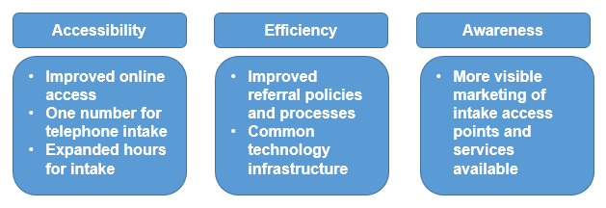
Implementation Projects
LOON: The first success we have had is the launch of Legal Organizations Online Network (LOON), the backbone of the coordinated infrastructure system. LOON is a database of information updated in real-time by more than 20 legal aid organizations. This tool helps intake staff make better referrals of clients they are unable to serve to a provider who can or be confident saying “no” if services are not available.
LawHelpMN: The website www.lawhelpmn.org has been redesigned to be make it easier to find information and is on a new platform that allows for regular improvements based on user feedback. It has two primary components:

LawHelpMN Guide - This guided interview is designed for people with legal problems and trusted intermediaries who often help families in crisis. By answering a few questions, relevant legal information is presented to the user before asking if they would like to go further and see what additional services may be available.

Provider and Clinic Directory - The website also includes a provider and clinic directory designed for users more familiar with the legal system, including pro bono attorneys making referrals at clinics, to quickly filter and find the best available resources for clients.

LegalServer Case Management System: The Legal Services Advisory Committee (LSAC) is funding a transition to the LegalServer case management system for many of the civil legal aid programs statewide starting in 2019. Being on the same case management system is critical to more efficient intake and referral processes across programs, as well as to share training and other infrastructure resources.
Toll Free Number Centralized Phone System: The most complex portion of the strategic plan is the creation of a single point of entry for phone intake statewide. Starting in 2022, prospective clients can call 1-877-MY-MN-LAW and after entering their zip code they will be routed to a centralized intake hub. These hubs will be regionalized for core poverty law services. Callers will be screened for eligibility and transferred to a civil legal aid provider for service based on geography and case priorities. We will have comprehensive statewide data about the requests for service and who is turned away in order to have a data-driven approach to meeting client needs.

Timeline
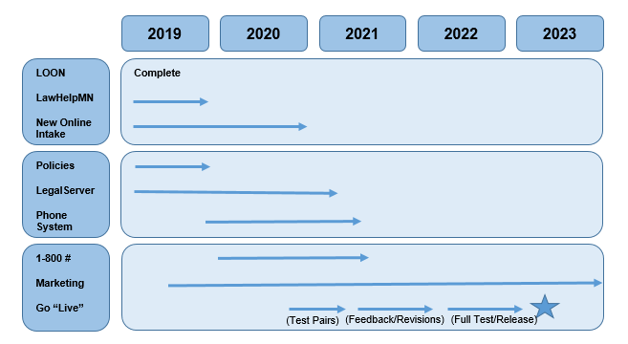
Additional Background
More information is available on the LSAC website at www.mncourts.gov/lsac.
Minnesota Intake Study – LSAC contracted with a national legal aid expert to review the current intake systems and to make recommendations.
Report to the Minnesota Supreme Court – Civil legal aid program leadership’s strategic vision proposal, which was approved by the court in January 2019.

Programs participating in the first phase of the statewide centralized intake number include Central Minnesota Legal Services, Judicare of Anoka County, Legal Aid Service of Northeastern Minnesota, Legal Assistance of Dakota County, Legal Assistance of Olmsted County, Legal Services of Northwest Minnesota, Mid-Minnesota Legal Aid, Southern Minnesota Regional Legal Services, Volunteer Attorney Program, and Volunteer Lawyers Network.

