How were the American’s influenced by their English background?
Middle School Level: Unit Two, Lesson 5

American’s knowledge of British government
Purpose of Lesson
This lesson describes the growth and development of constitutional government in England. It discusses the limitations that were placed on that government over a period of many centuries. It will help you to understand the background of the basic ideas of constitutional government in the American colonies.

When you have finished this lesson, you should be able to describe the struggles for power between the English monarch (king or queen) and the Parliament (legislature). You should also be able to explain how these struggles led to a system of separated powers and representative government.
Terms to know
Feudalism/feudal system
Royalty
Monarch/monarchy
Nobility
Common people
Magna Carta
Representative government
Parliament
English Bill of Rights

The American colonies had been ruled by the British government for over 150 years before the American Revolution. As a result, Americans knew quite a bit about the British government. The men who wrote our Constitution were greatly influenced by their experiences with the British government. They were also influenced by their knowledge of its history. Understanding what they knew is important to understanding why they wrote the Constitution as they did.
The feudal system
English history goes back many centuries before the discovery of America. For much of that time, England was made up of a number of kingdoms, each with its own ruler. Then in 1066, William the Conqueror invaded England and became its king. He then began a new system of government known as feudalism.
Under the feudal system, the people in England belonged to one of the following three groups.
Royalty. This group included the monarch (king or queen) and his or her family. A government ruled by a monarch is called a monarchy.

Nobility. This group included the “lords” and “ladies” who held titles such as earl, duke, duchess, and baron. They worked for the king and made it possible for him to control all of England.

Common people. The group included such people as knights (soldiers of the king), merchants, and peasants (people who worked the land). The peasants were often called serfs because they were not free and could not leave the area in which they worked.

England’s land all belonged to the king or queen. There was too much land for a king or queen to rule alone. So, they gave some of the responsibility for governing the kingdom to the nobility. Under the feudal system, the nobles were allowed to control parts of the land and the people who lived there. In exchange, they pledged their loyalty to the king and fought for him. You will see how his sharing of power by royalty with the nobility eventually led to a government that represented more of the people.

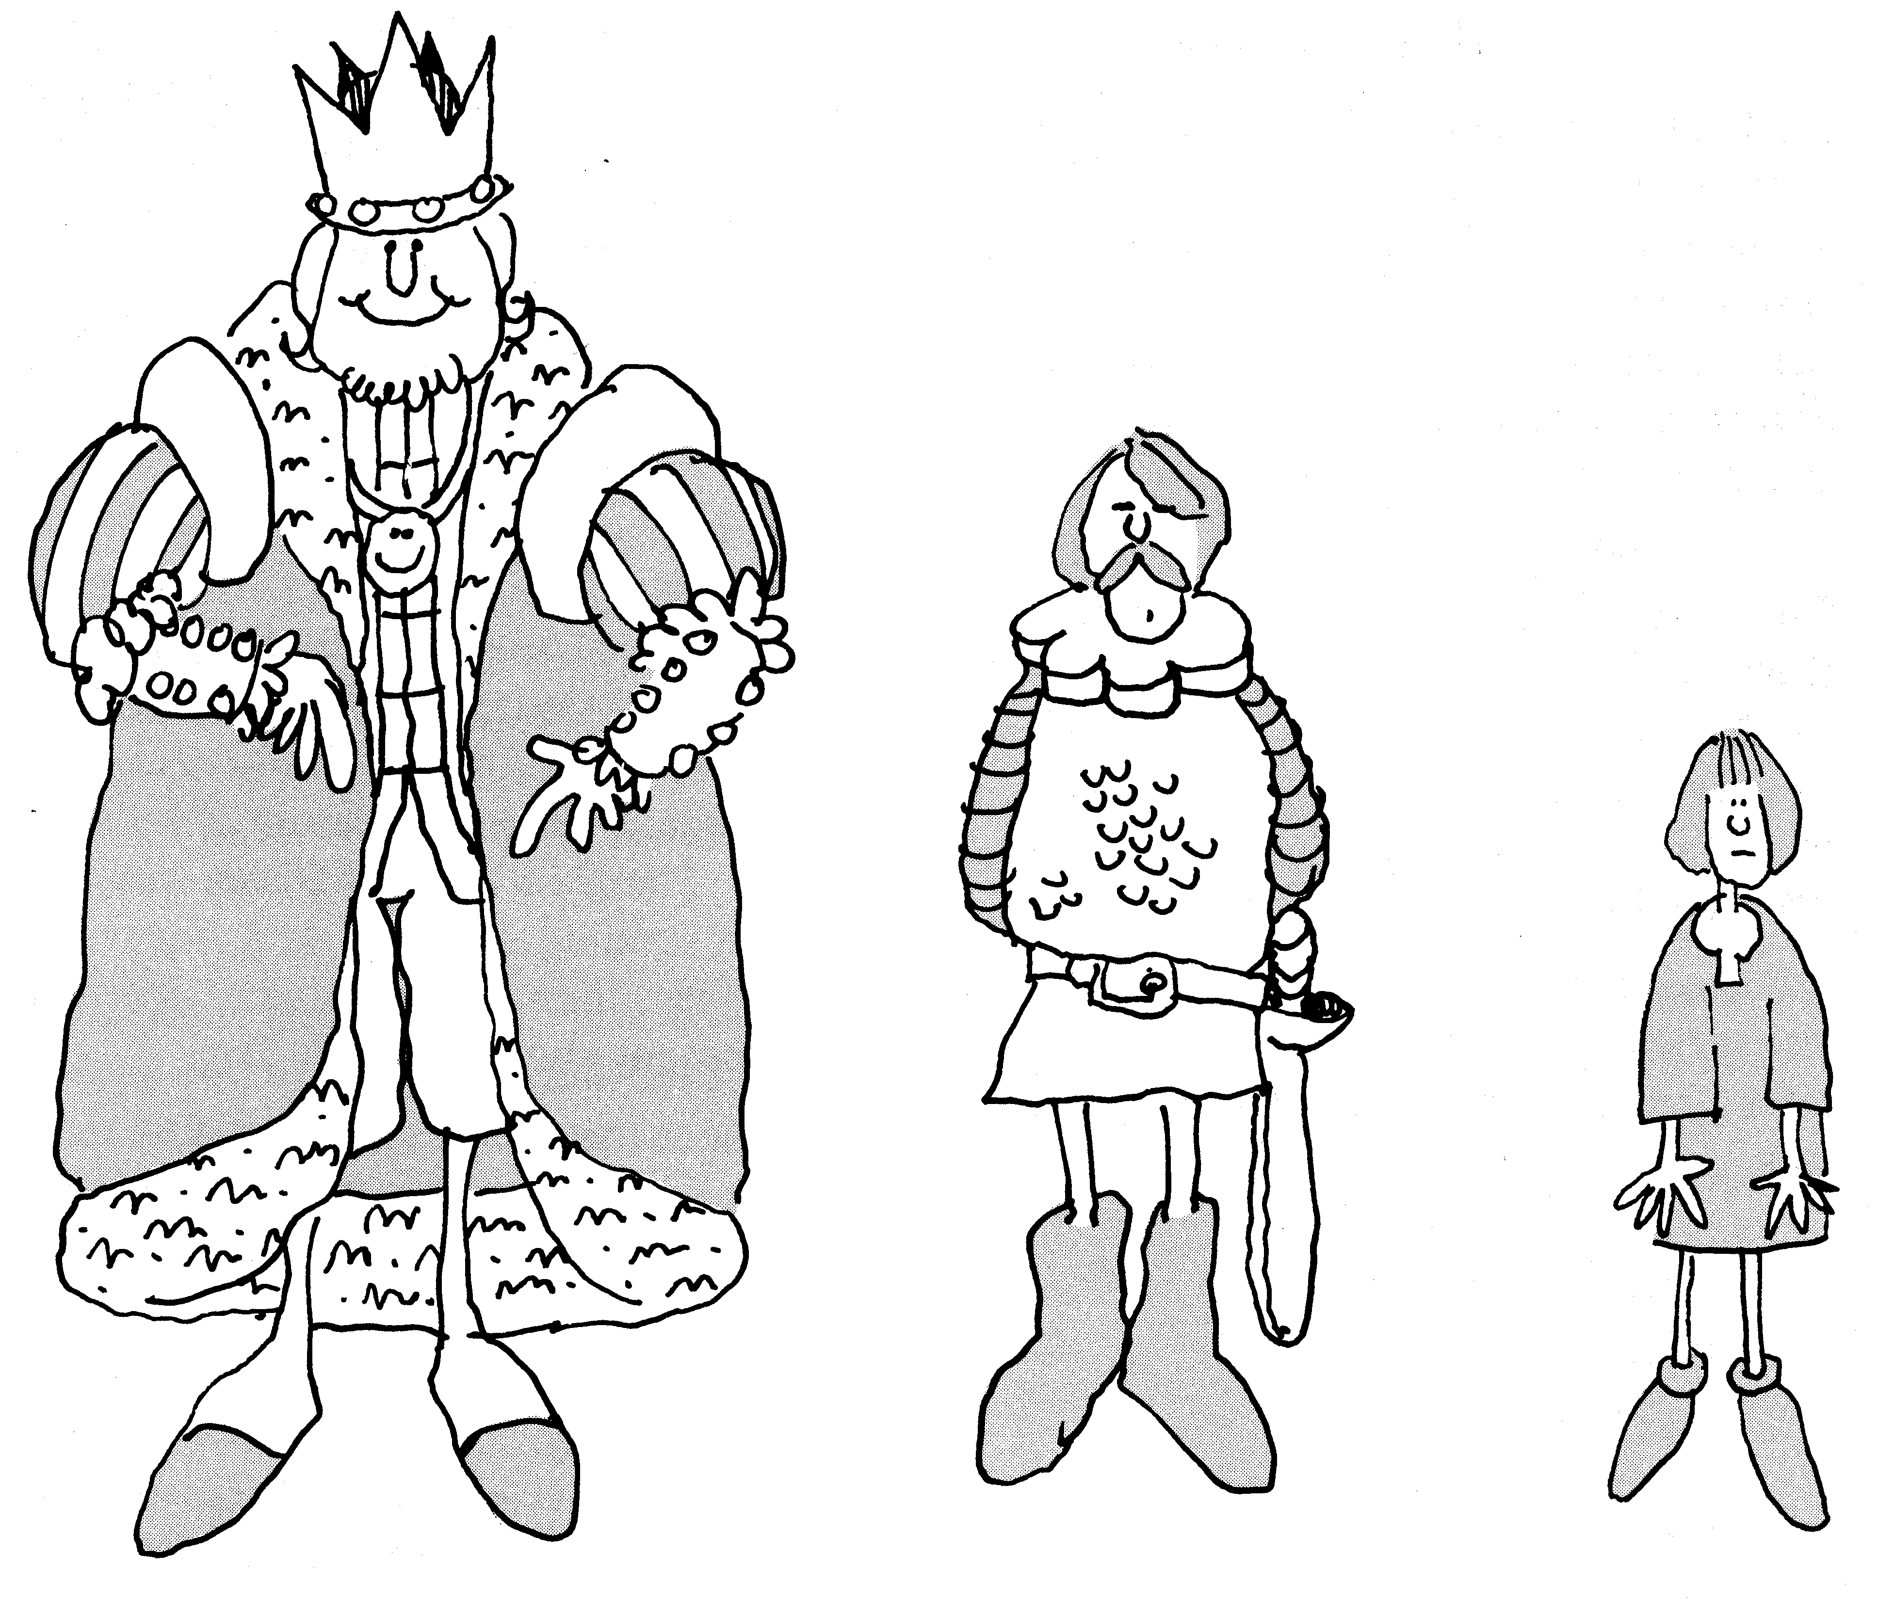
How does this drawing illustrate the distribution of power in the feudal system?

The Magna Carta
Under the feudal system, it became a custom or tradition for the royalty to share some of its powers with the nobility. As a result, the nobles became used to having certain rights and powers. When King John tried to take back some of these rights, the nobles rebelled.
The nobles were powerful enough to force the king to sign an agreement with them. This agreement, signed by King John in 1215, became known as the Magna Carta or Great Charter. It said that the nobles would obey the king only as long as he protected their rights.
The Magna Carta was a major step in the growth of English constitutional government. It contained two very important ideas.
* Governments are based on an agreement or contract between the ruler and people to be ruled. In the case of the Magna Carta, this was a contract between the king and the nobility.

Most of the people in England were not a part of this agreement. But it was an early step in establishing the idea that government should be based on a contract which includes all the people. You may recognize this as the same idea as the social contract discussed hundreds of years later by the natural rights philosophers.

A government by contract means that both sides of the agreement are responsible for fulfilling its terms. In the Magna Carta, the king was responsible for not depriving the nobility of their rights. The nobility, in turn, was responsible for supporting the king and obeying the laws of England

A government by contract also includes the idea that if either side breaks the contract it is no longer valid
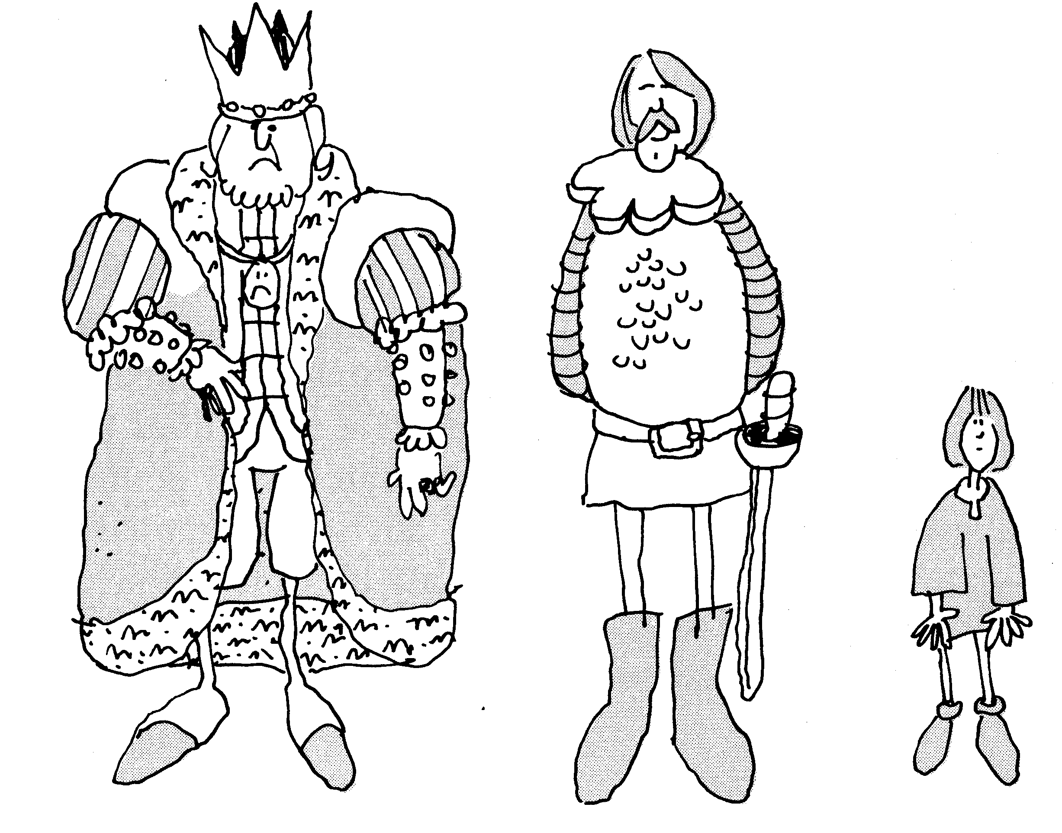
What changes occurred in the distribution of power when the Magna Carta was signed?
* The Magna Carta also includes the idea of the rule of law. This means that both the government and the governed must obey the law. The law limits the powers of the government. For example, the king could not take away the property of a noble without following agreed-upon procedures and rules.

The rule of law also meant that if the king broke the laws, the nobles had the right to overthrow him. They could place a new king on the throne. This idea became part of the natural rights philosophy. It is also included in our Declaration of Independence.

The early English customs and traditions and the Magna Carta protected certain basic rights. These rights were not given to all the people of England. Men who owned property were given far more rights than other people. Men without property, and women and children had fewer rights. However, the Magna Carta was an important step in protecting the rights of the people and limiting the power of the government.

The establishment of Parliament

Important changes in the English government resulted in the establishment of other basic ideas you have studied. These are the separation of powers and the beginning of representative government. In 1258, the nobles forced King Henry III to create a new council called Parliament to advise the monarch. Parliament was made up of two houses which represented the most powerful groups in the kingdom. The House of Lords represented the nobles. The House of Commons represented people who owned large amounts of land but were not members of the nobility.
For hundreds of years after the creating of Parliament, the royalty, nobility, and commons struggled for power. No one group was able to control all the power for very long. The struggle became so intense during the 17th century that a civil war resulted. The nobles won and in 1649, Parliament ordered the execution of the king. By the time of the Glorious Revolution of 1688, the balance of power had shifted in favor of Parliament.

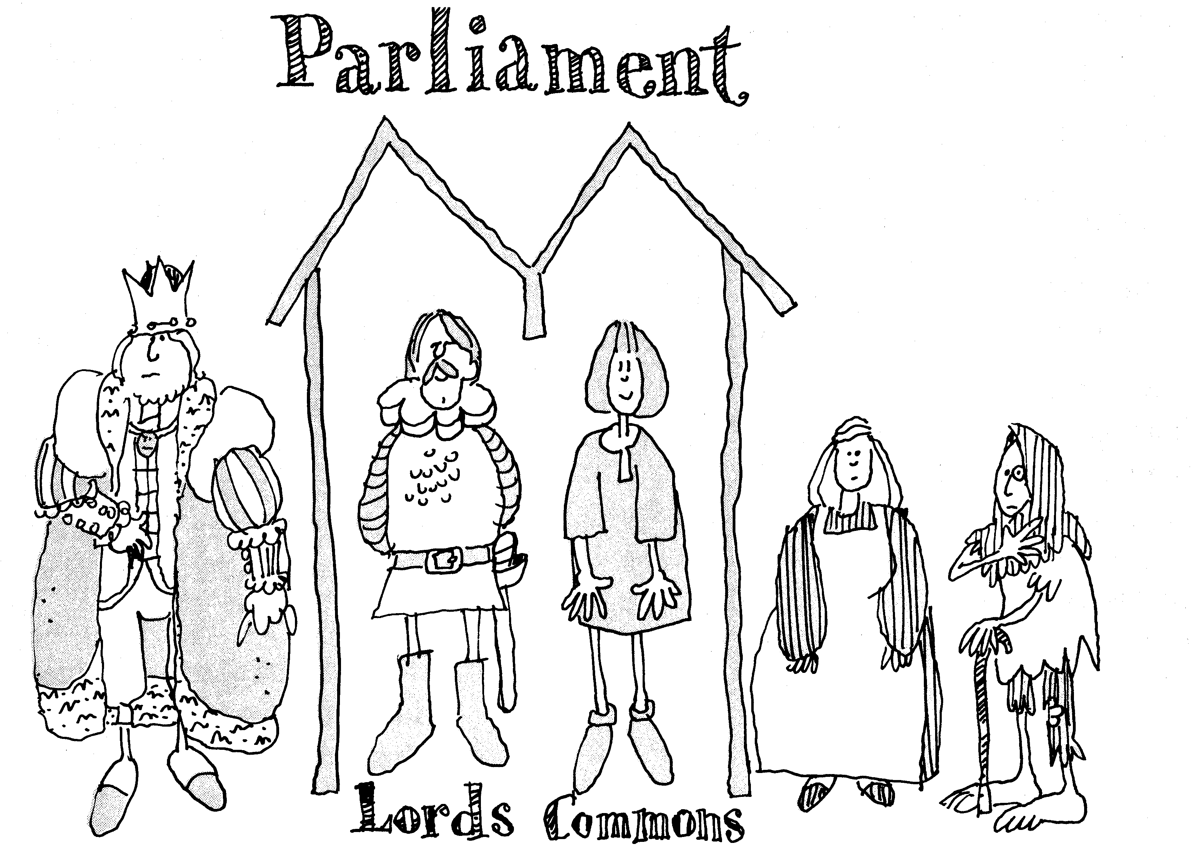
Who benefited most from the creation of Parliament?

The English Bill of Rights
In 1689, Parliament passed an important law, the English Bill of Rights. This law gave certain rights to Englishmen and further limited the powers of the monarch. The Bill of Rights gave Parliament the balance of power in the English government.
What did the Bill of Rights guarantee? It said that elections to Parliament must be free and that the people have the right to keep and carry weapons. It said that kings and queens were not allowed to
- collect taxes without the consent of Parliament
- interfere with the right to free speech and debate that went on in Parliament,
- maintain an army in times of peace (since it might be used to take over the government).
- require excessive bail or administer cruel punishment for those accused or convicted of crimes,
- declare that laws made by Parliament should not be obeyed.
By the end of the 17th century, the British government became increasingly limited in what it could do. During this same period, the government was establishing colonies in North America. The colonists brought with them the English system of constitutional government.

Problem solving
Your class should be divided into small groups to answer the following questions. When your group has completed its answers, it should share them with the rest of the class.

The Magna Carta was written in 1215 and the English Bill of Rights was passed in 1689. During the more than 400 years between these documents, many changes occurred in the English government. Review what you have read about these two documents and discuss the following questions.

1. How was the Bill of Rights different from the Magna Carta?

2. What basic rights that you think are important were not included in either of these two documents?

Reviewing and using the lesson
1. How and why did the feudal kings in England share their power?

2. What were some of the basic ideas included in the Magna Carta?

3. Parliament won a struggle with the king in 1689, when the English Bill of Rights was adopted. Which parts of the English Bill of Rights do you think the Framers might have included in our Constitution? Explain your answers.

4. Four ideas that were very important to the Framers were limited government, representative government, the balance of power, and separation of powers. Give examples of these ideas from English government.

Reproduced with permission. We the People…Unit 2, Lesson 5. Copyright 1998. Center for Civic Education. Calabasis, California. For more information about We the People and other CCE programs call 800.350.4223 or check out their web site at http://www.civiced.org.

To obtain a free classroom set of We the People, contact Debra Berghoff at the Minnesota Center for Community Legal Education, 612/624.8112 or bergh004@umn.edu. Visit our web site at http://www.ccle.fourh.umn.edu for more information about We the People in Minnesota.

