Important Notice to Respondent

If you are served with these papers, one of the following has happened (see attached papers for specifics):
- A temporary harassment restraining order has been issued against you. A hearing has been scheduled.
OR
- A temporary harassment restraining order has been issued against you. A hearing has not been scheduled. You have 20 days from the date of service of the Temporary Restraining Order to request a hearing.
OR
- A harassment restraining order has not been issued at this time. A hearing has been scheduled.

Review the attached papers carefully.

What is a Harassment Restraining Order?
A person who is a victim of harassment may seek a restraining order from the Court. The parent or guardian of a minor who is the victim of harassment may seek a restraining order on behalf of the minor. The restraining order prohibits harassment. A restraining order may be issued against an individual who has engaged in harassment, or against organizations that have sponsored or promoted harassment.

What is Harassment?
Under Minn. Stat. § 609.748, harassment is defined as:
1. A single incident of
a. physical or sexual assault, or
b. stalking in which the victim’s personal information is used by another without consent of the victim, to invite, encourage, or solicit a third party to engage in a sexual act with the victim [See Minn. Stat. § 609.749, subd. 2 clause (8)], or
c. intentionally disseminating a private image of the victim, without consent of the victim, that shows the victim in a sexual act or whose intimate parts are exposed, in whole or in part, and the victim is identifiable by the victim or by another person or from personal information displayed in connection with the image. (See Minn. Stat. § 617.261).
2. Repeated incidents of intrusive or unwanted acts, words or gestures that have a substantial adverse effect or are intended to have a substantial adverse effect on the safety, security or privacy of another, regardless of the relationship between the victim and the alleged harasser.
3. Targeted residential picketing, which includes:
- marching, standing, or patrolling by one or more persons directed solely at a particular residential building in a manner that adversely affects the safety, security, or privacy of an occupant of the building, or
- marching, standing, or patrolling by one or more persons which prevents an occupant of a residential building from gaining access to or exiting from the property on which the residential building is located.
4. A pattern of attending public events after being notified that one’s presence is harassing to another.

Change of Address:
It is important that the court knows your mailing address to send you notices. If your mailing address changes, give court administration (http://mncourts.gov/Find-Courts.aspx) your new mailing address.

Hearing:
If a temporary restraining order has been issued, you have the right to ask for a hearing. You have 20 days from the date the petition is served to file a Request for Hearing with the court. You will be required to pay a civil filing fee unless the judicial officer has waived the filing fee due to the allegations in the petition. Review the Order Regarding Fee Waiver in Harassment Restraining Order Proceedings to see if the filing fee has been waived.
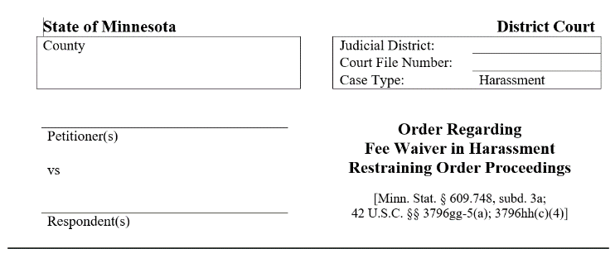
If the judicial officer did not order your filing fee waived, you may complete and file a fee waiver application (Affidavit for Proceeding In Forma Pauperis, IFP102) that would be reviewed by a judicial officer who would determine whether to waive your filing fee based on your income. Fee waiver forms are available from the court administrator and online (http://mncourts.gov/GetForms.aspx?c=19&p=69). The court will notify the parties with a date and time to appear for a hearing.

Violations:
You may be charged with a misdemeanor, subject to a sentence of up to 90 days in jail and/or a fine of $1,000.00, if you are aware of the existence of a restraining order and you violate it. Some repeat violations are gross misdemeanors that may result in a sentence of up to one year in jail and/or a $3,000.00 fine. Other violations are felonies that may result in a sentence of imprisonment for up to five years and/or a fine of $10,000.00.
You may be arrested and taken into custody without warrant if a peace officer has probable cause to believe you are in violations of the restraining order. You will be held in jail for at least 36 hours, excluding the day of arrest, Sundays, and legal holidays, unless you are released earlier by a judicial officer. Violation of the restraining order also constitutes contempt of court. See Minn. Stat. § 609.748, subd. 6 (https://www.revisor.mn.gov/statutes/cite/609.748#stat.609.748.6).

