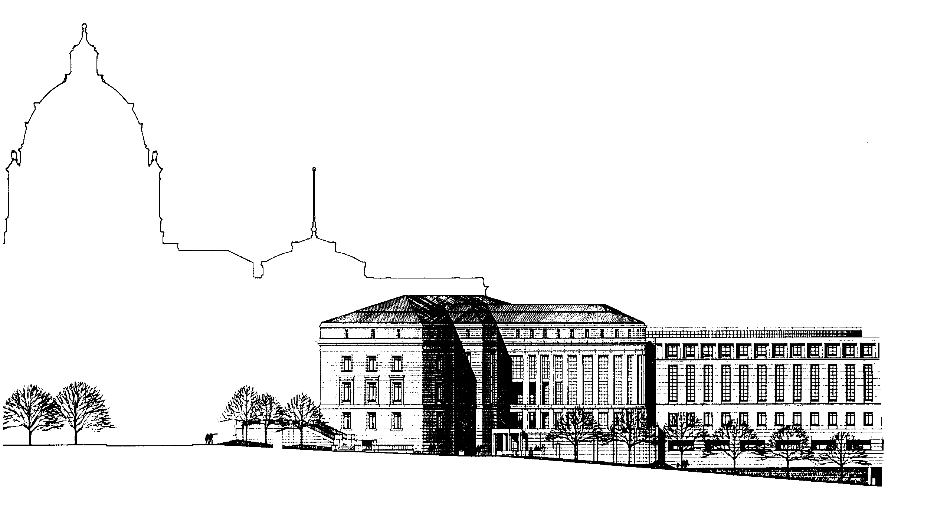
LEGAL SERVICES GRANT PROGRAMS STATE COURT ADMINISTRATOR’S OFFICE
25 Rev. Dr. Martin Luther King, Jr. Blvd.
Saint Paul, Minnesota 55155
www.mncourts.gov/lsac
651-284-4379

MEMORANDUM

TO: Potential 85% Grant Applicants
FROM: Bridget Gernander, Executive Director
RE: FY23 Application for Anoka County 85% Funding
DATE: December 20, 2021
The Legal Services Advisory Committee (LSAC) intends to award one grant for a one-year period from July 1, 2022 to June 30, 2023 (FY23). There is $593,347 in available state legislative funding for Anoka County from the 85% poverty population funding formula described in Minn. Stat. § 480.242(a). Only programs meeting the statutory criteria can submit a proposal under this section. LSAC will choose from among the applications submitted by eligible programs.

How Will LSAC Score the Proposals?
Minnesota Judicial Branch Policy requires that all grant review be conducted using set review criteria. In this grant cycle, each proposal for grant funding will be evaluated and awarded up to 30 points (up to 15 organizational capacity points + up to 15 points for each proposal type) based on the following criteria:

A. Organizational Capacity Evaluation
Scoring Category | Description (with correlating application questions) | Points
Board Strength | A high scoring organization will demonstrate:  - diversity of Board membership (A3)  - clear training on good governance principles, such as what is described on the Minnesota Council of Nonprofits website (A4)  - active and engaged Board of Directors (A5) | Up to 5
Evaluation and Planning | A high scoring organization will demonstrate:  - evaluation processes in place to improve organizational programming, such as what is described on the National Council of Nonprofits website (A6)  - strong strategic planning process where the organization has both a long term plan and short term objectives for accountability (A7)  - clear succession planning in place for Executive Director position (A8) | Up to 5
Financial Strength | A high scoring organization will demonstrate:  - ability to anticipate challenges and demonstrated capacity to adapt (A9)  - a realistic and clear budget that is part of an overall program plan (A10) | Up to 5
Total Possible Points = 15

B. 85% Legislative Funding Evaluation
Scoring Category | Description (with correlating application questions) | Points
Community Impact | A high scoring proposal will:  - demonstrate the work of the Organization to effectively serve clients through comprehensive needs assessment (B4)  - demonstrate the work of the Organization to effectively use resources to meet their mission through strategic planning (B5) | Up to 5
Delivery System Impact | A high scoring proposal will:  - ensure coverage of basic civil legal services in Anoka County through effective use the statutory formula funding. (B1) | Up to 5
Collaboration | A high scoring proposal will:  - demonstrate efforts to prevent duplication in the Anoka County. (B2)  - demonstrate high quality services, outreach and local relationships with social service providers, courts, law libraries or other partners in Anoka County. (B3) | Up to 5
Total Possible Points = 15

What Is the Schedule for the LSAC Grants?
LSAC applications for this FY23 funding distribution must be received through the online grant management system by 4:30 p.m. on February 25, 2022.
Please direct inquiries regarding grant applications to Bridget Gernander, Legal Services Grant Manager, at bridget.gernander@courts.state.mn.us or 651-284-4379.

What Should I Know Before Applying for an LSAC Grant?
LSAC reserves the right to reject any or all applications received that do not, in its opinion, serve the best interest of the Minnesota Supreme Court or the intent of this funding. The application is made for informational or planning purposes only. Neither the Supreme Court nor LSAC will be liable for any expenses incurred by any prospective grantee prior to the issuance of the grant. Upon submission, all applications become the property of the Supreme Court, which has the right to use any or all ideas presented in any application submitted, whether or not the application is accepted. All application materials are public data and may be made available to other interested organizations and individuals.
The selected grantee must understand and agree to the following conditions that shall be included as part of the final grant award agreement. A copy of the full grant award agreement is available on request.
- Inspection and Audit. The office and representatives of the Supreme Court, and the Minnesota Legislative auditor, or any of their duly authorized representatives, shall have access for purposes of audit and examination to any books, documents, papers, and records of the grantee.
- Certification of Non-profit Status. The grantee must certify that it is a 501(c)(3) non-profit corporation that it is governed by a board of directors composed of attorneys-at-law and consumers of legal services, including at least one client eligible member as defined in the Statutory Interpretation and Financial Guidelines document, available on the website at www.mncourts.gov/lsac.
- Supplemental Data Requests. In accepting a grant from LSAC, grantees will be asked to comply with all reasonable requests for supplemental data.

Definitions Used Throughout LSAC Application
This section describes the terms that have specific meanings in the LSAC application materials. Please read through before starting the online grant application.
Comprehensive Needs Assessment. A comprehensive needs assessment is a process where a legal representation program surveys eligible clients, staff and community about what services should be the highest priority. A comprehensive needs assessment will help determine the allocation of scarce resources and staffing, incorporate information from a variety of stakeholders, including applicants and clients, and engage with the community to get feedback on how efficient, visible, and accessible the organization is, and generate data and information that the organization can use in its media effort to increase the visibility of legal aid, develop support for legal aid work, and encourage resource development
Legal Representation. Refers to those services through which lawyers and other legal advocates provide legal representation to clients, in an attorney/client relationship, whether using a staff, volunteer, judicare, or some other model.
Organization. Refers to your corporate entity, including all Programs as defined below and other parts of your entity, if any.
Other Eligible Services. Refers to law-related services (other than Legal Representation) eligible for LSAC funding. Examples include community legal education; advocacy on issues affecting eligible clients at the legislature or before other elected bodies, in administrative rulemaking, or the like; support to Programs that provide Legal Representation; mediation and/or other dispute resolution services, administration of justice; and other eligible law-related services not defined as Legal Representation.
Private Attorney Involvement (PAI). Refers to legal services provided by private attorneys, rather than staff attorneys, and includes both pro bono and judicare.
Program. Refers to that part of your Organization that provides law-related services, including but not limited to, services eligible for LSAC funding. Program services may include Legal Representation and/or Other Eligible Services.
Proposal. Refers to LSAC’s Request for Proposals across different areas: general operating grant for staff services, general operating grant for private attorney involvement (PAI) services, and project grants. Organizations can submit Proposals in more than one category.

